Criterion C: Development

Website3.sln is an ASP.NET and Visual C# based web application for IB Coordinator Ms. Hema Rajan and teachers; Administrator (Coordinator) can add students, teachers, configure and/or add slots (different subject lectures happening simultaneously) and lastly can check the overall report of class attendance. Teachers mark the lecture-wise attendance of students with their slot-IDs.

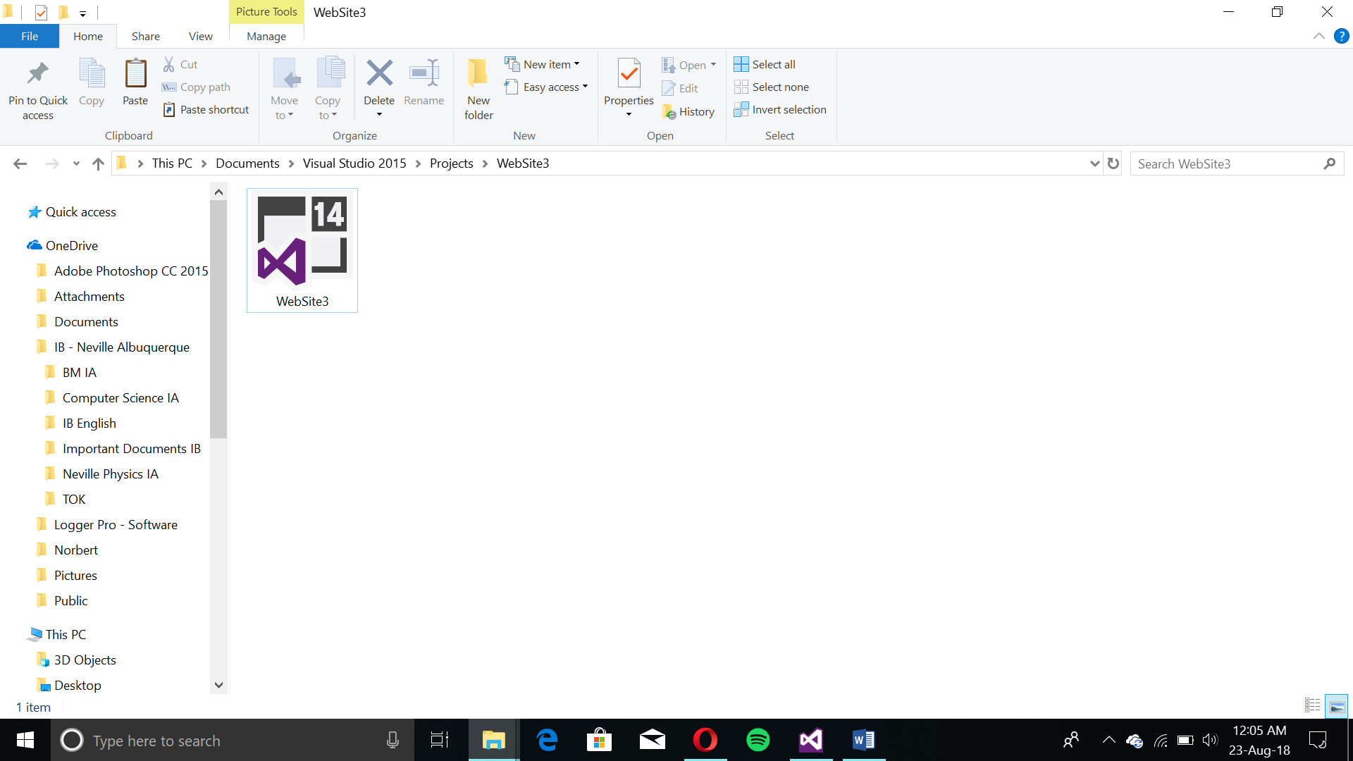

This file should be in the folder where the entire website’s contents are present.

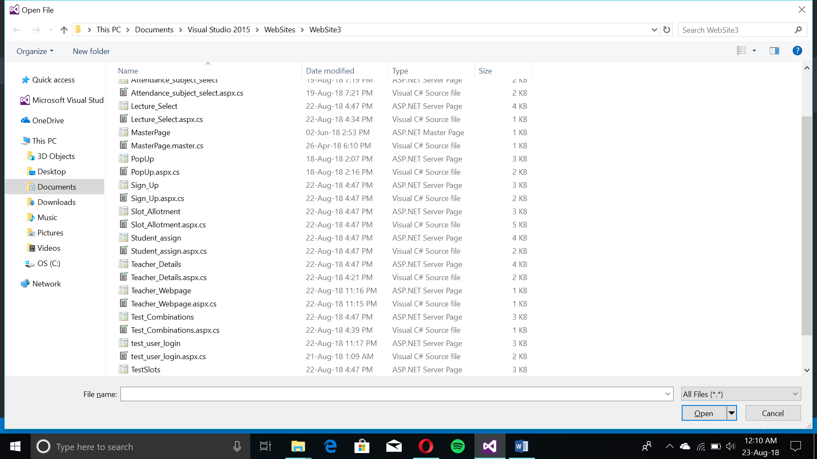

Computational Thinking based programming statements and techniques:

* For Loops
* While Loops
* Conditional Statements (if/else if/else)
* Database Views
* Dynamic Tables
* Collections
* Try-catch
* Joins
* Sub-Queries
* Auto-increment

Program Structure

I have used Microsoft Visual Studio 2015 for creating front-end elements like Labels, buttons, panels, textboxes, etc. As seen in the below structure of the program.

Commonalities throughout the application:

* Navigation provided by buttons redirecting back to the main page.
* Confirmation of successful input to the back-end tables in the database.
* Submit button submits queries to the tables in the database
* Declaration of variables with string/integer/etc. as appropriate.

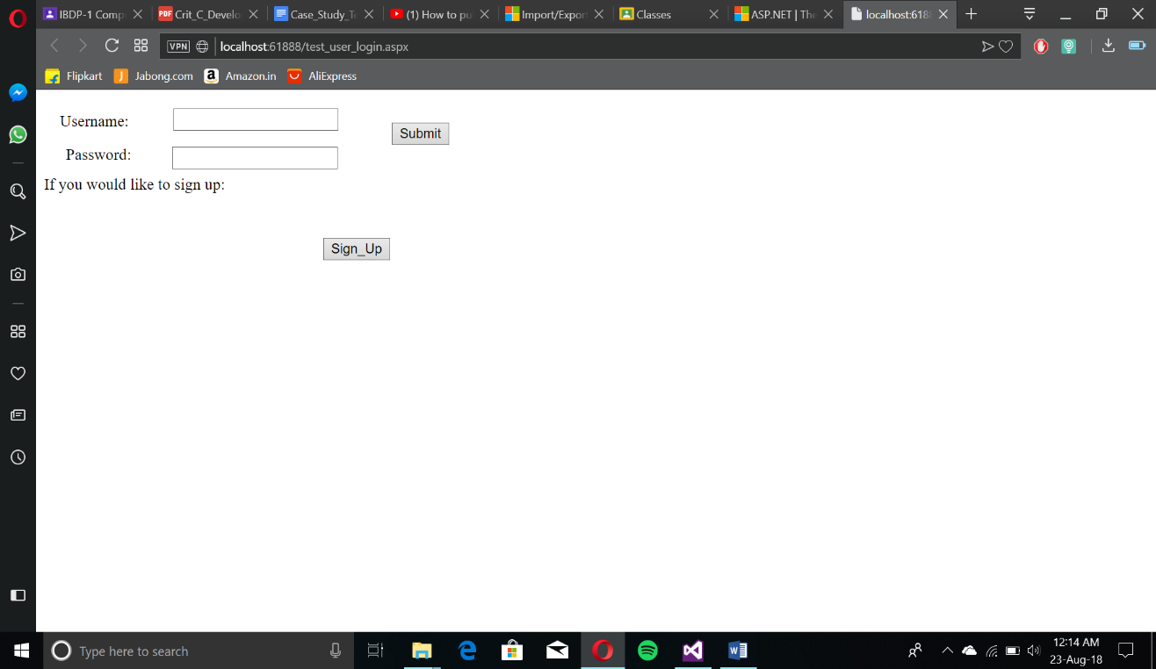

The login is the first page. The sign-in page uses existing user login details for the admin and the teachers. New teachers can sign up via the “Sign_Up” button. The “Submit” button will submit the “Username” and “Password” entered in. 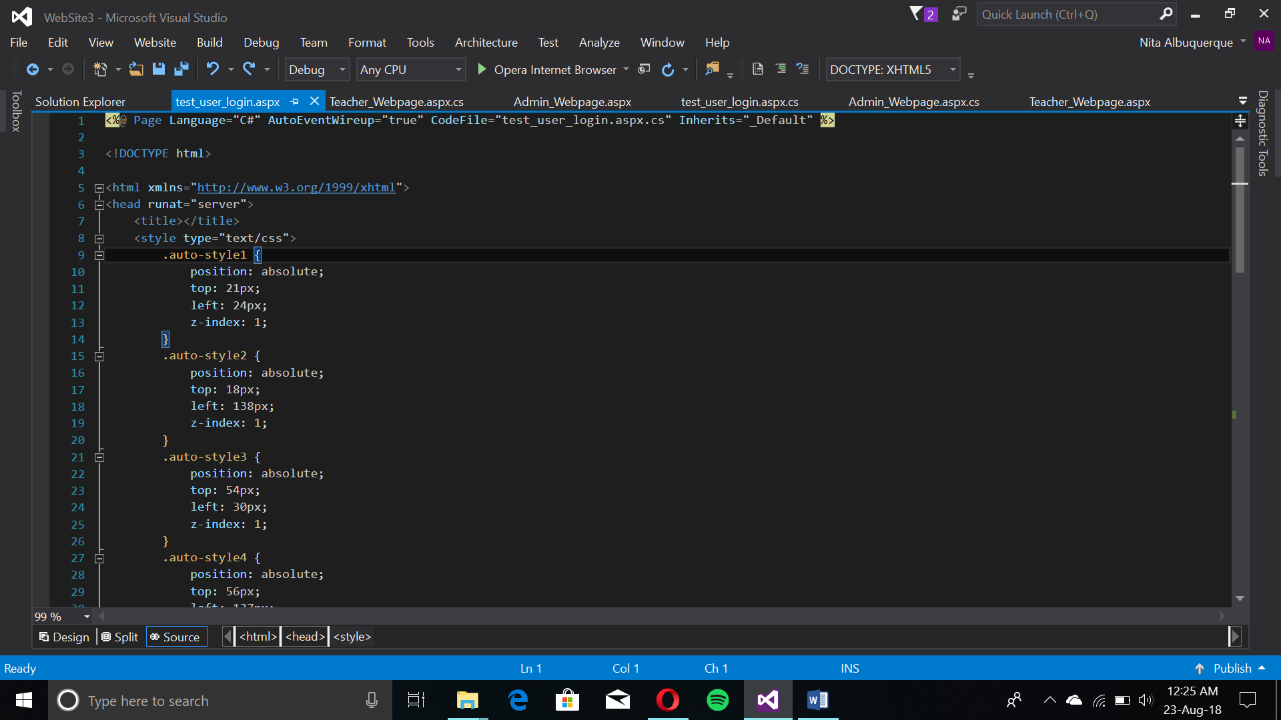

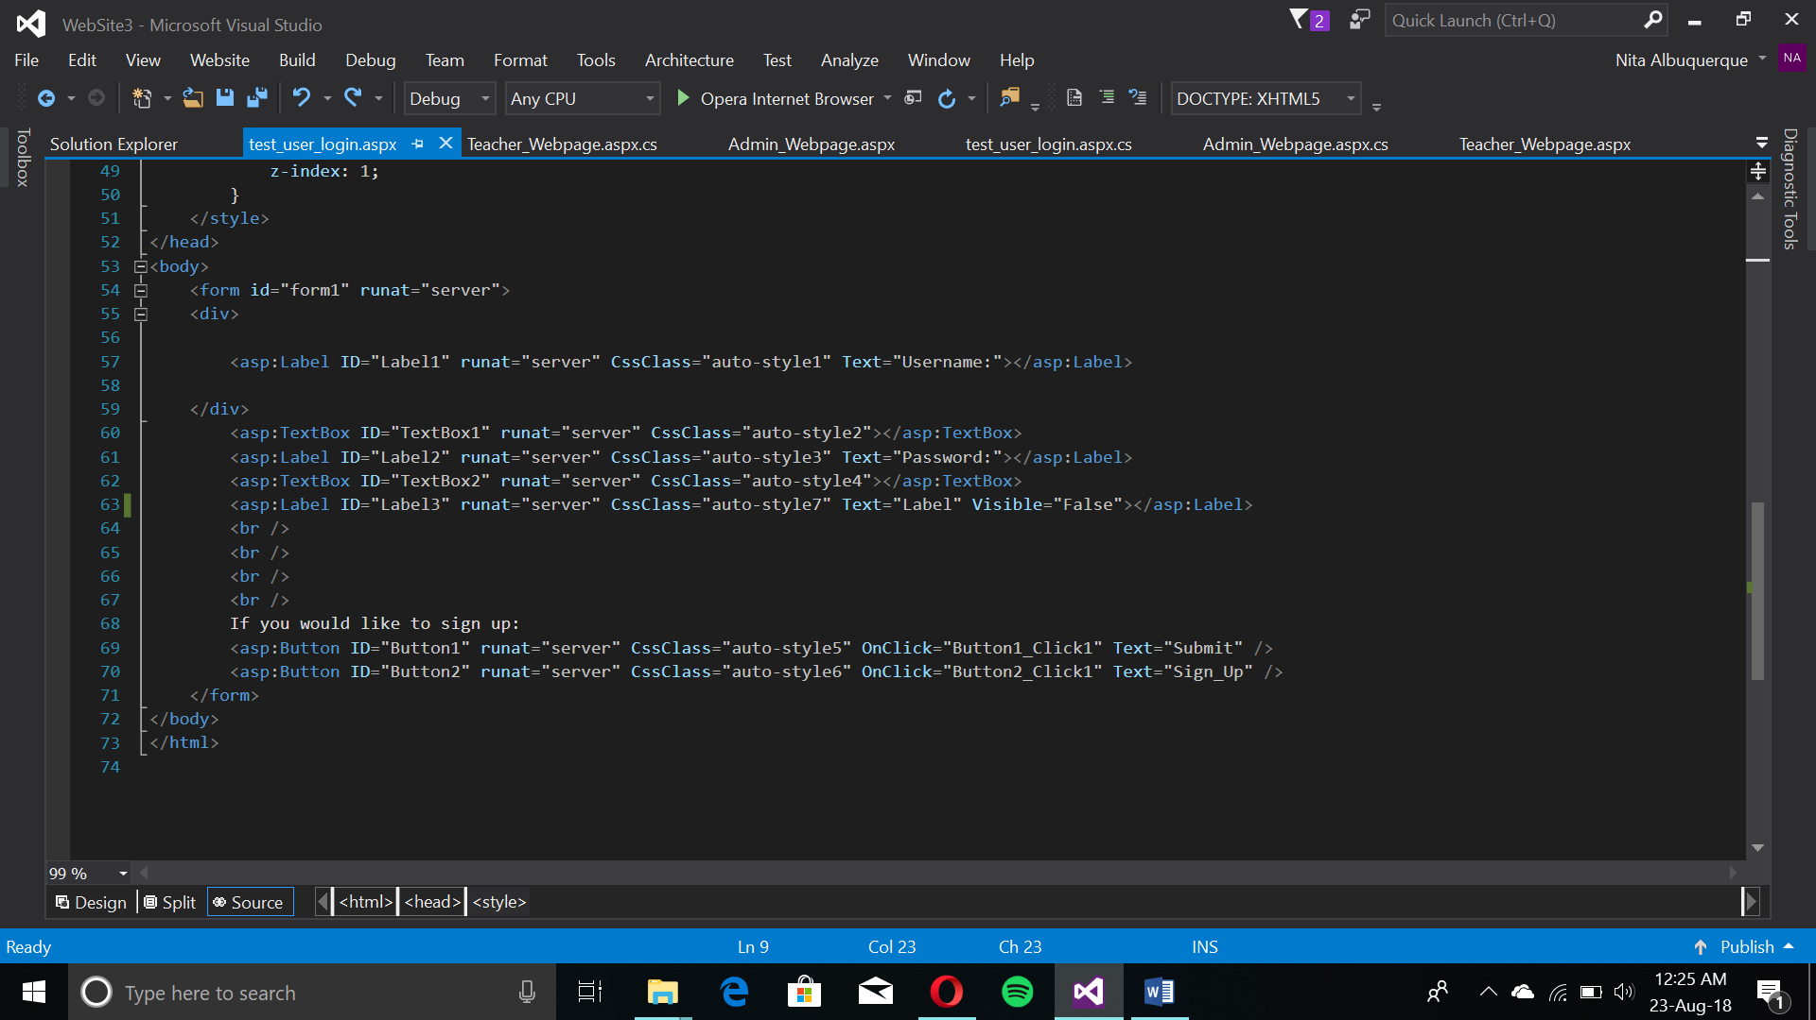

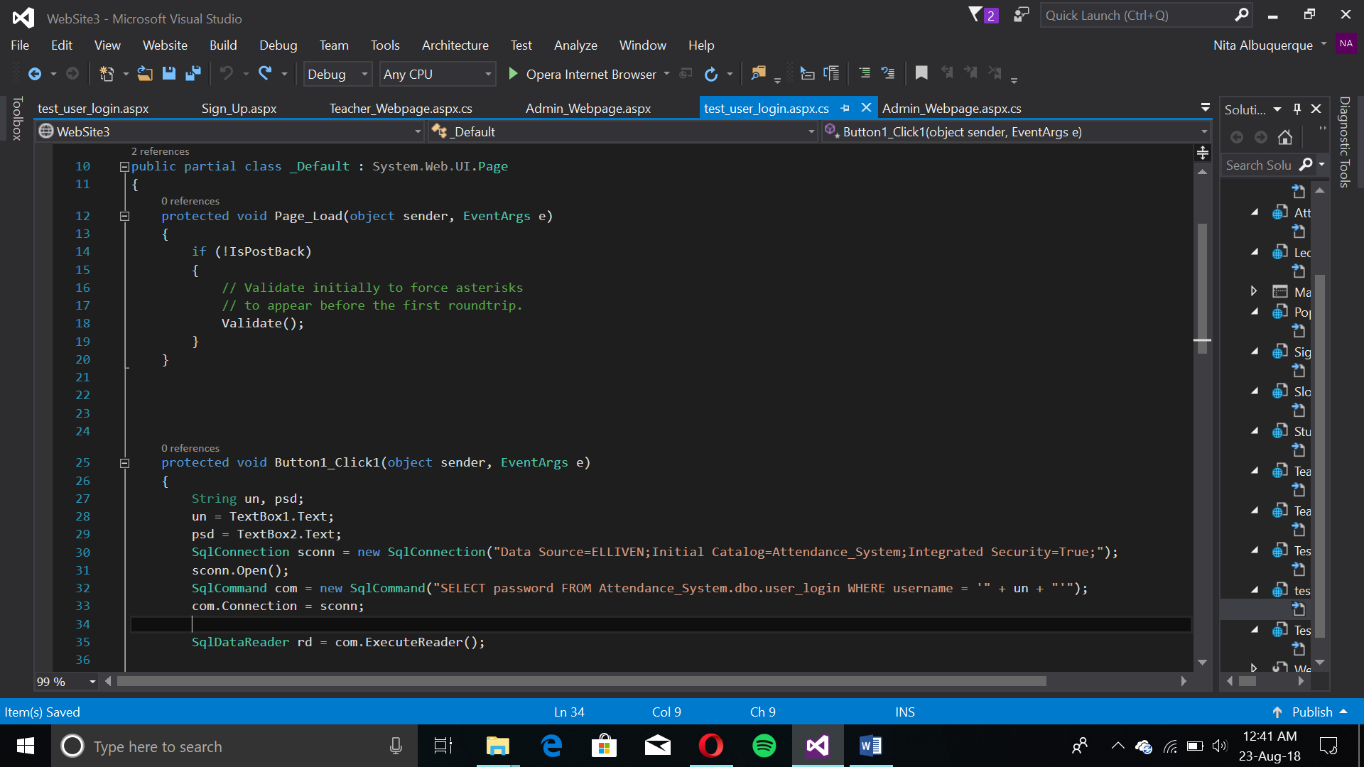If the user is the admin and logs in with their respective details, the admin main page is loaded, for any other user it's the teacher’s main page. To check the login:

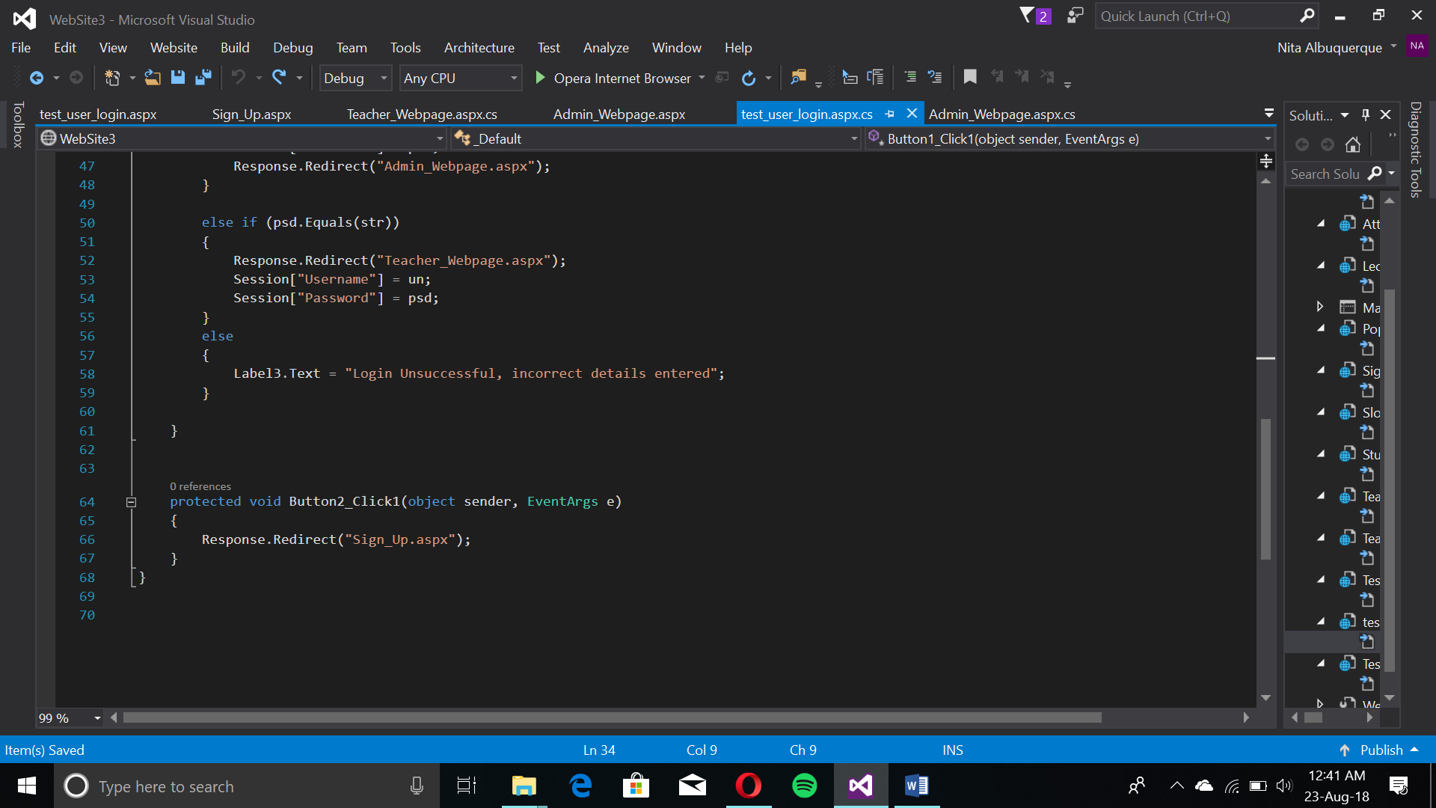

The conditional “if (!IsPostBack)” gives a Boolean value whether the page is rendered for the first time or from posting back.

Upon clicking submit, an SQL query is sent to a user_login table in the Attendance_System database connected with the program via a connection string. It will check for the username and password upon entry and verify. If it’s the admin, it will redirect to Admin Webpage, if any other user, the teacher webpage. If none, a label appears saying login was unsuccessful.

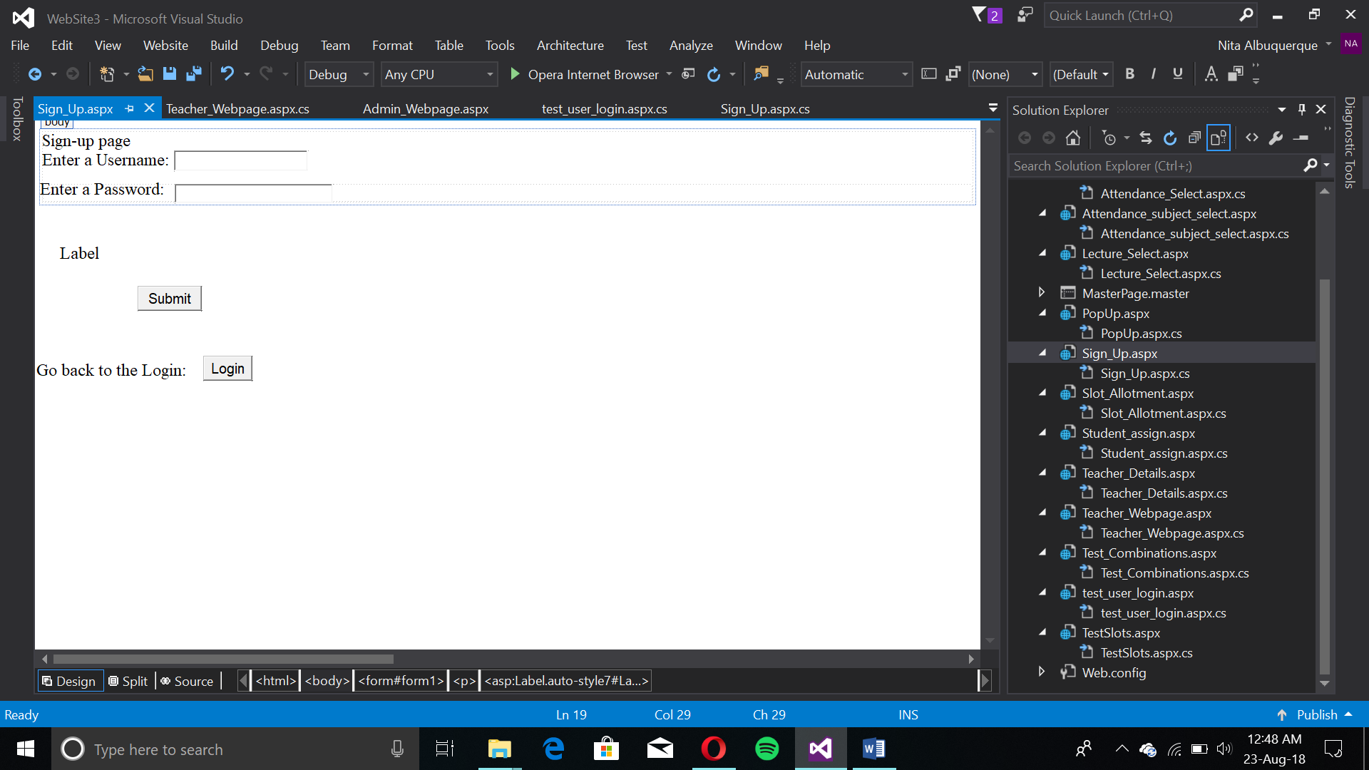Sign_Up Page

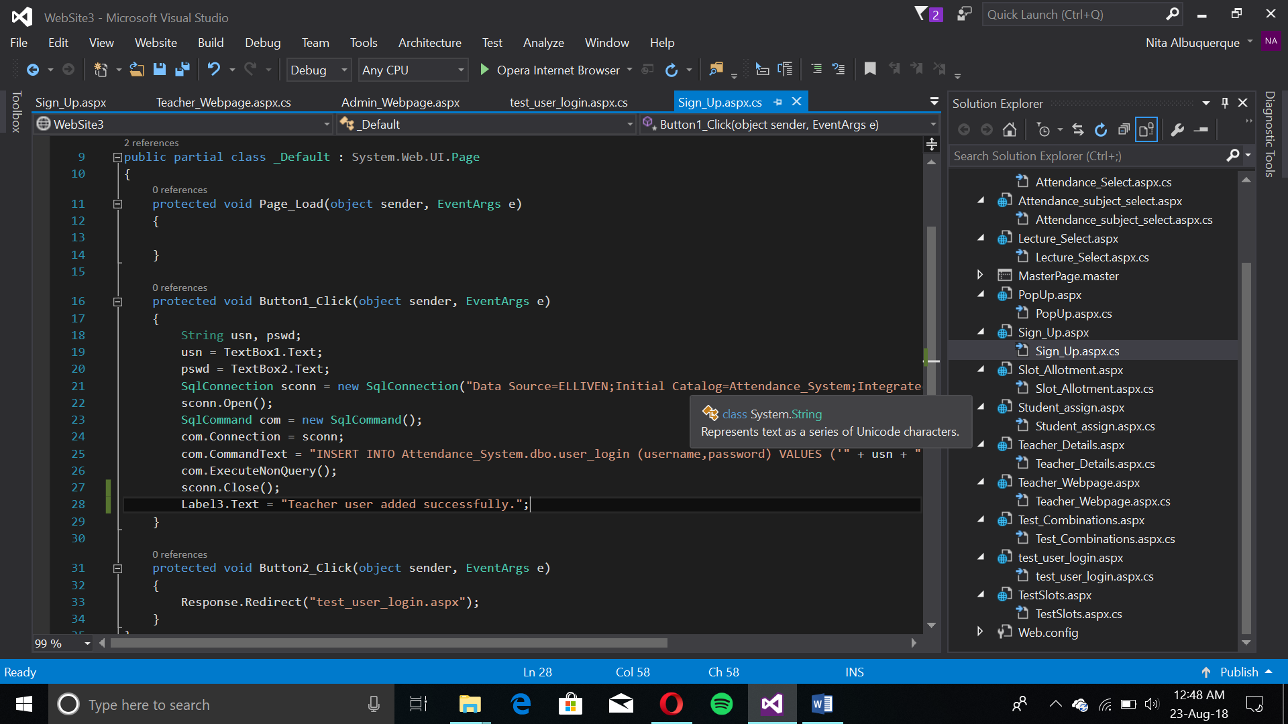The page enters the username and password of the teacher into the system. Upon completion, the label changes to successful entry. The second button (Login) redirects back to the login page.

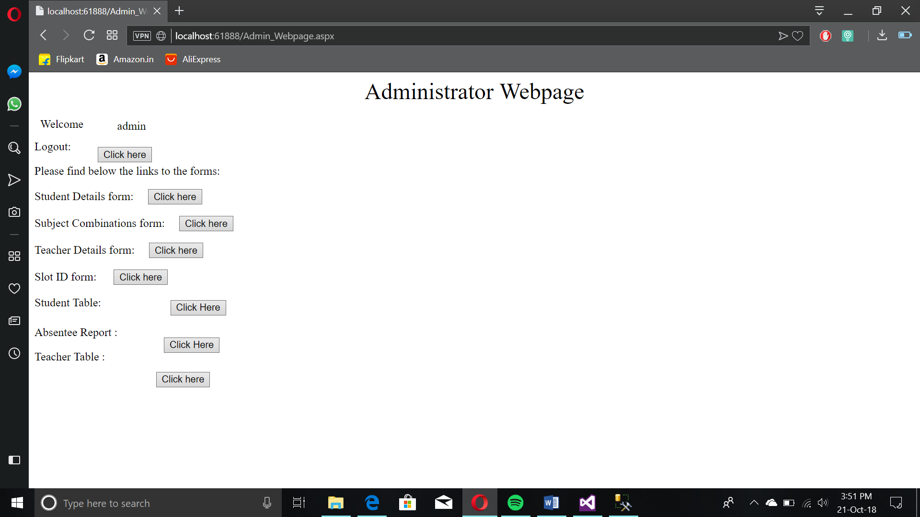Administrator Webpage

This webpage acts as the homepage for admin. All features described by the Success Criteria are available to the admin. The Label after “Welcome” is coded to display the username. Clicking any of the buttons would redirect to that respective webpage. All pages have a button that redirects to this page.

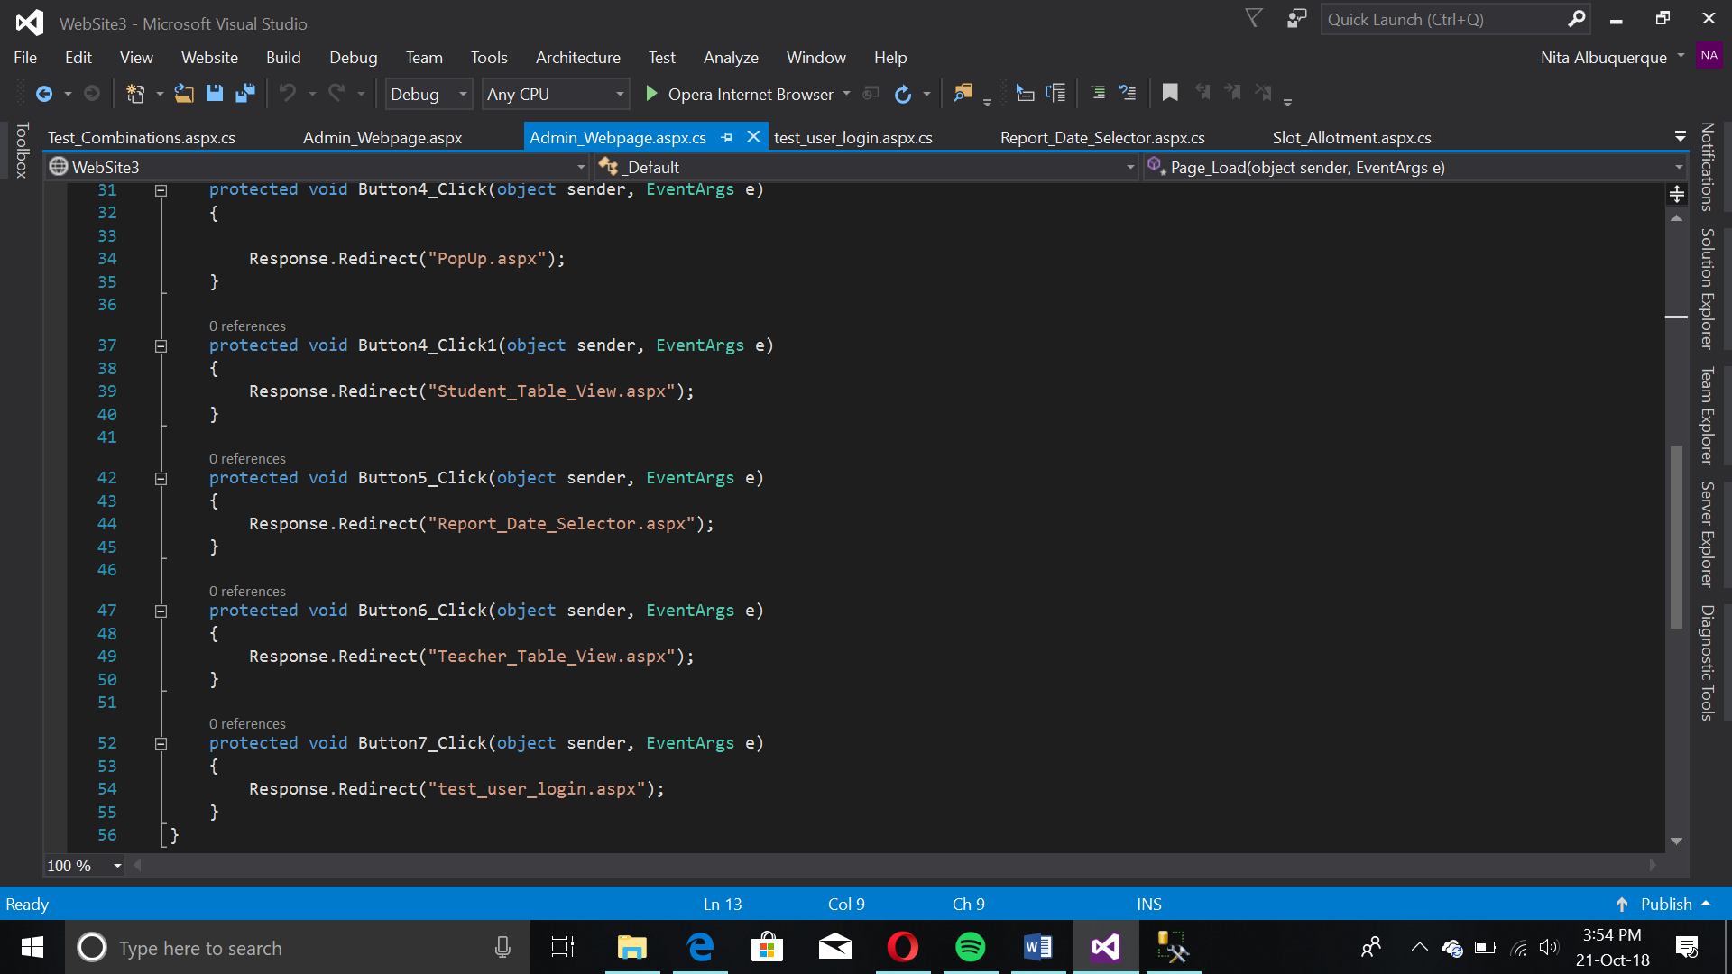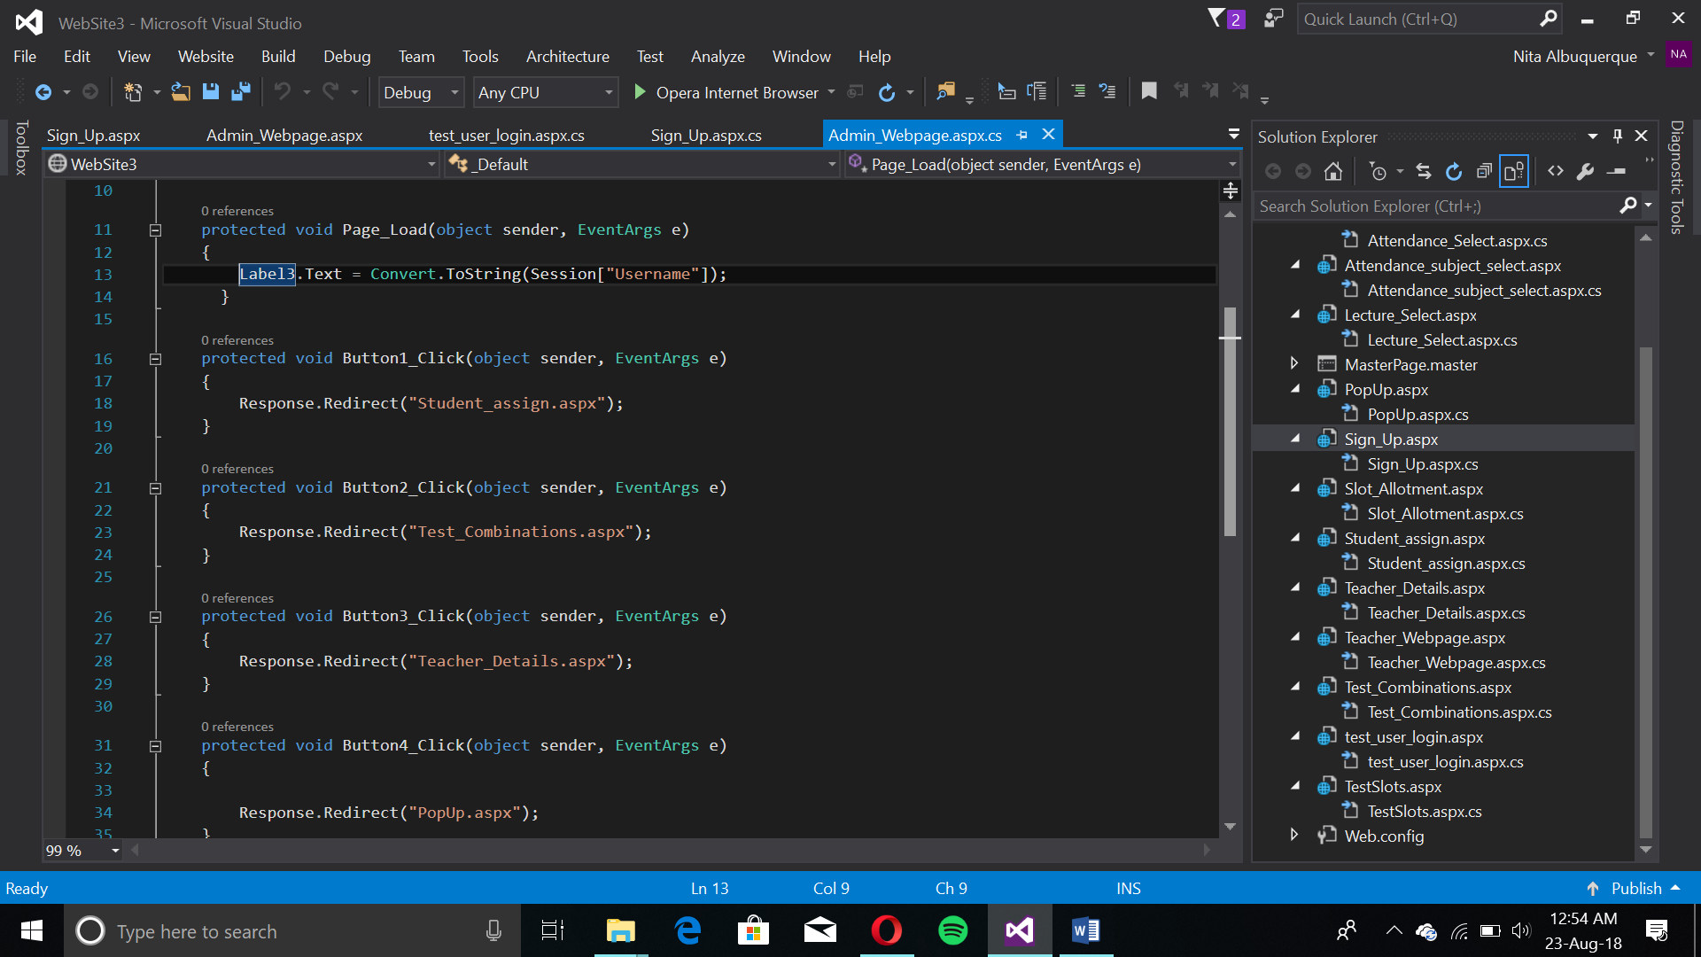

Student Form

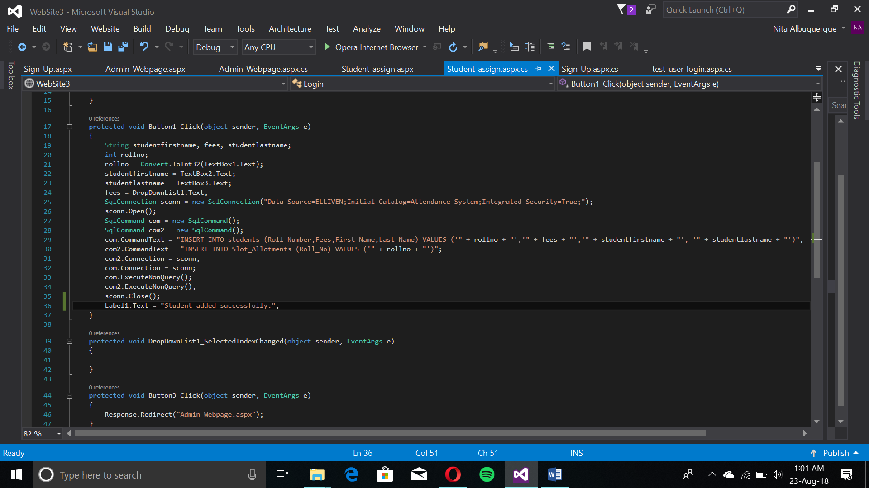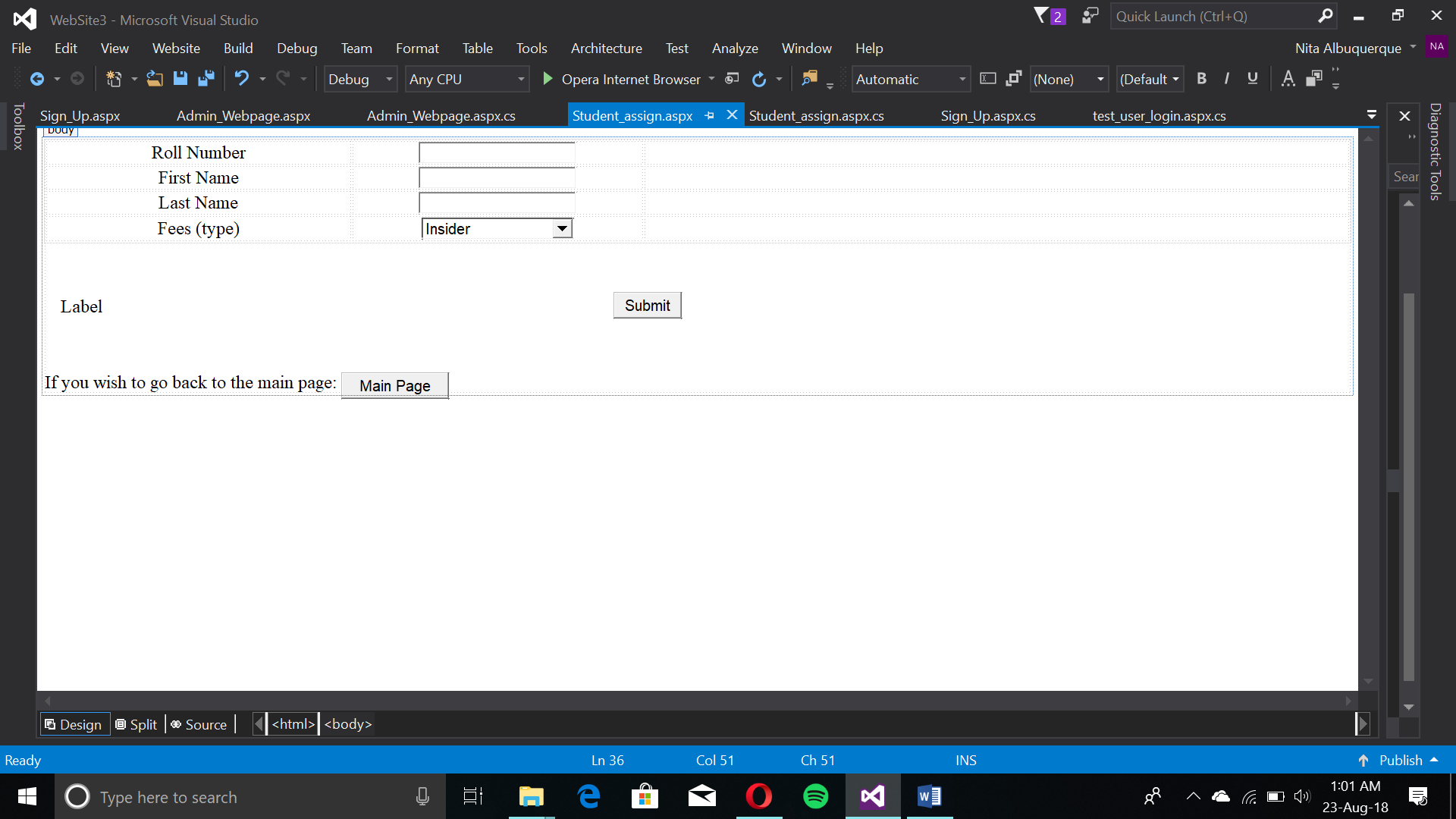The student details form adds a student into the database for attendance purposes. Using an INSERT SQL query, the data is added to the table. Simultaneously, it is inserted as a roll number row for another table used for configuring students and their subjects in a slot. A dropdown list differentiates in-house from new students in their current documentation.

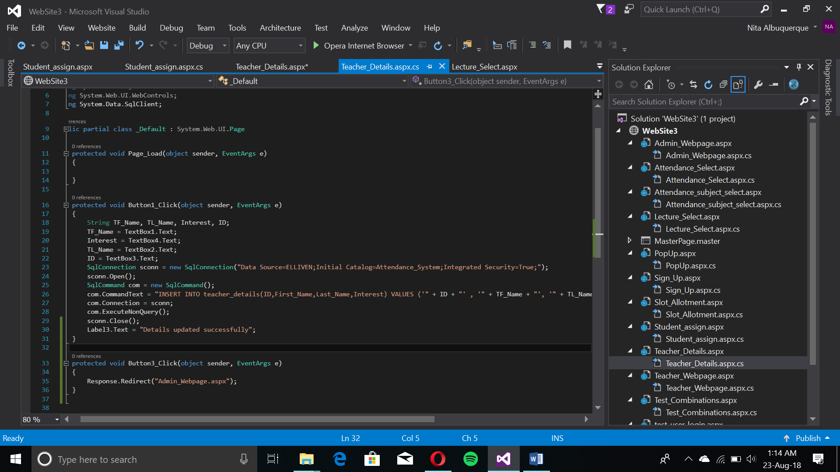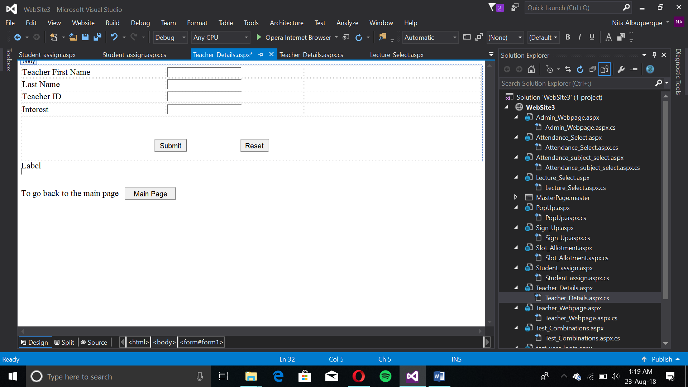

The admin adds a new teacher to the database with their subject. A “Teacher ID” allows unique identification and creates relations.

Slot-ID form

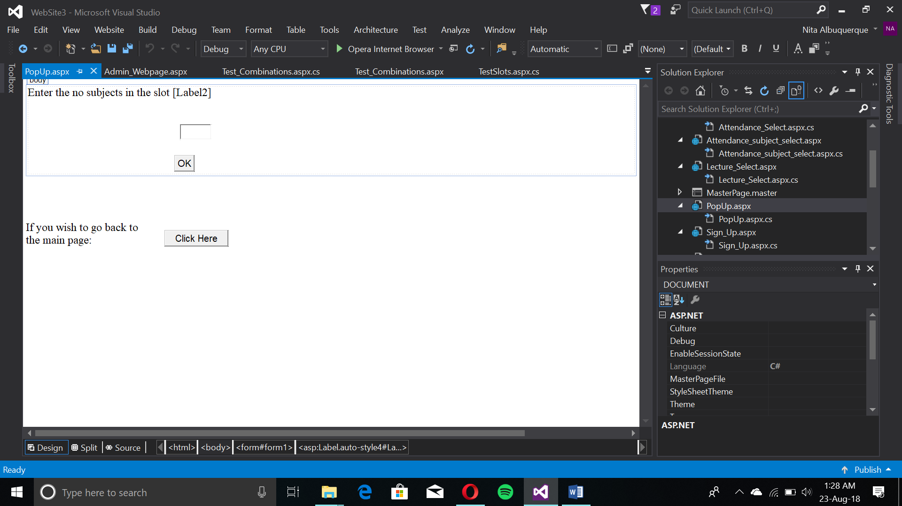

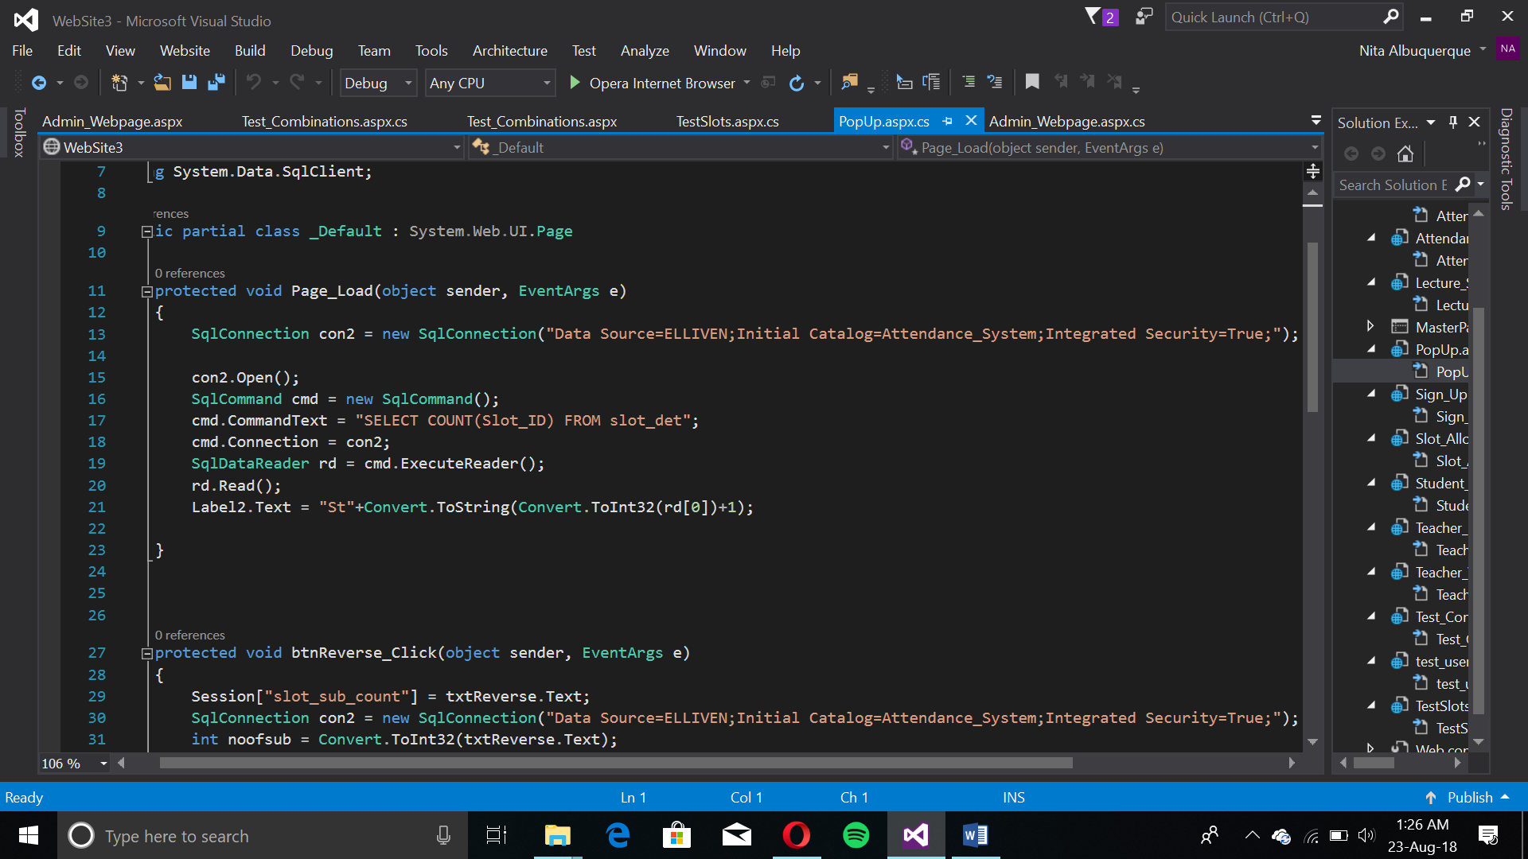

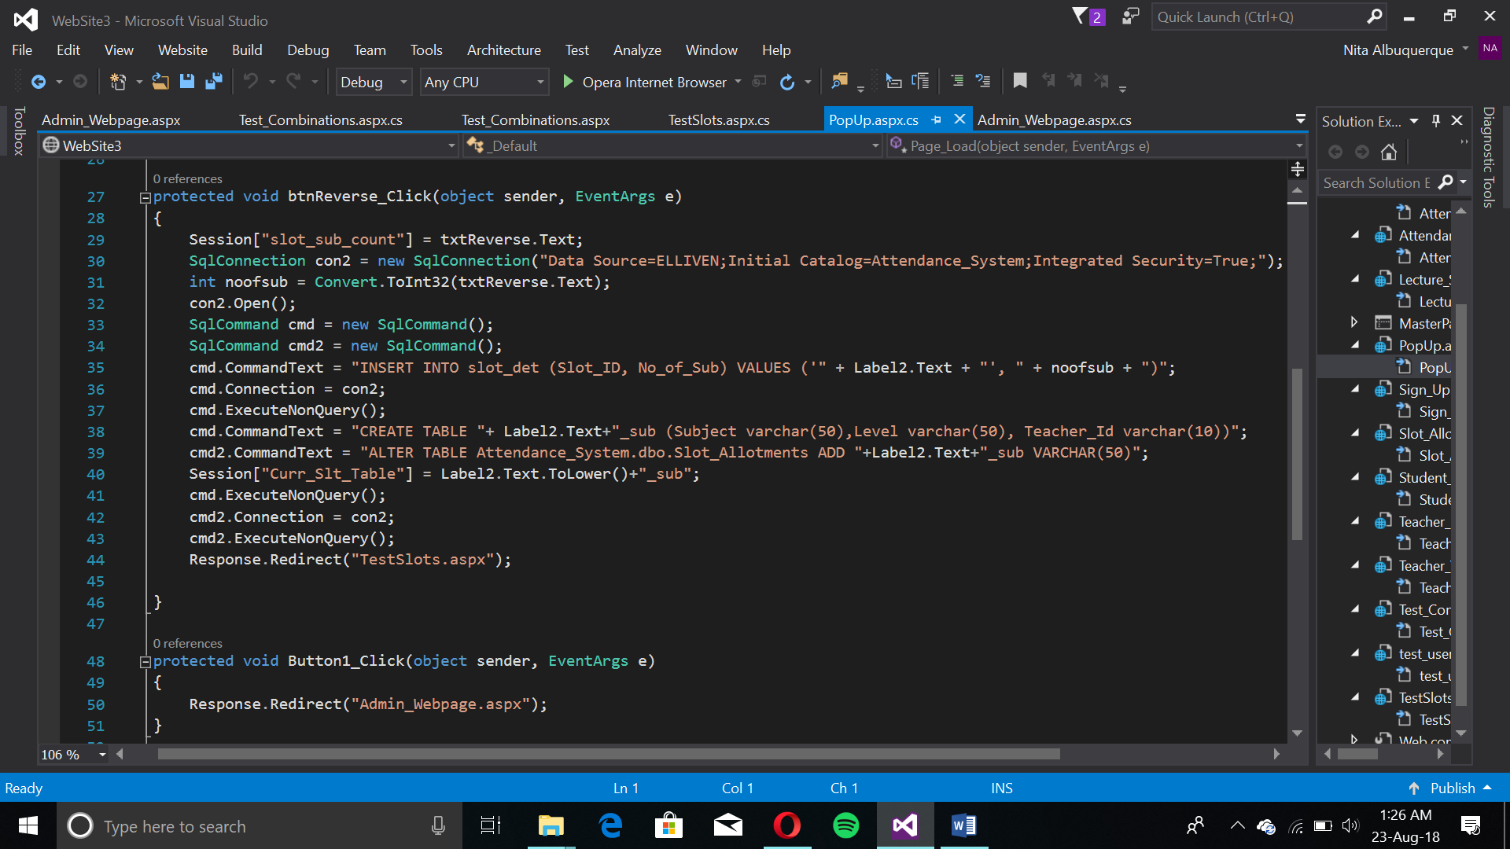

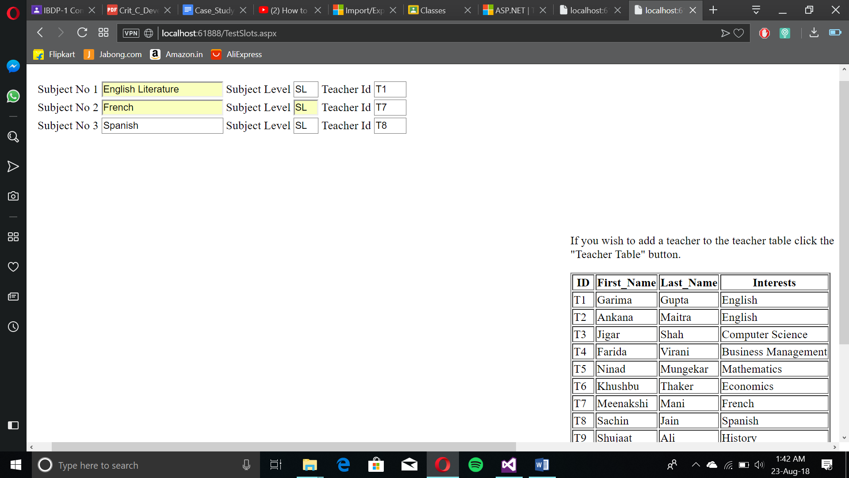This page creates new slots. The admin specifies how many subjects and the “[Label]” displays the Slot-ID and name of the new table. It is made the same as “Stx_sub” where “x” is the number of that slot. It is auto-incremental. INSERT, SELECT COUNT, CREATE TABLE and ALTER TABLE queries make a new slot table and design it according to the admin’s slot specifications. A Slot Details table is made which has the Slot ID and number of subjects. Upon submission, it redirects to the Test_Slots.aspx page.

Main Slot Creation Form

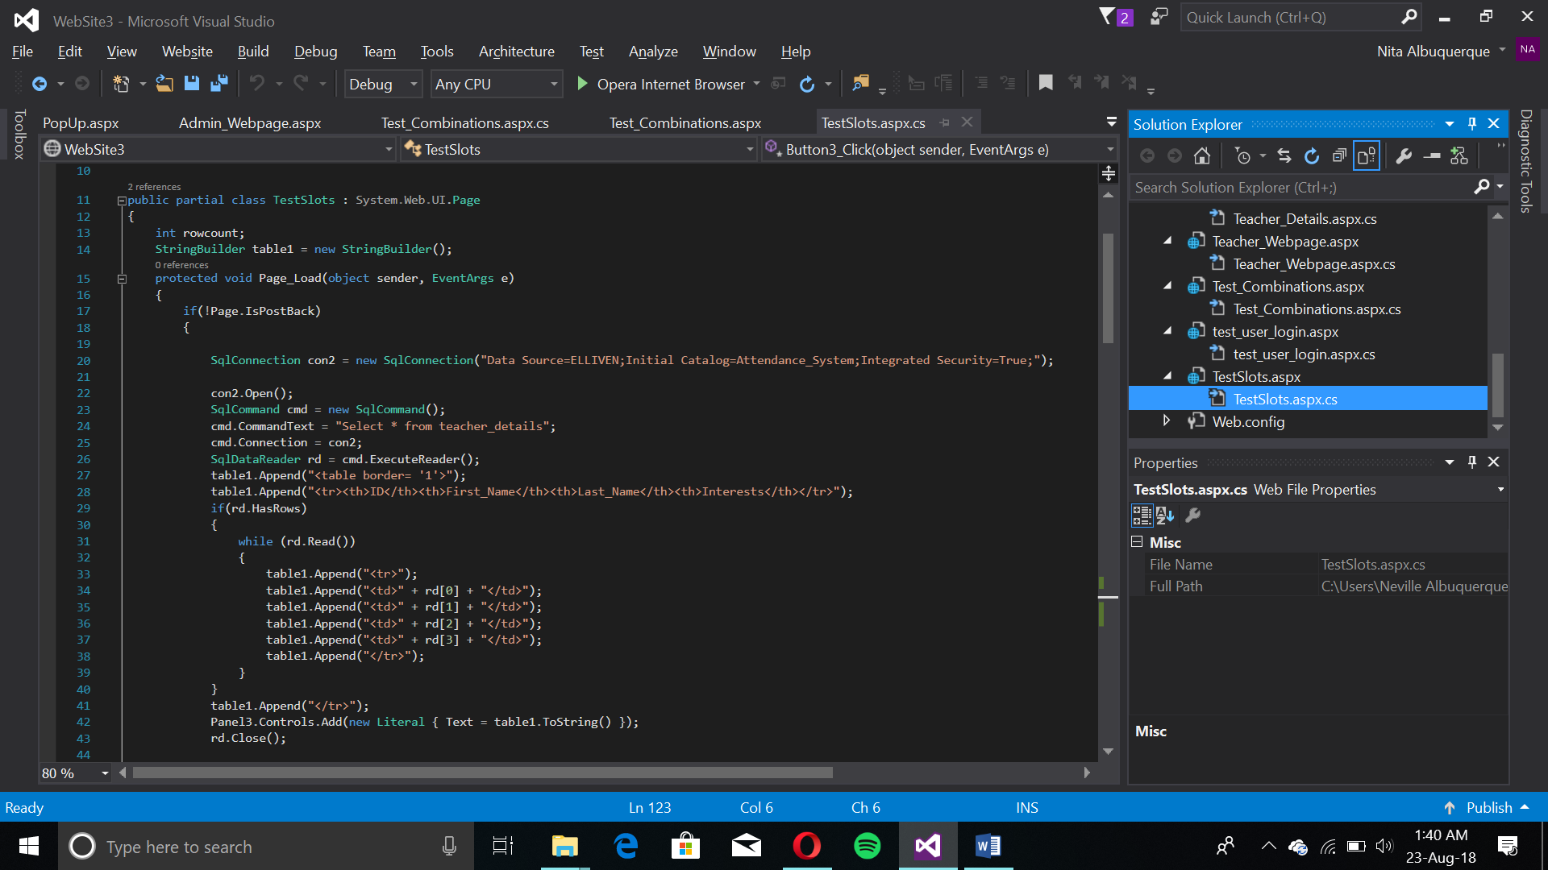

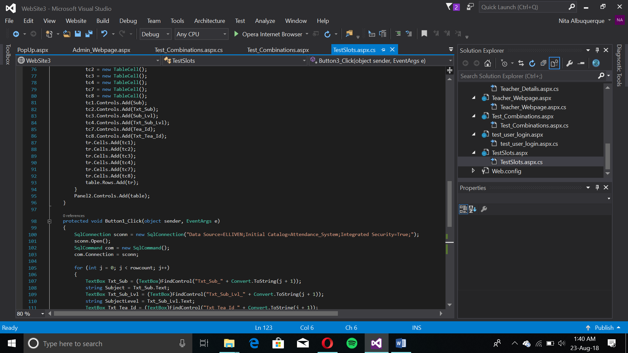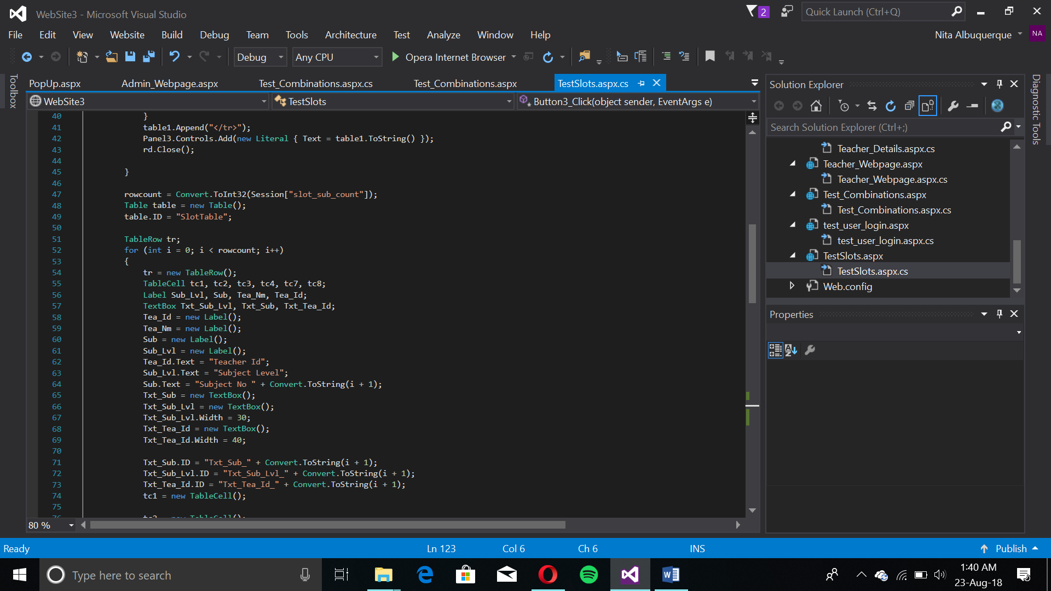

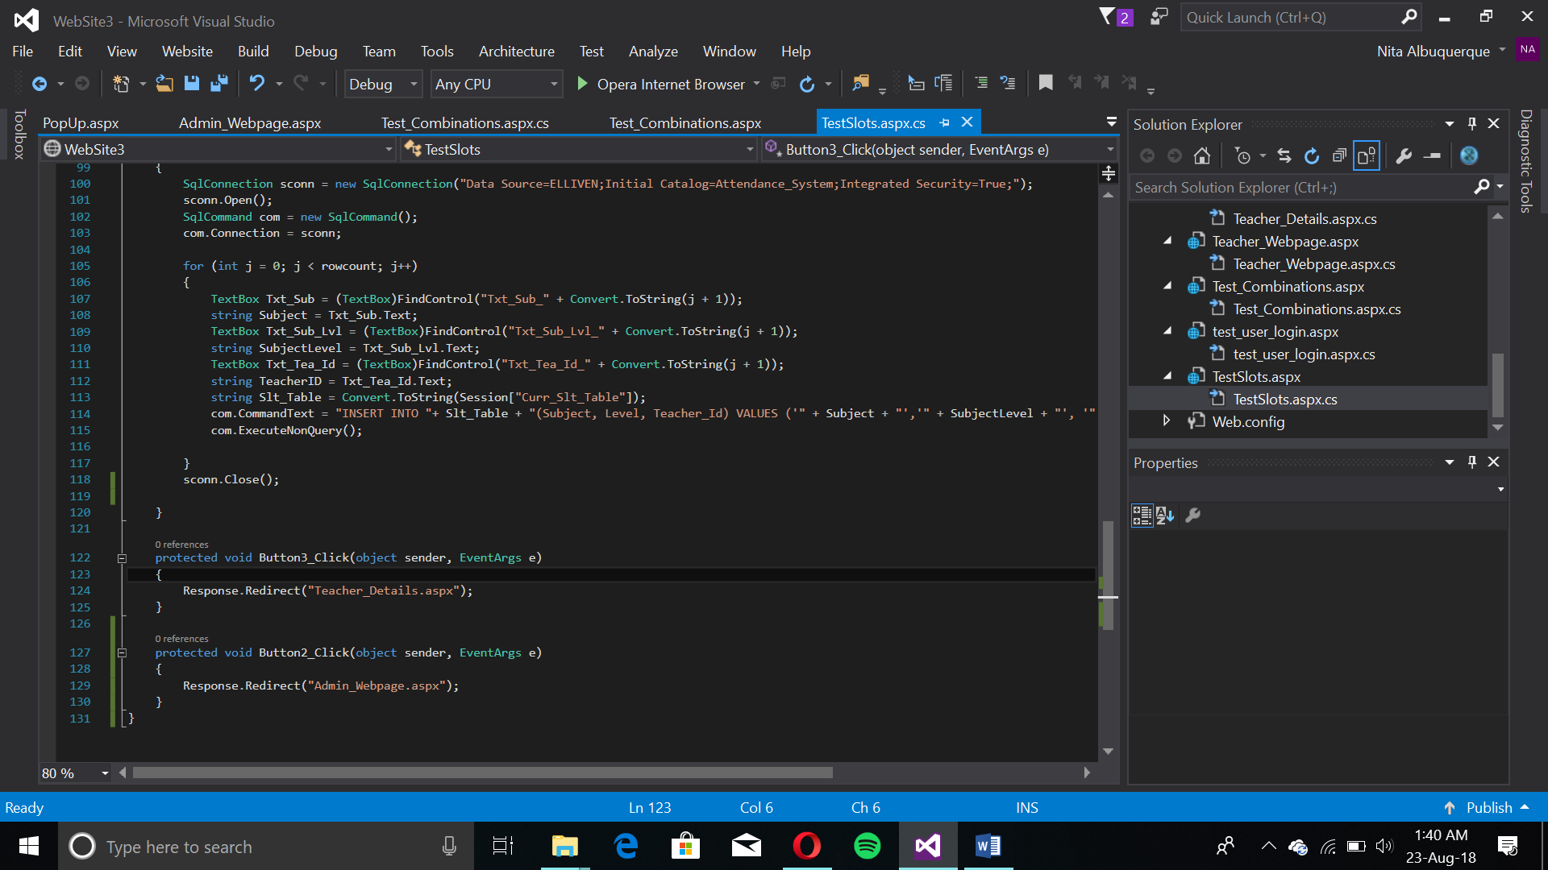

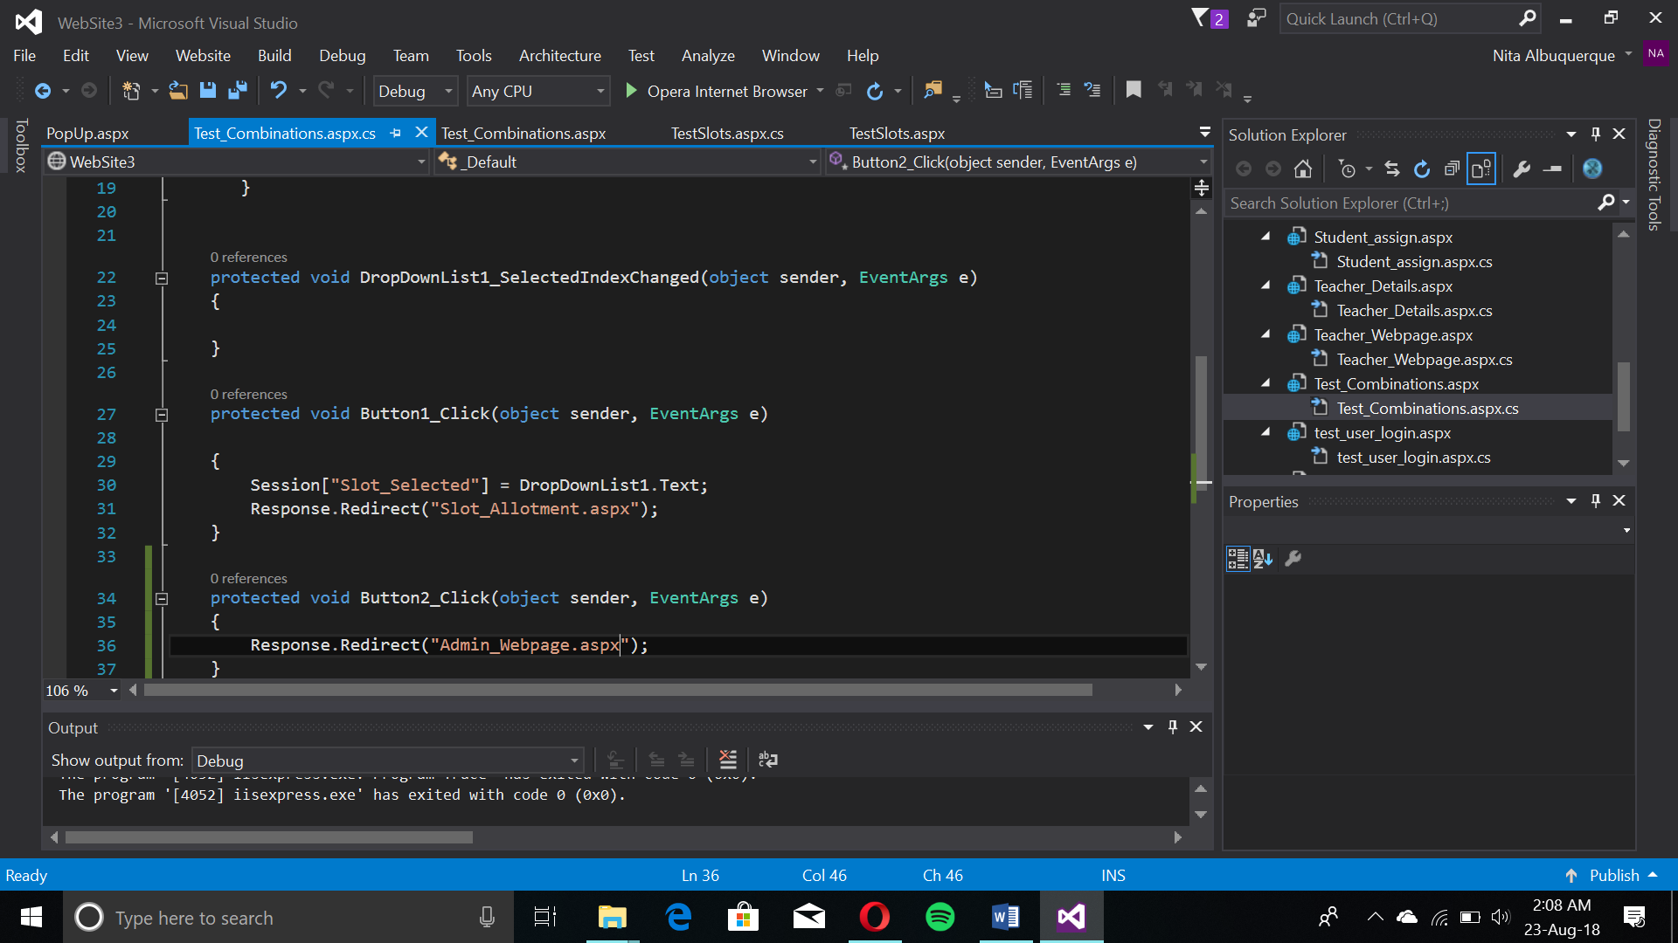Here, subjects, their level and the teacher ID are added to the created and designed slot. Using a for-loop and a string-builder, a dynamic table is created showing teacher’s information to see their IDs. An INSERT query is performed with a for-loop on the table and hence multiple data entries are added.

Subject-Slot Combinations Selector

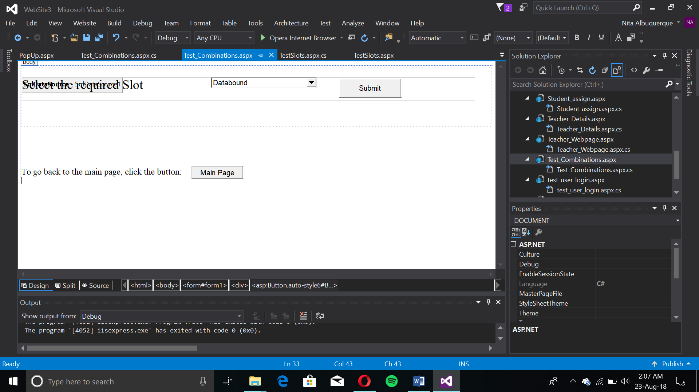

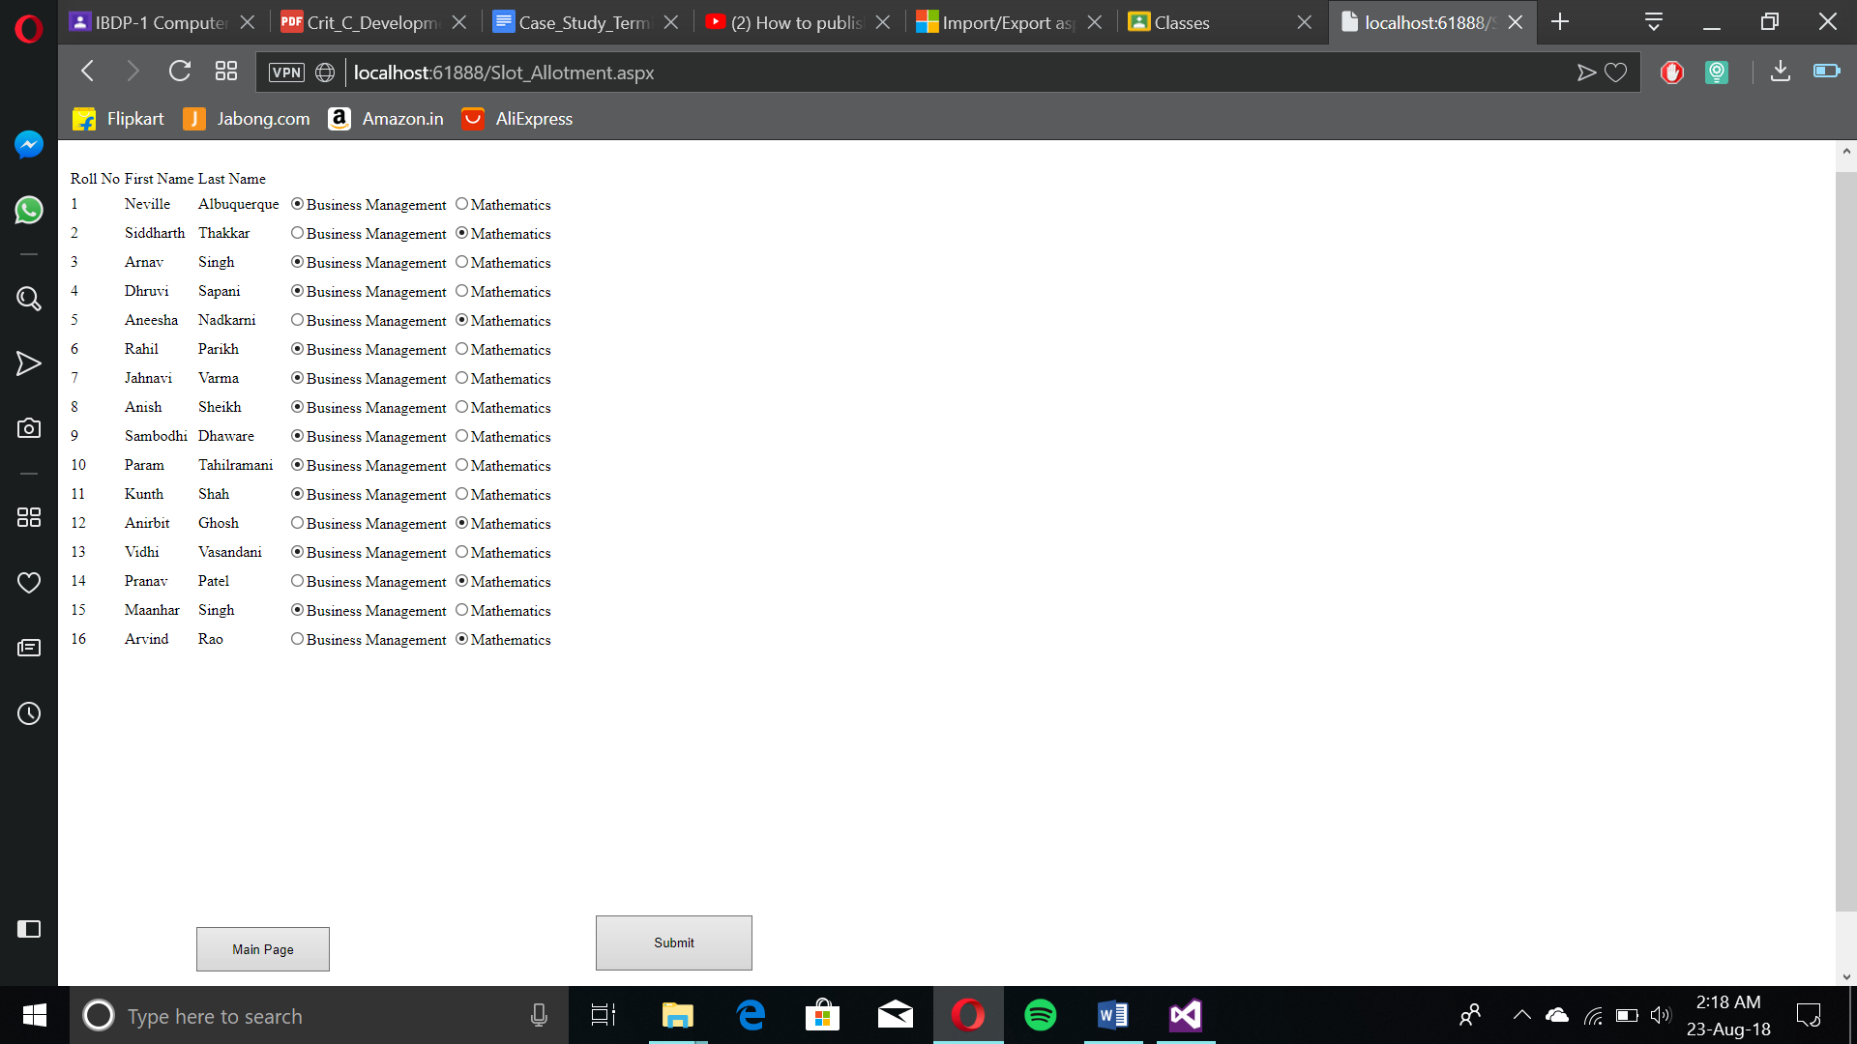In “Select Required Slots”, the “Sql Datasource 1” is written, this shows the dropdown list’s source seen by “Databound”. This means that the list is bound to data from the databases to provide indexes, the names of the slot tables. After selection, the data passes through Session data. The slot selection for configuration happens here.

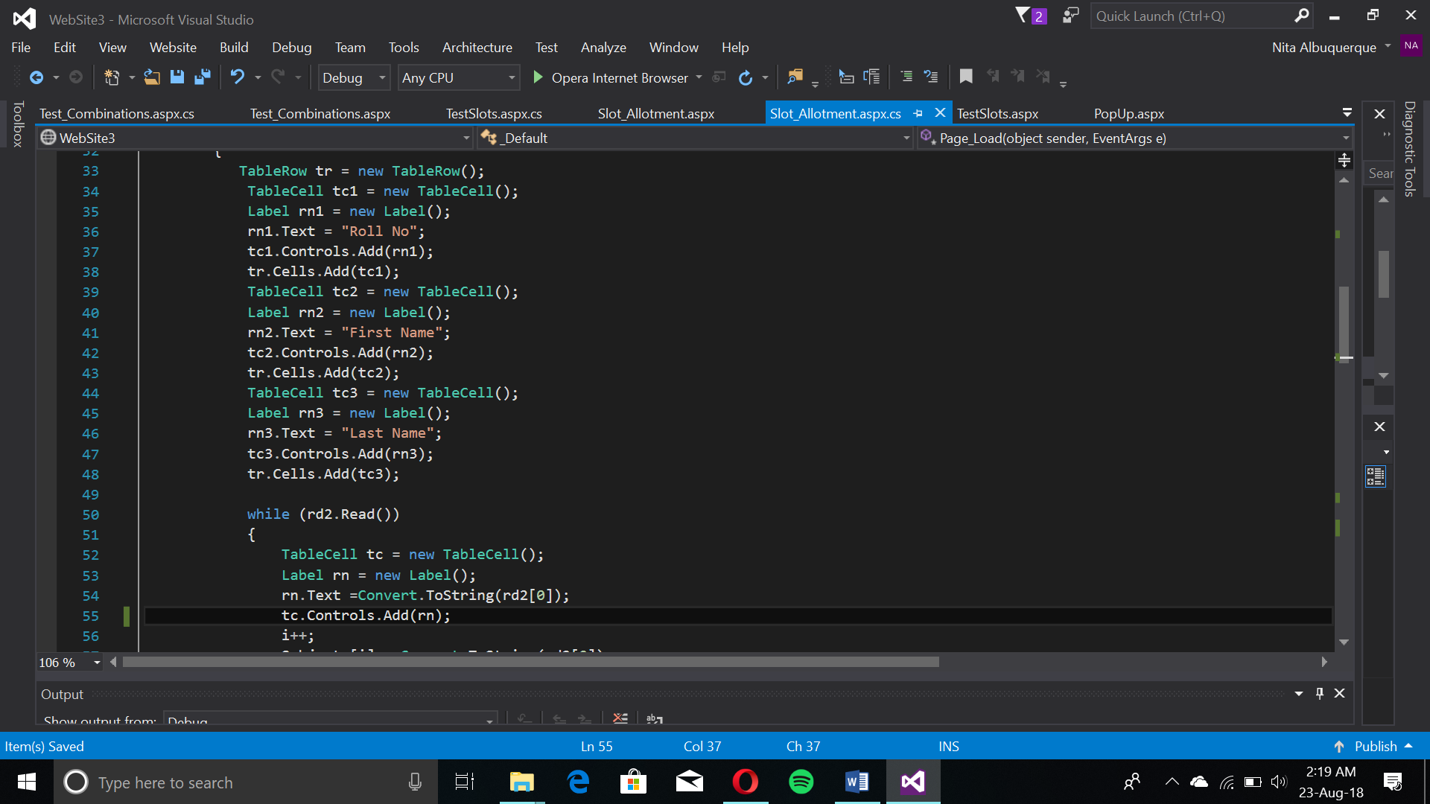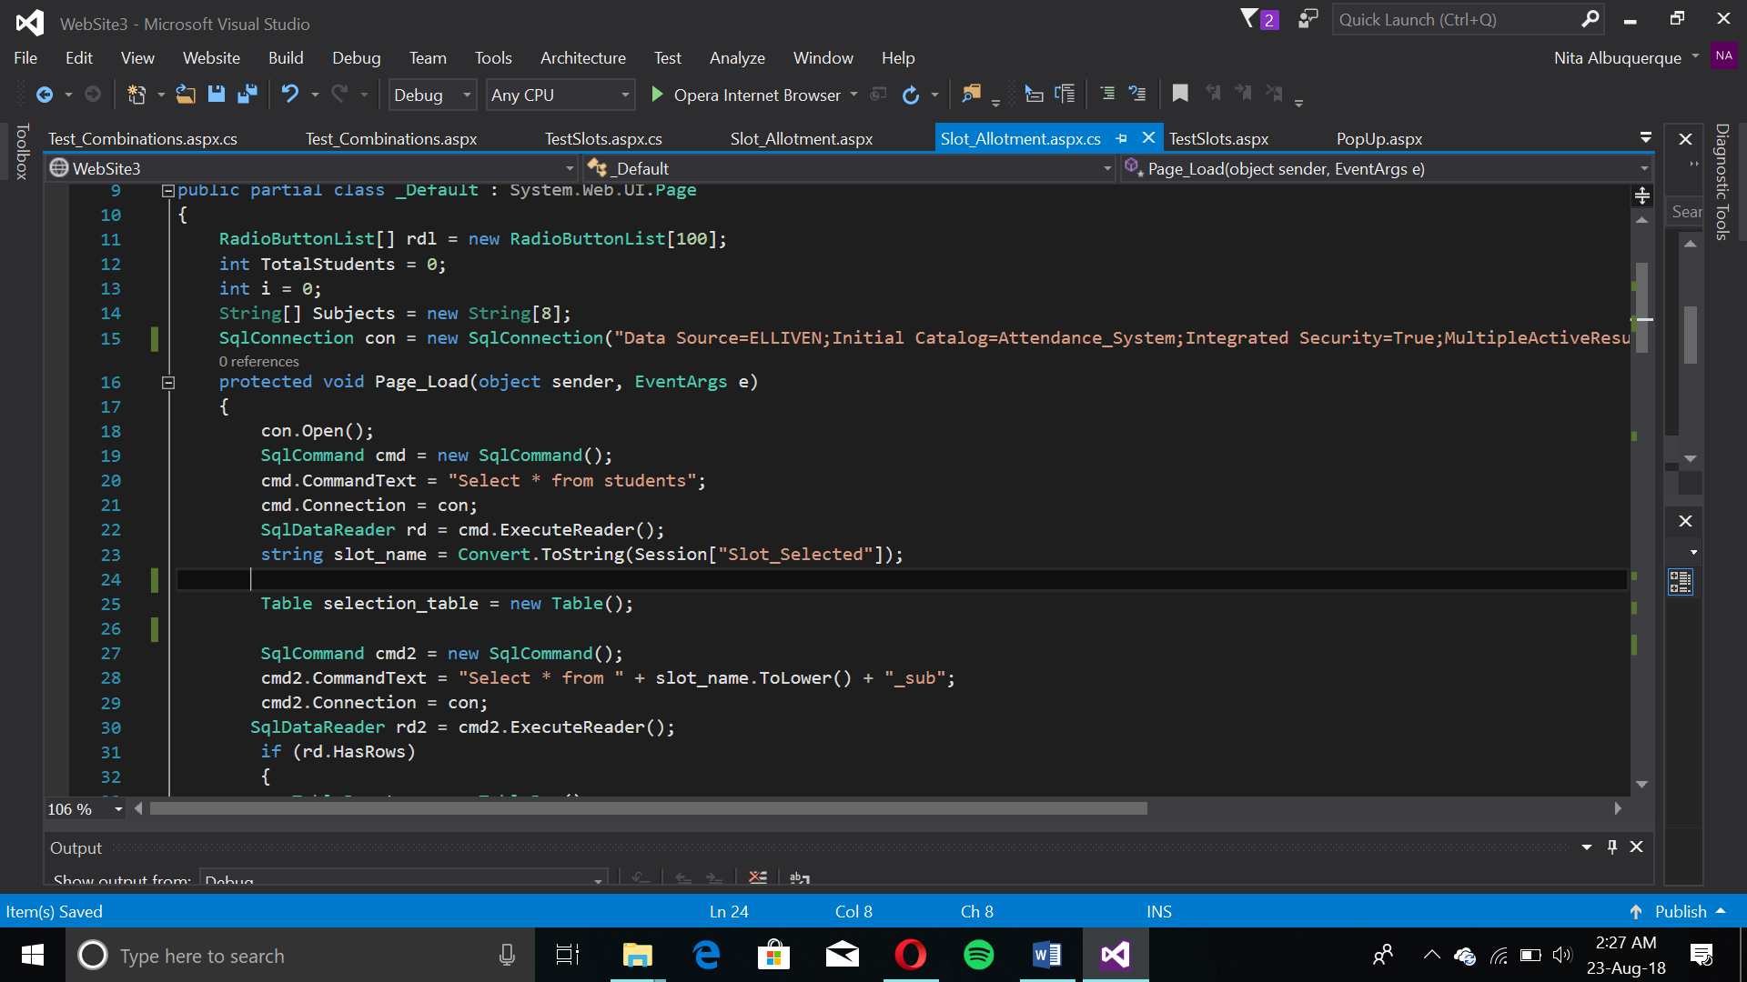Slot Configuration Page

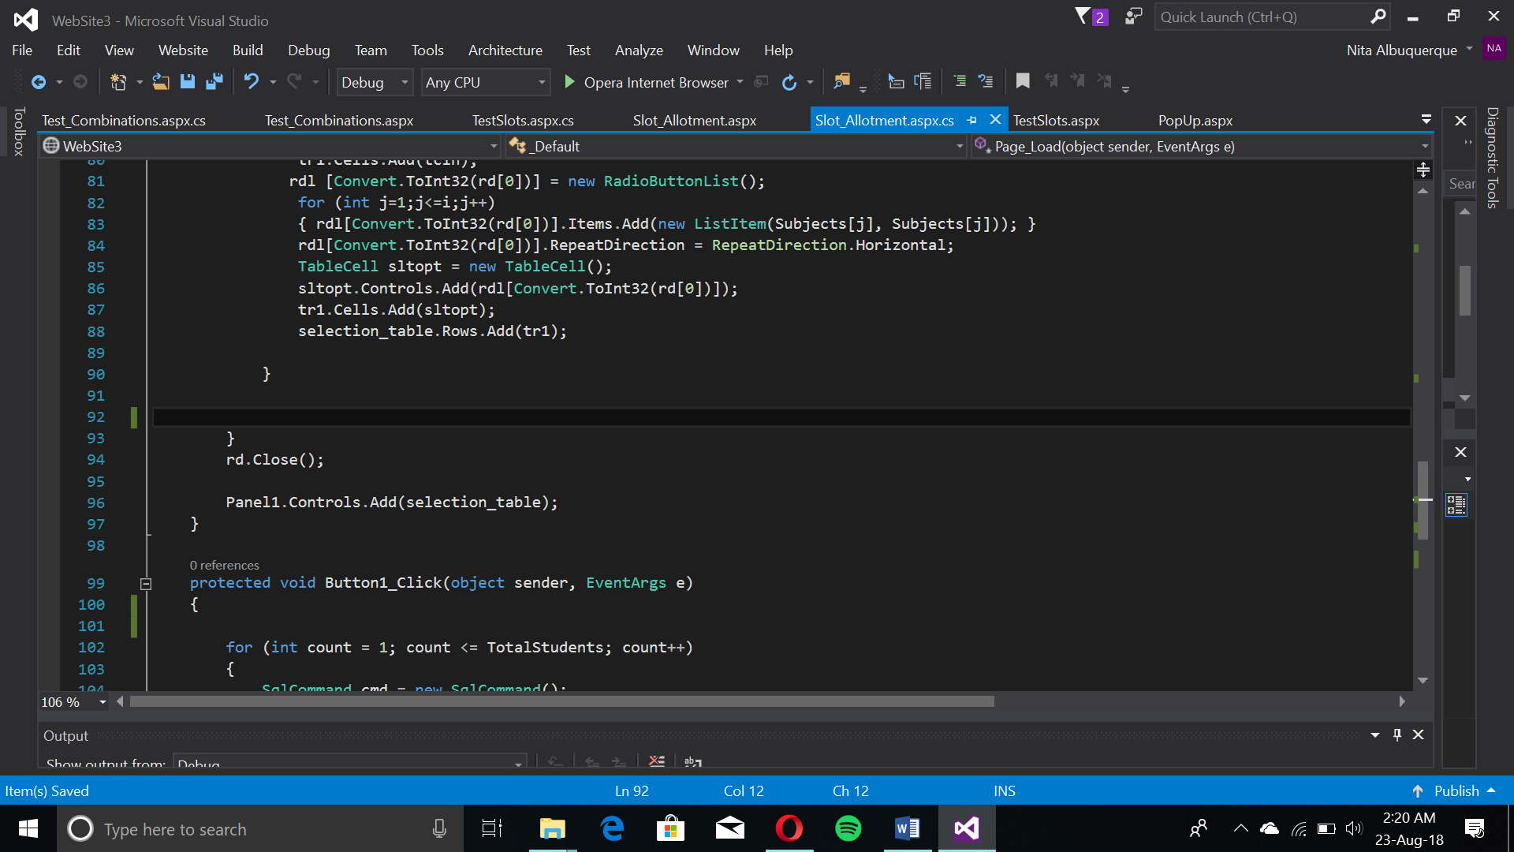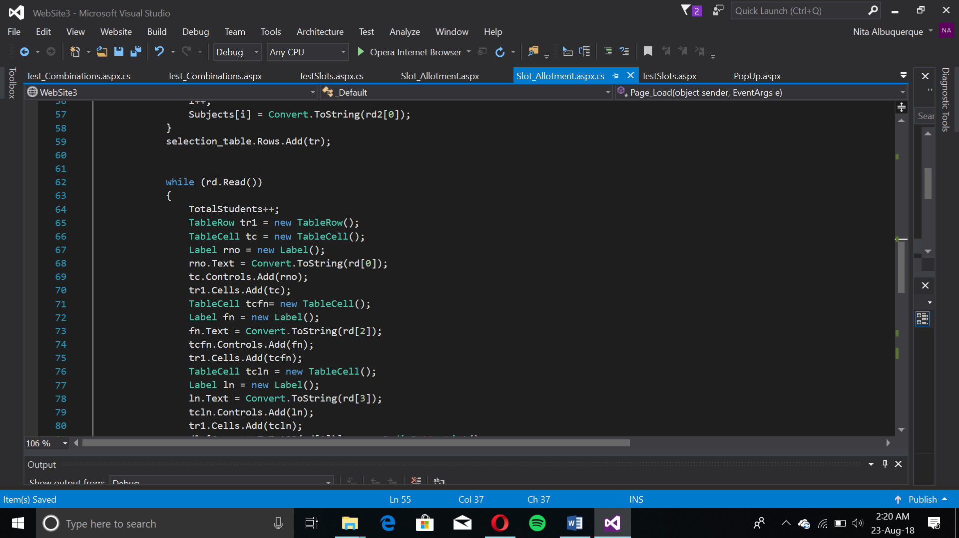

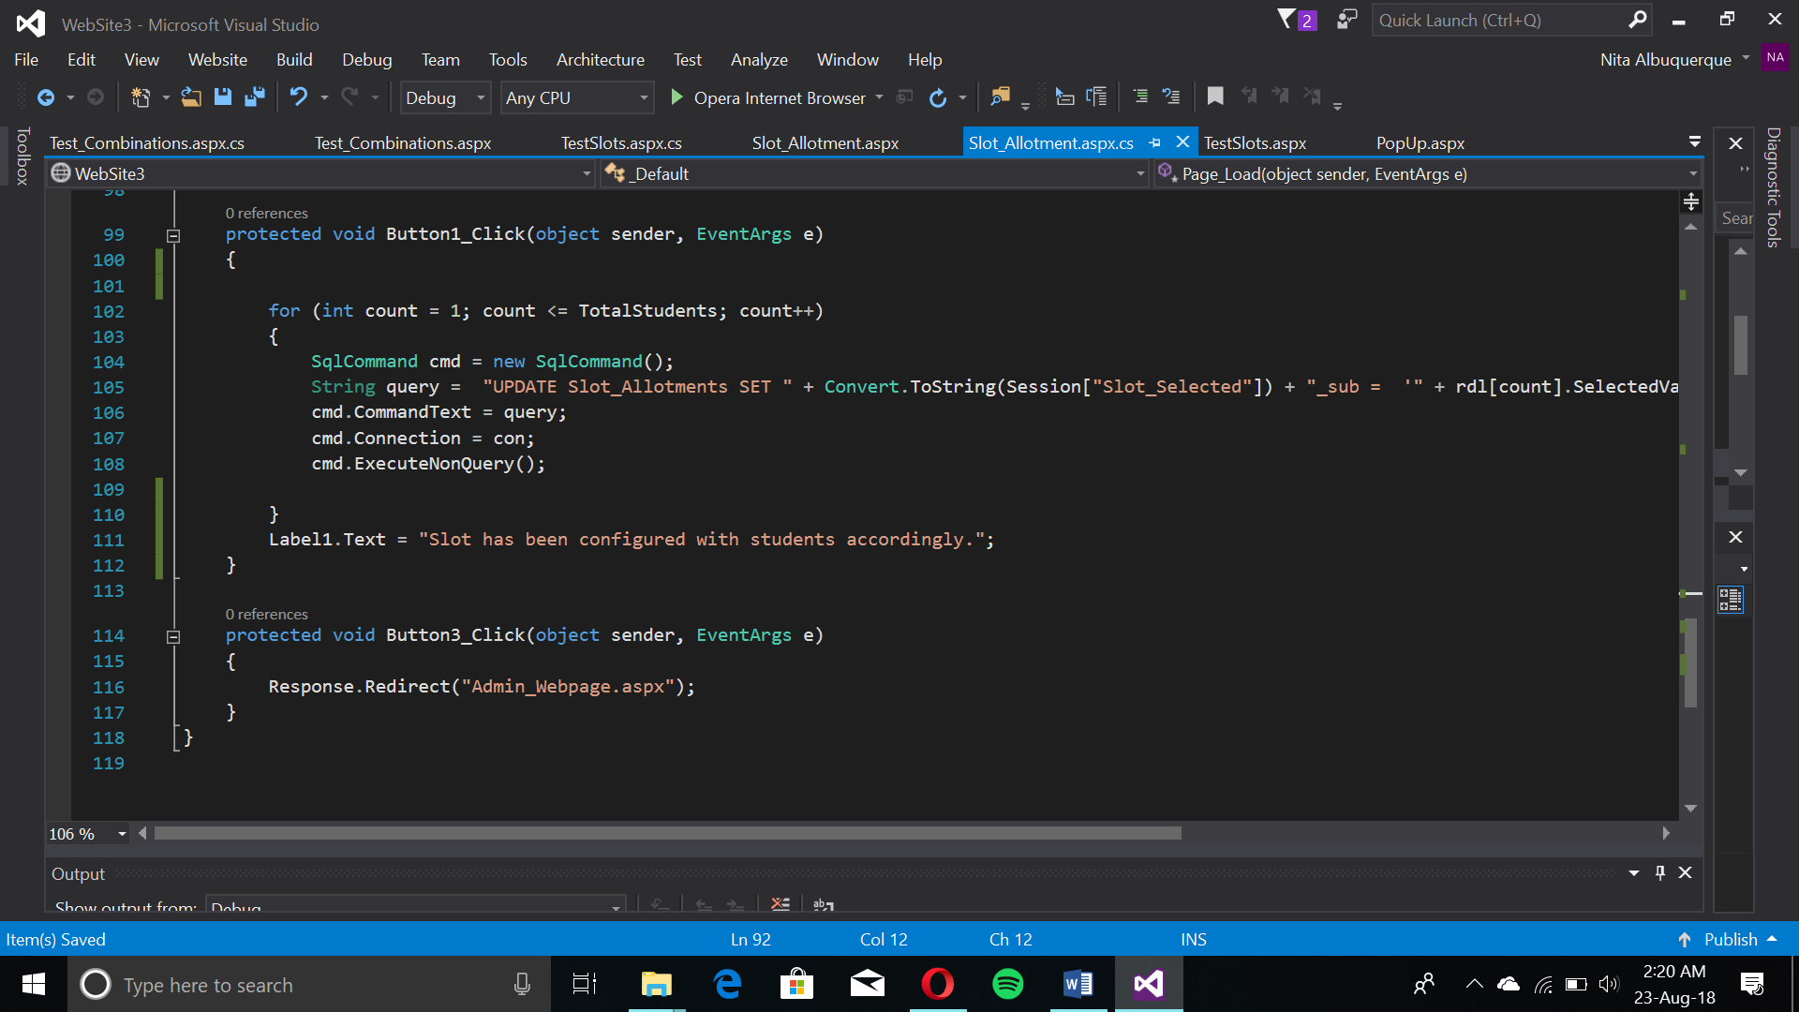

The page creates a table for displaying the Name, Roll Number and subject for configuration. A Radio Button List holds chosen values. A SELECT query outputs the data for students in general and the subjects for that slot.

Using loops for creating tables, views were created for the student and teacher tables, with a link for adding/deleting them.

Student View & Removal

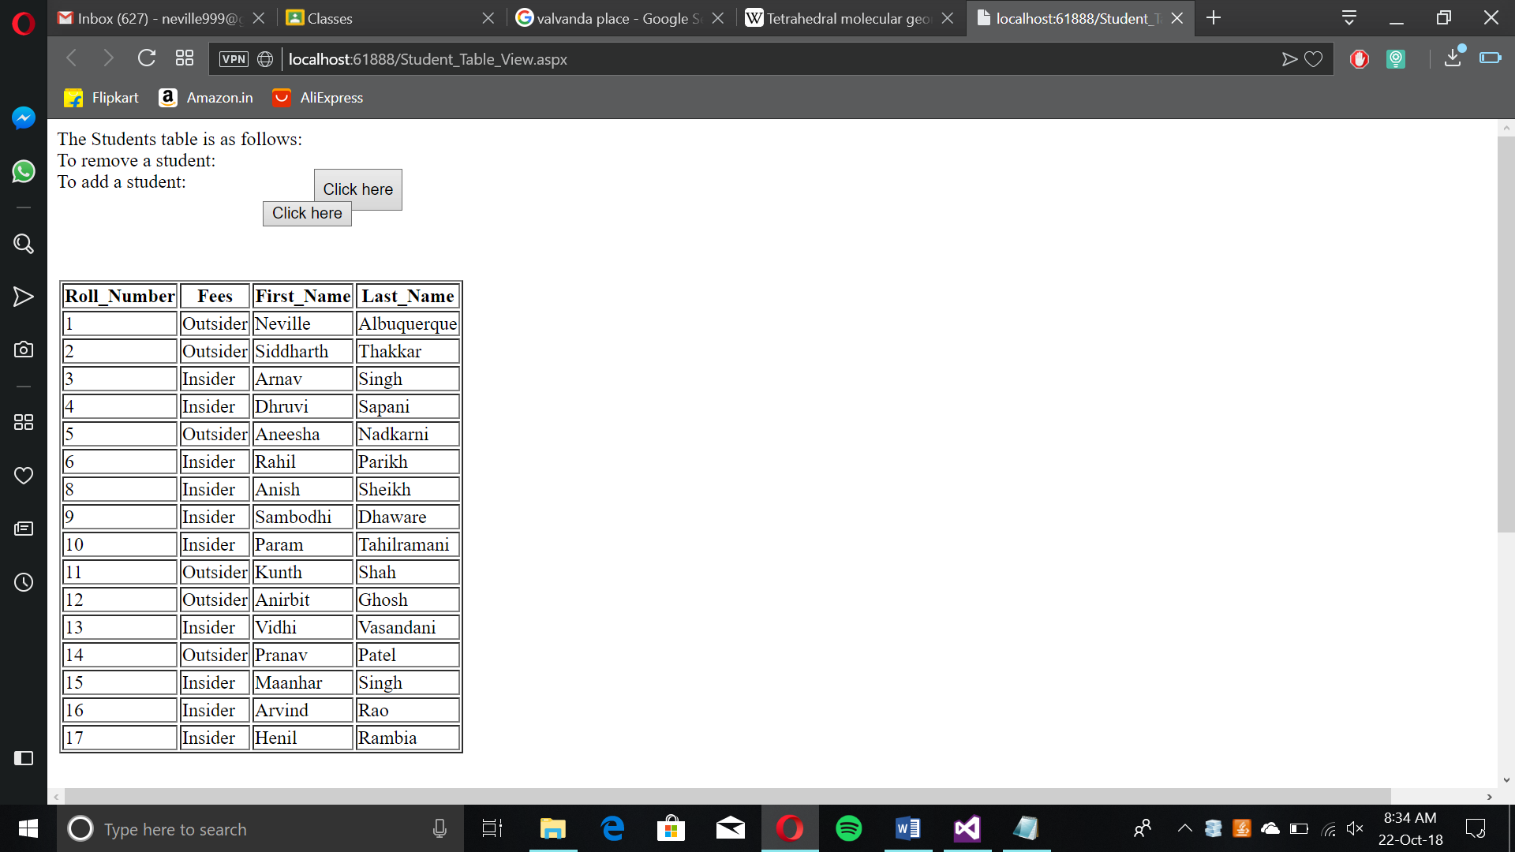

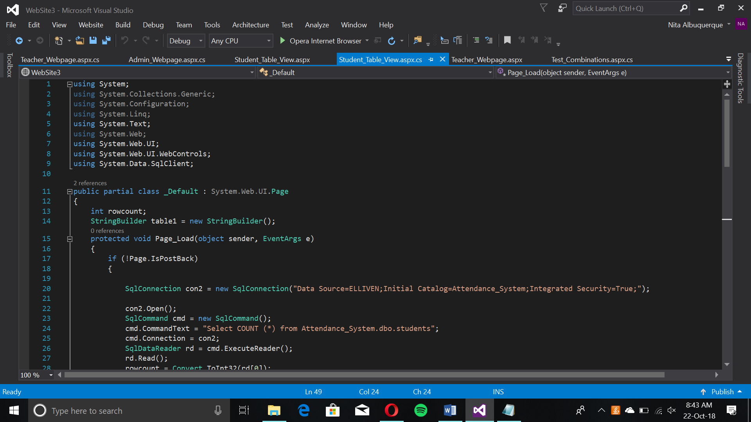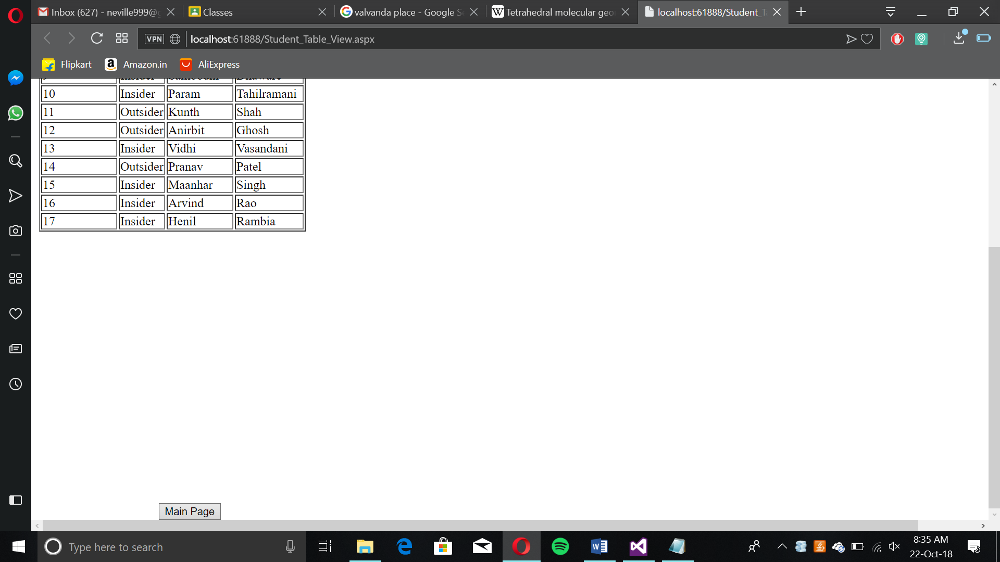

A view is created with options to add or delete students. The same generic table with a SELECT query shows the students and their details.

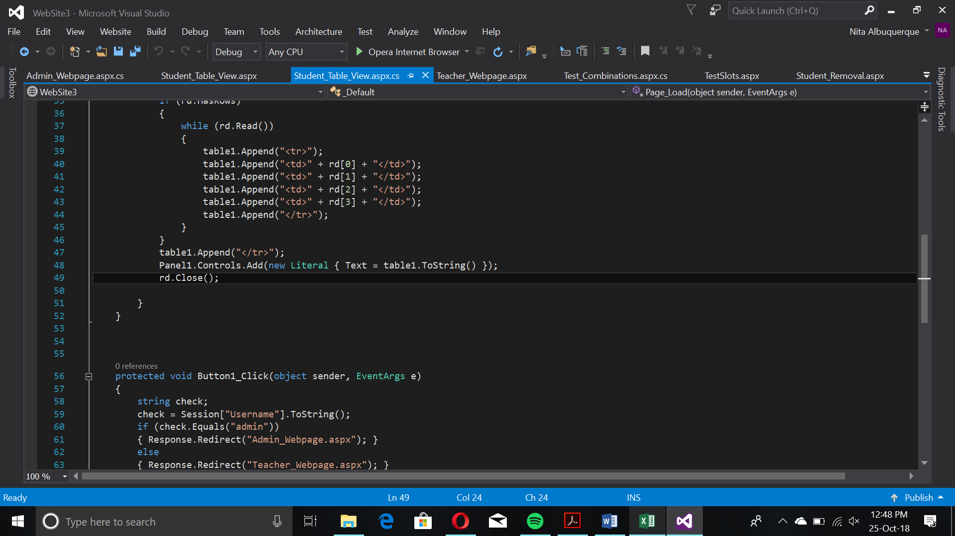

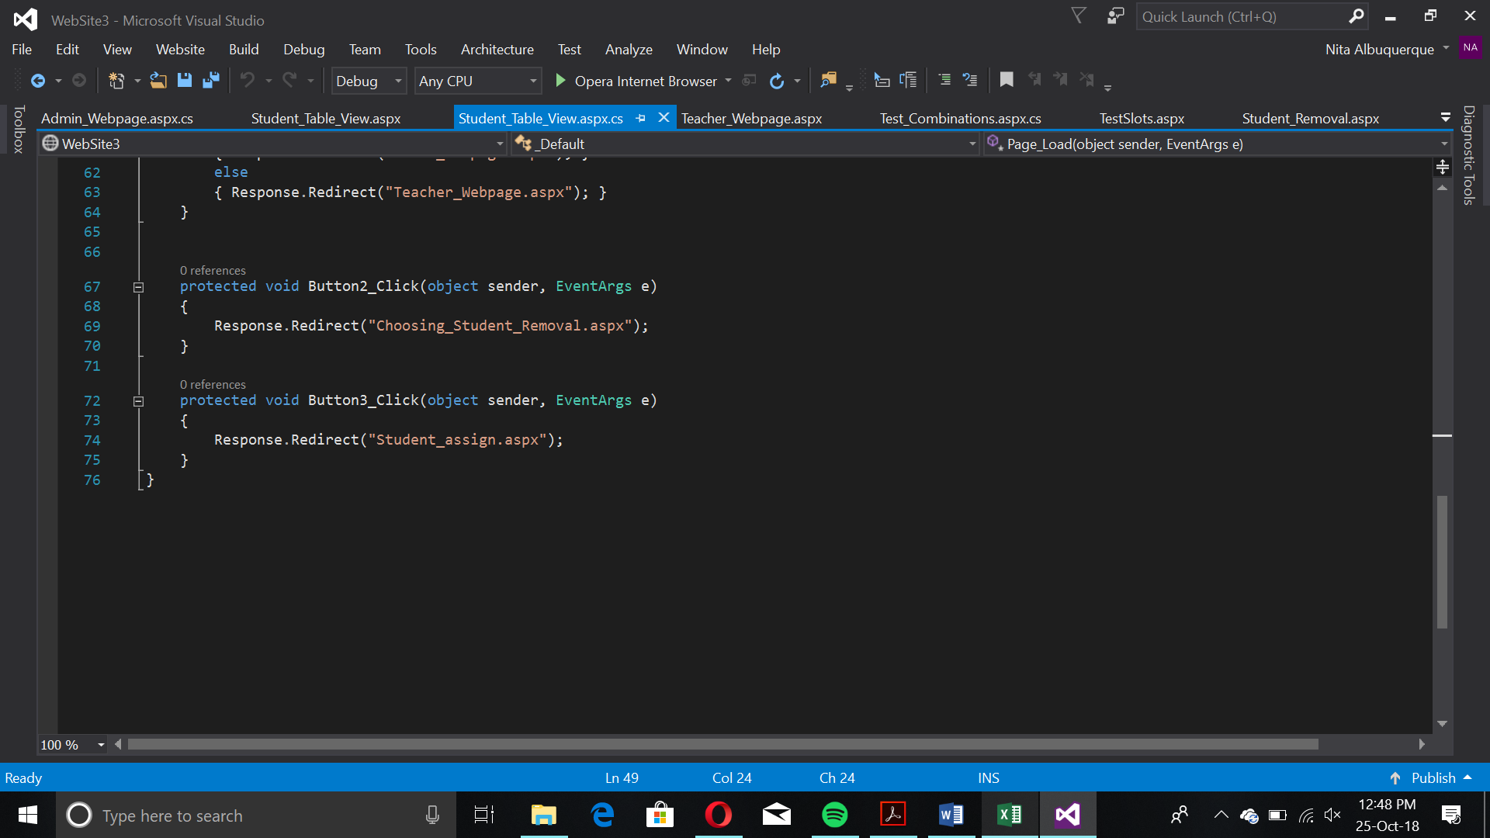

When removing a student, the page redirects and the user selects a roll number whilst showing a table containing the current students. Once chosen, the page accepts the response and verifies the user’s choice.

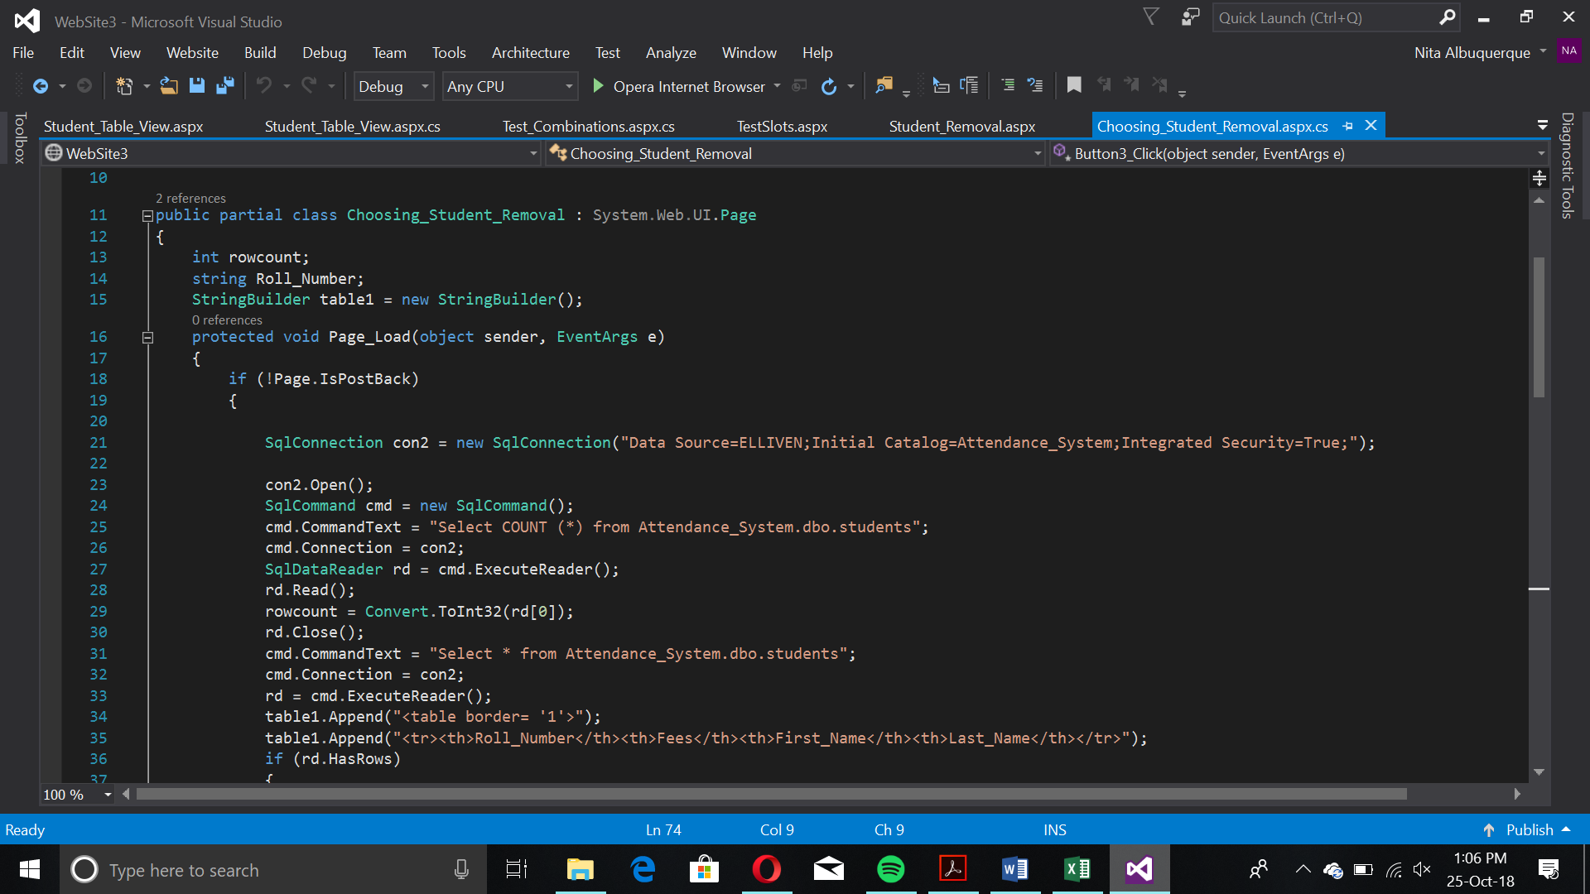

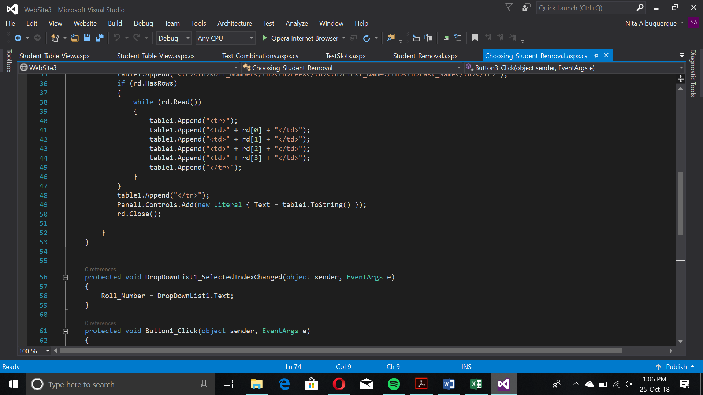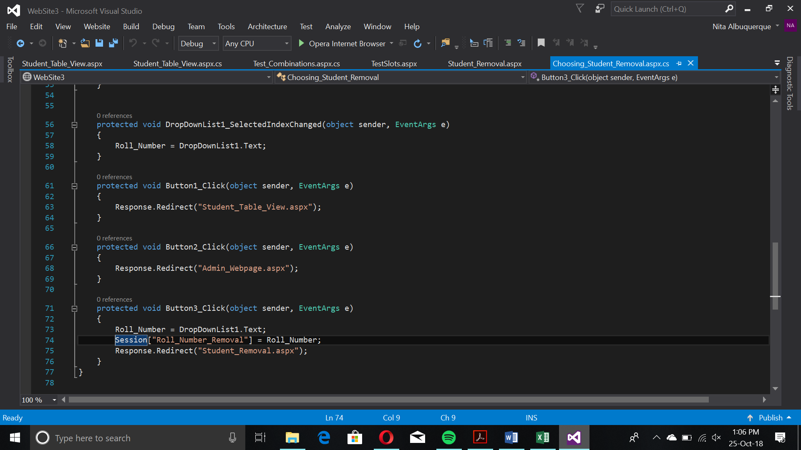

Upon selecting a roll number, the finalization page comes up:

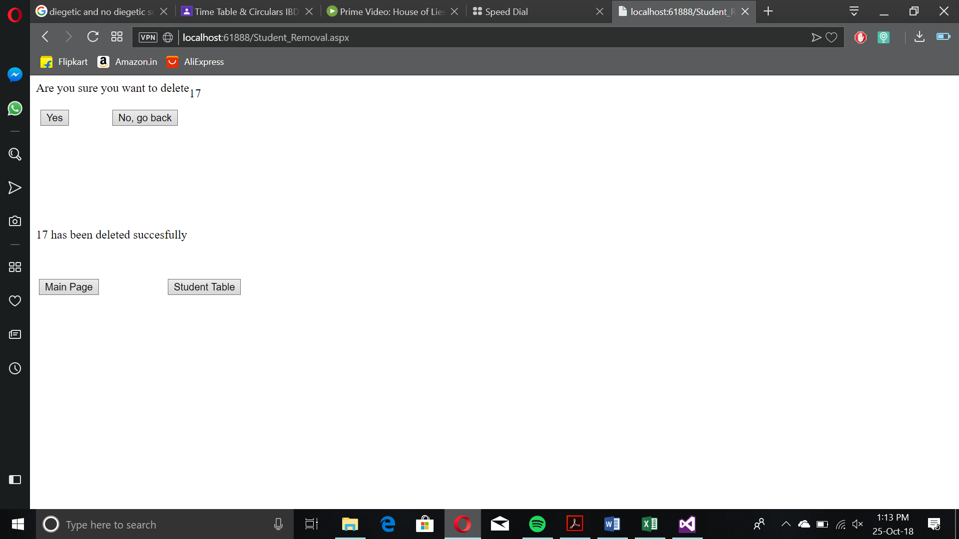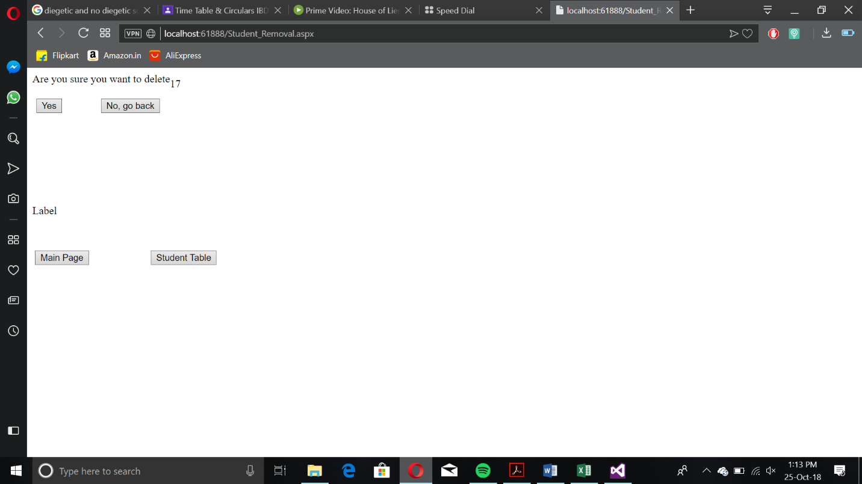

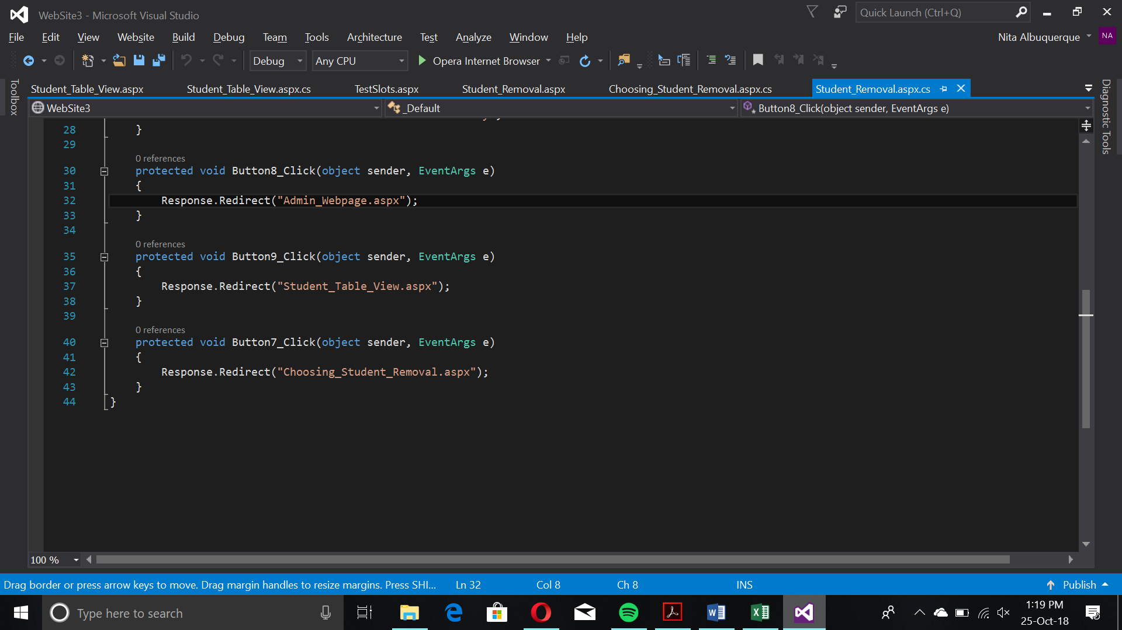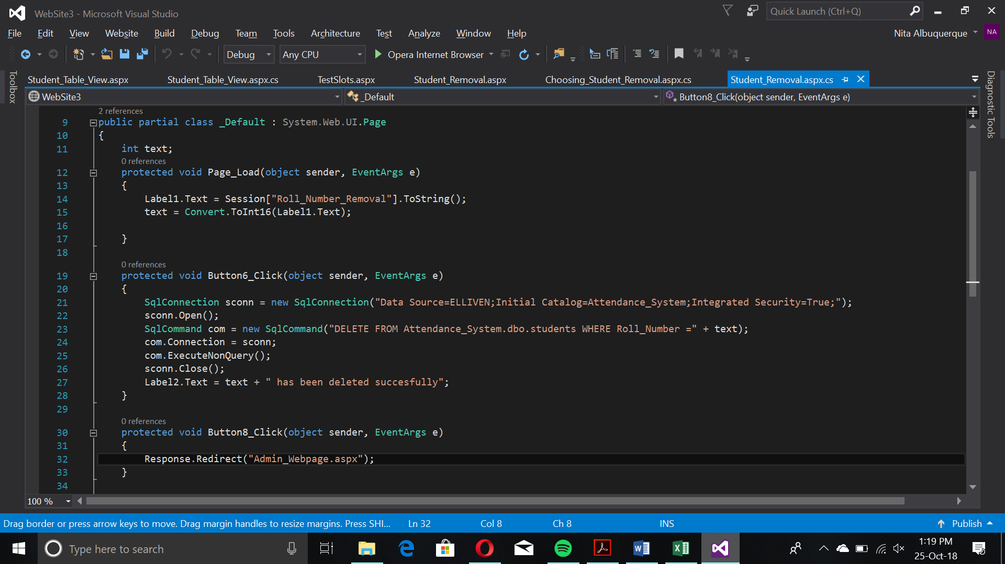

With the DELETE Query, the row is deleted. There’s a view and removal option for the teacher table too.

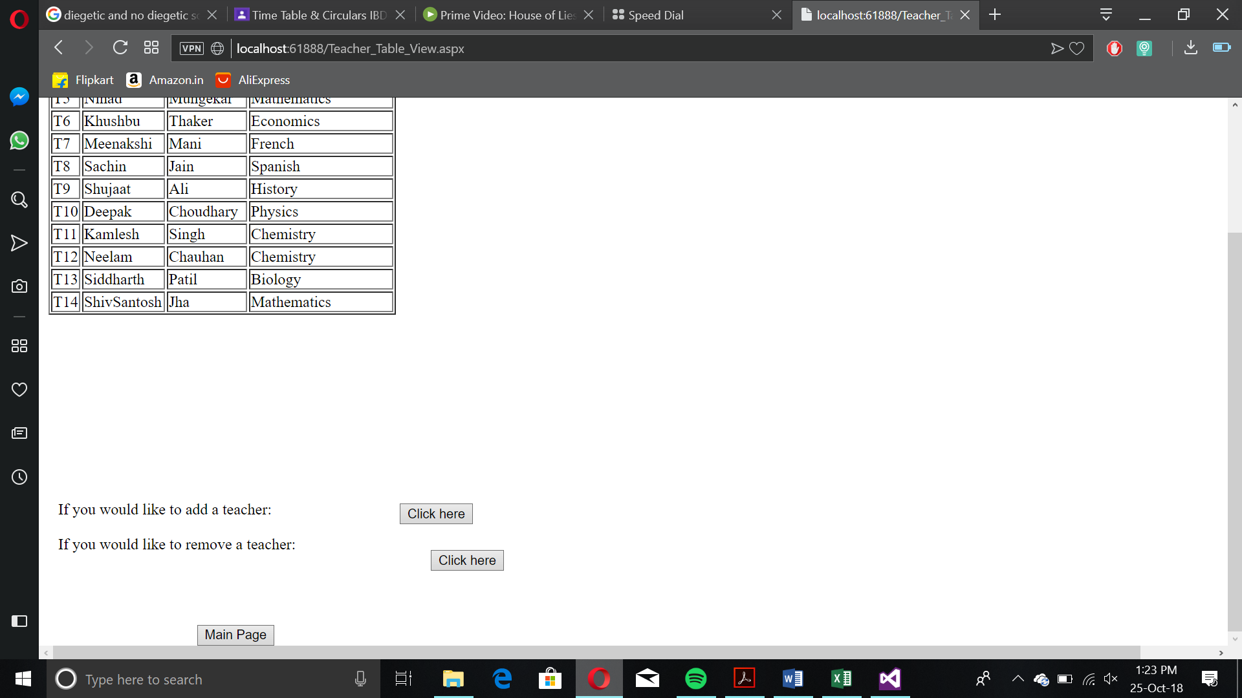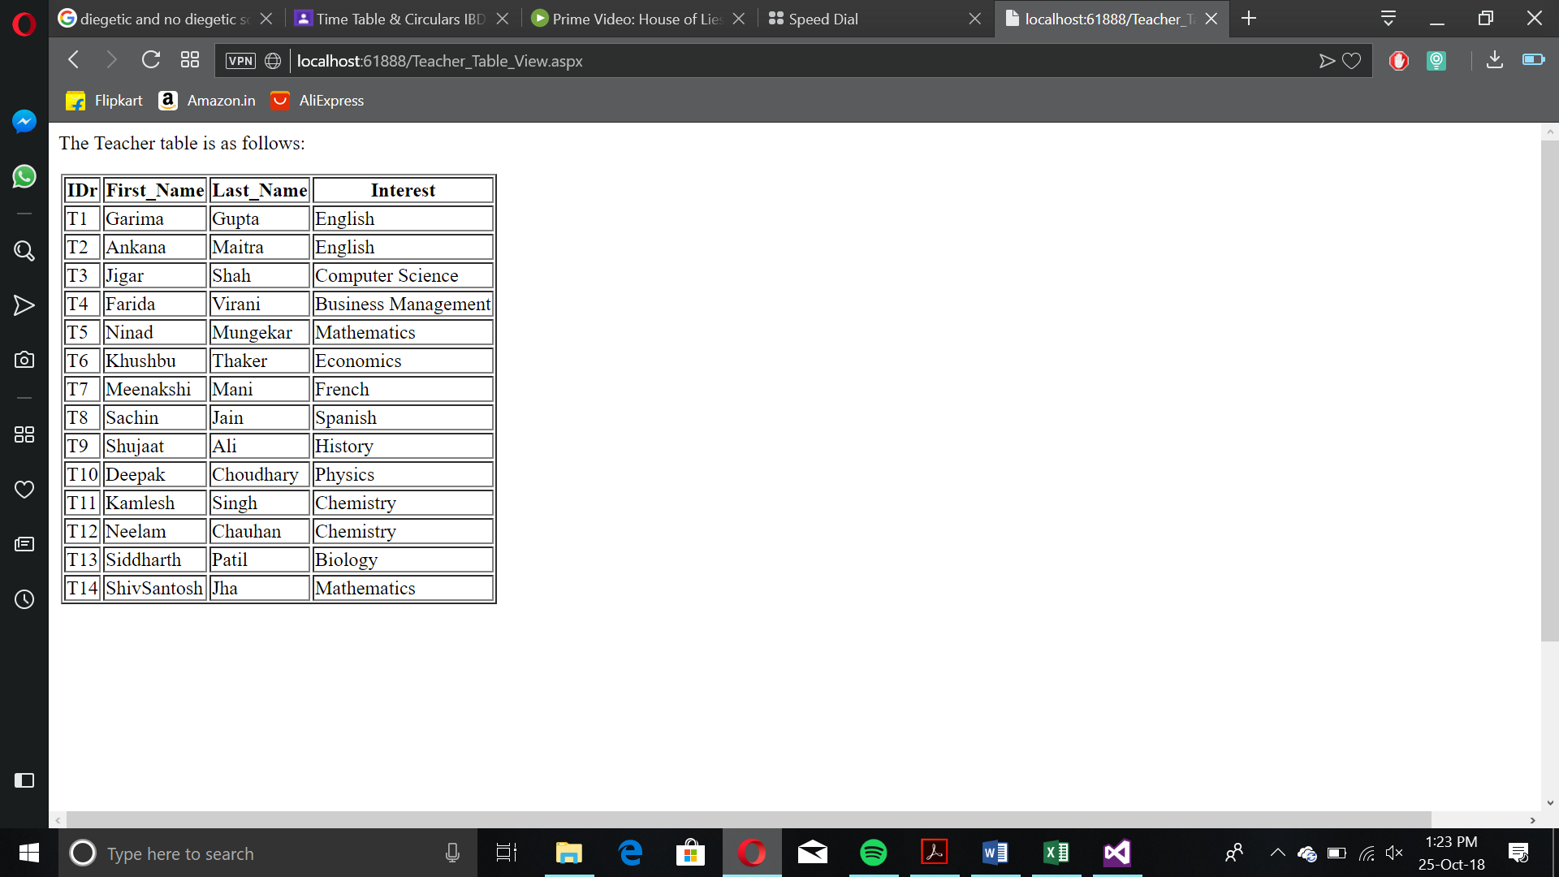

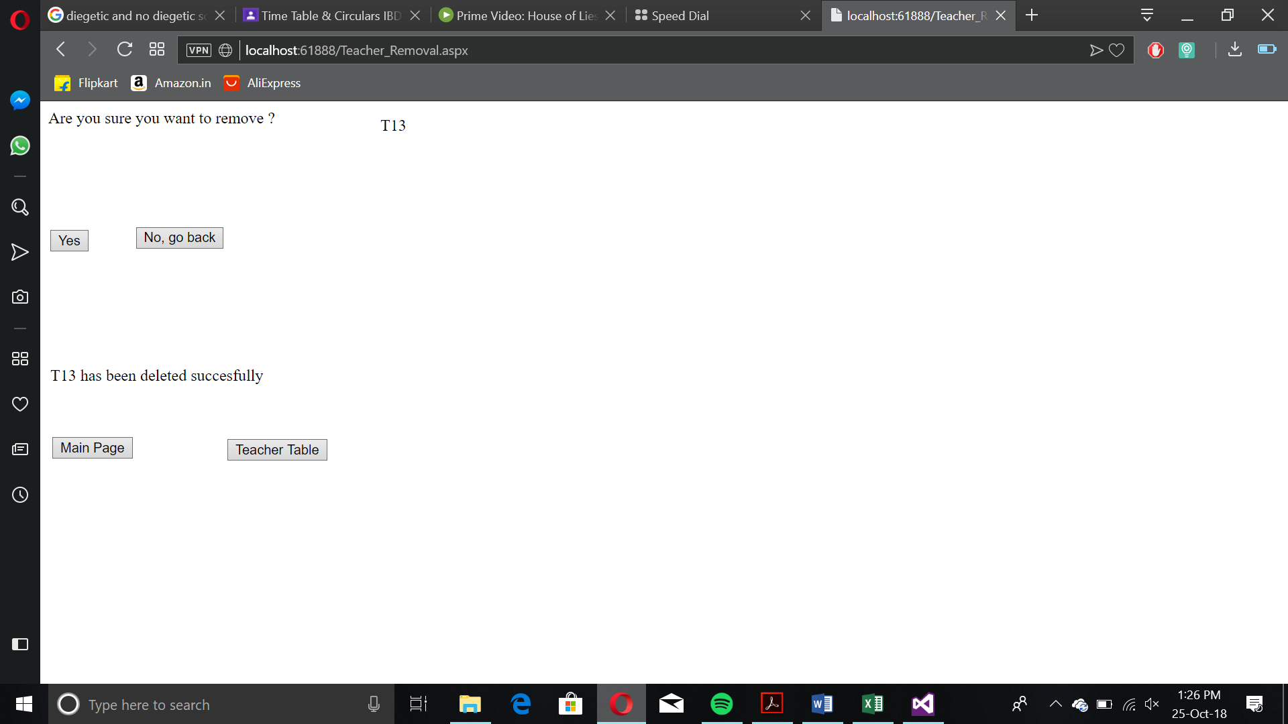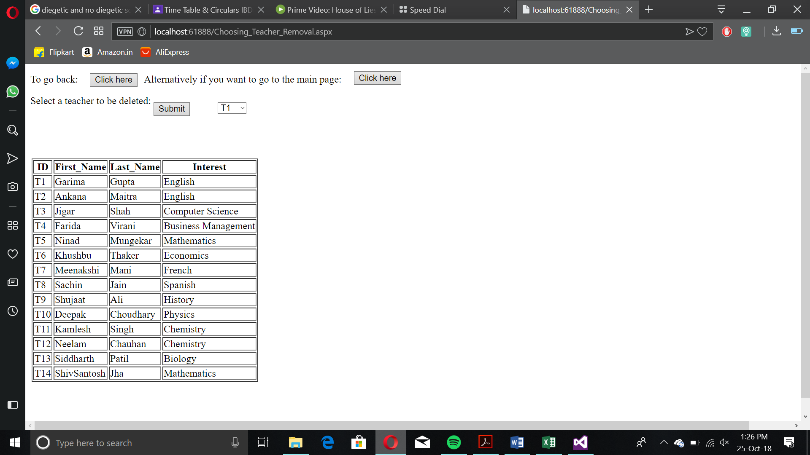

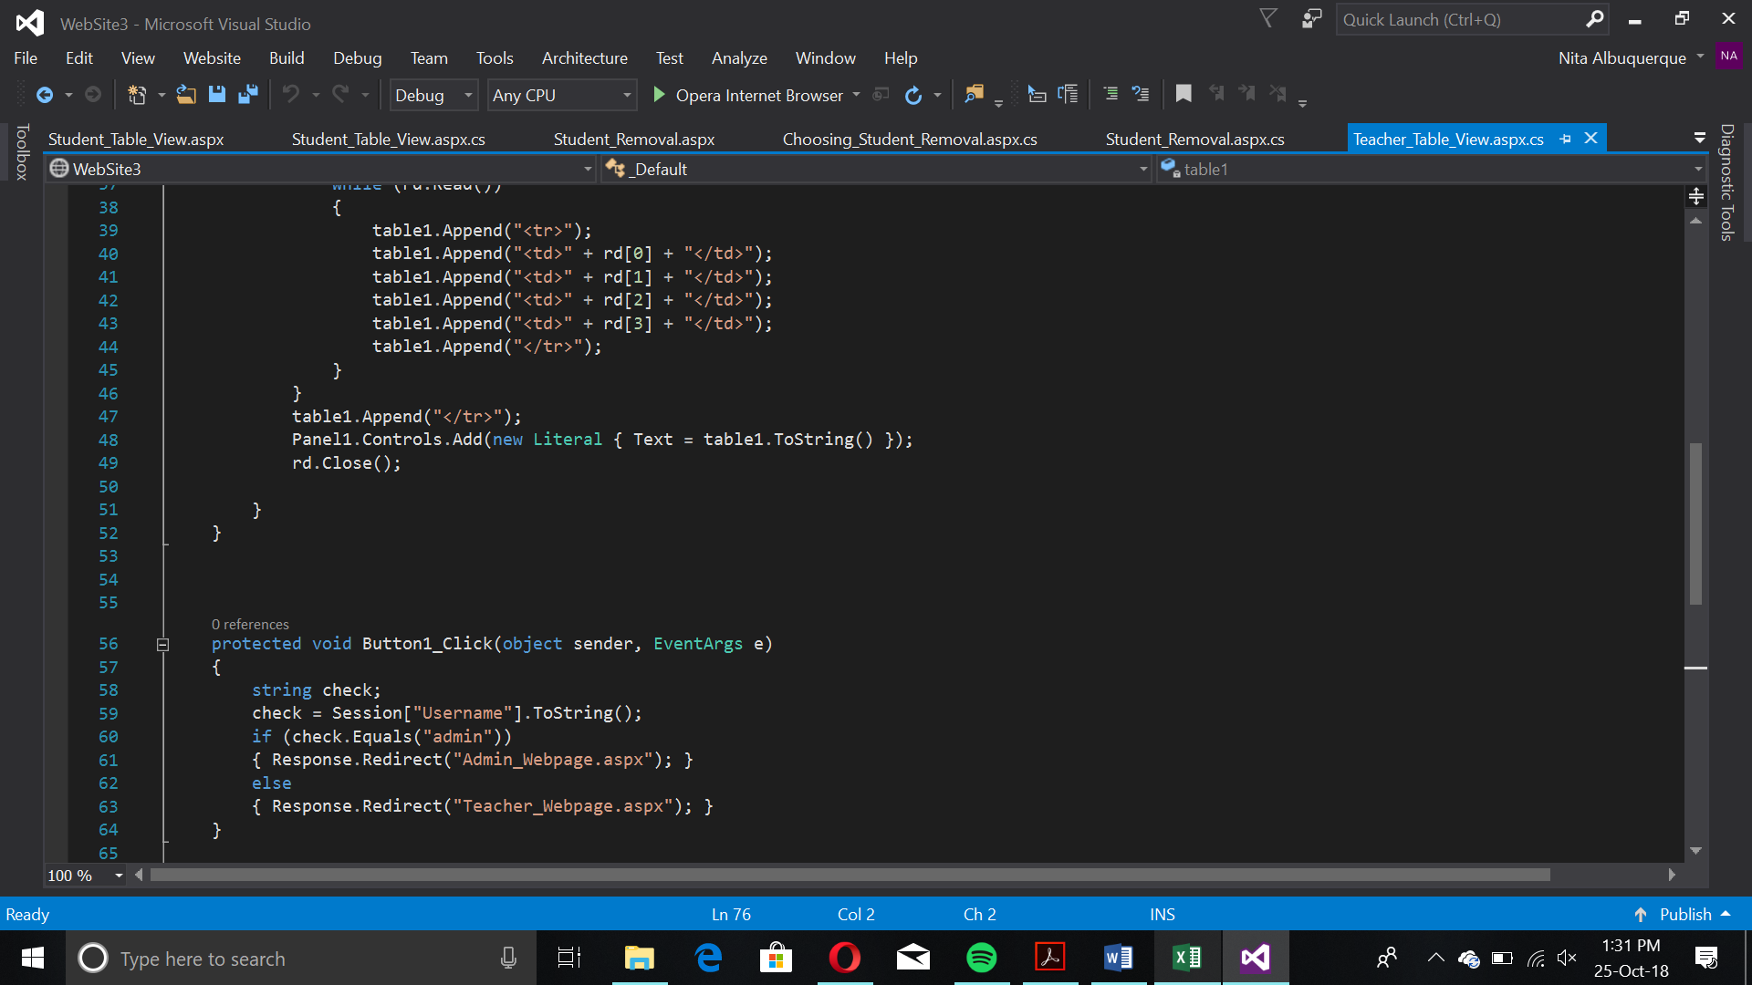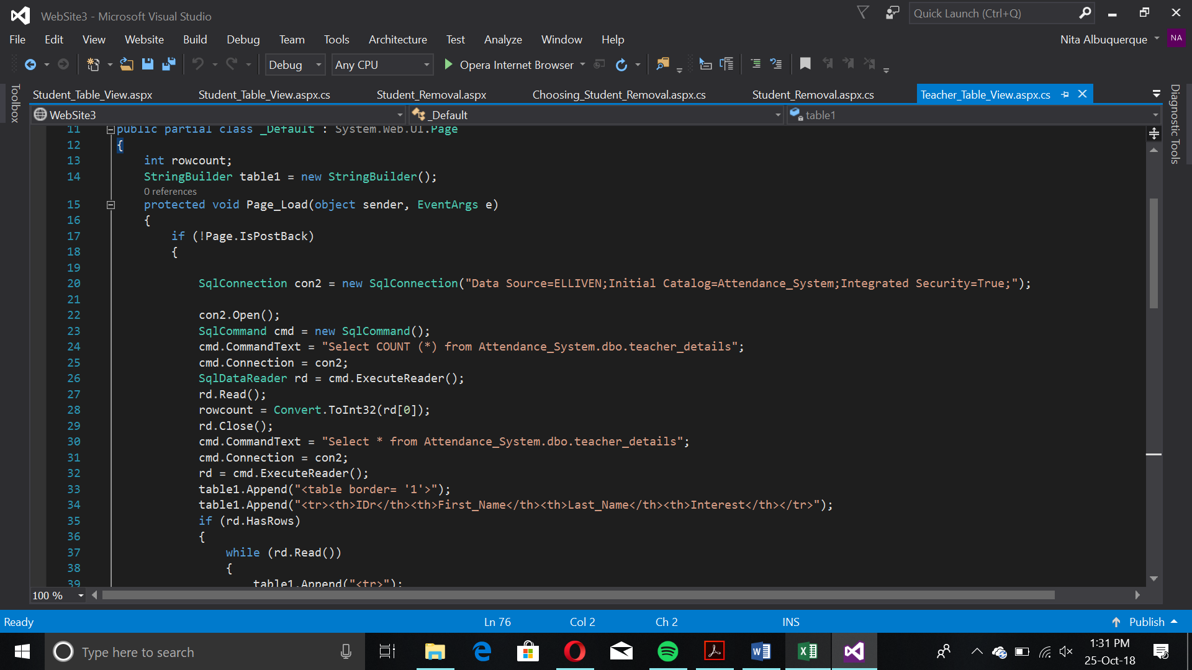

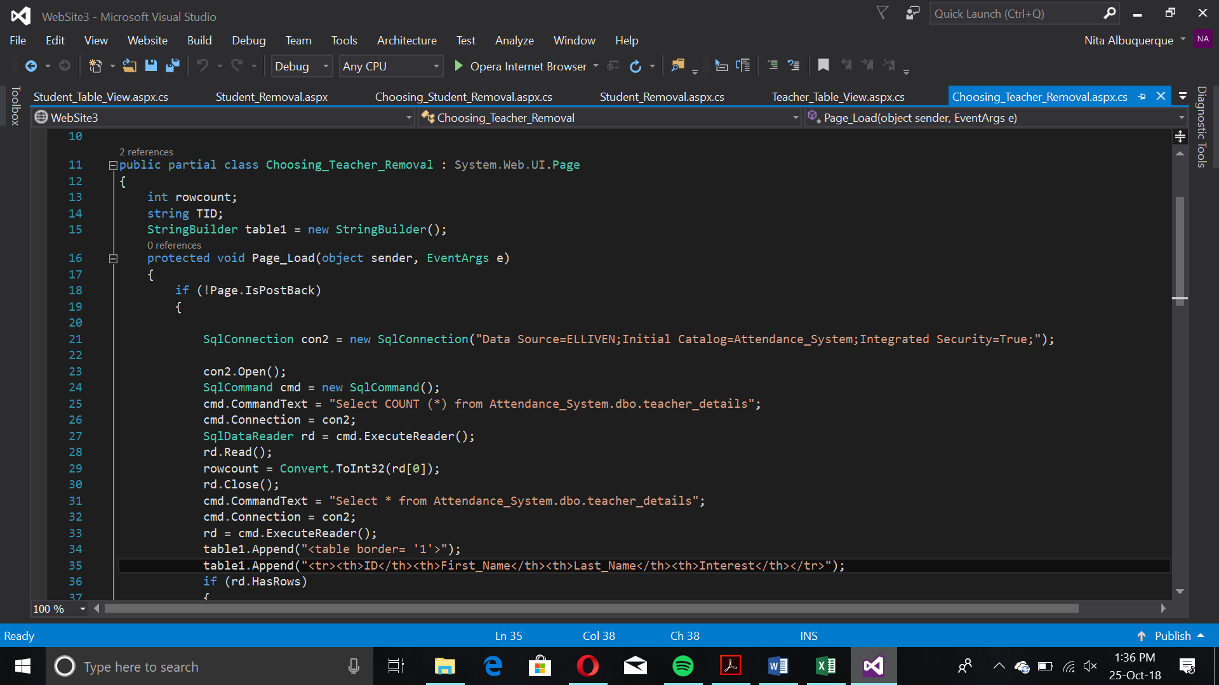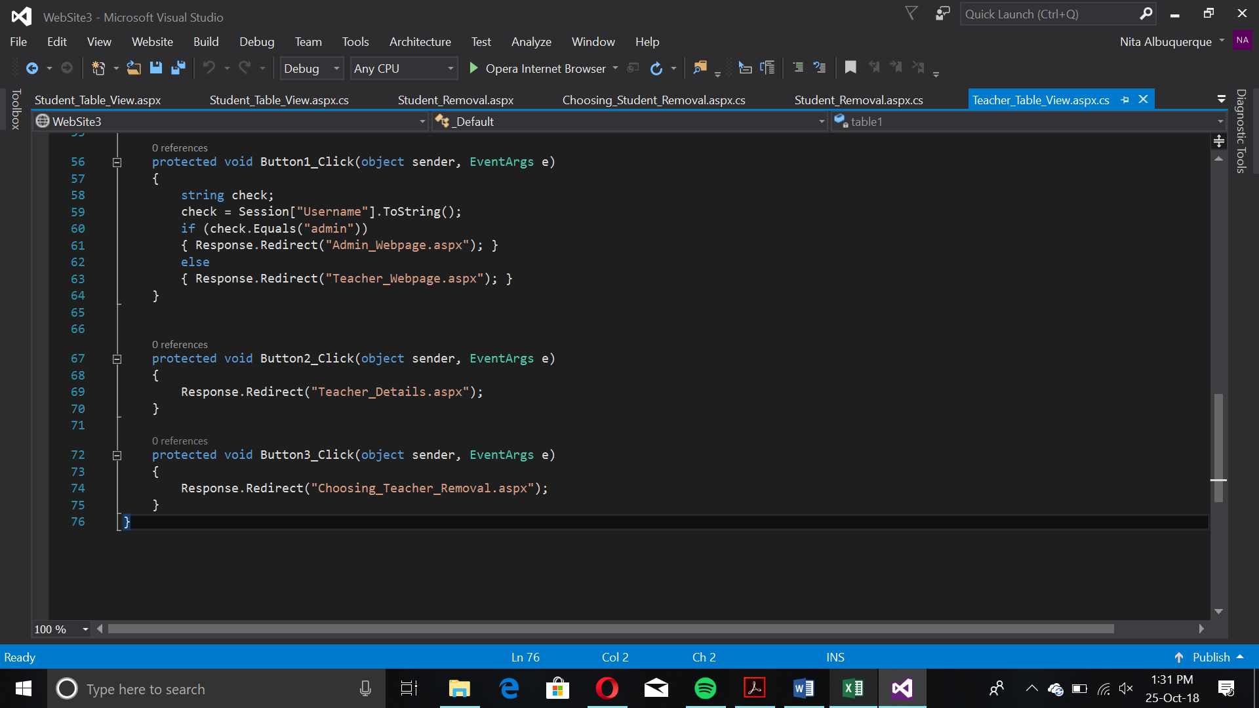

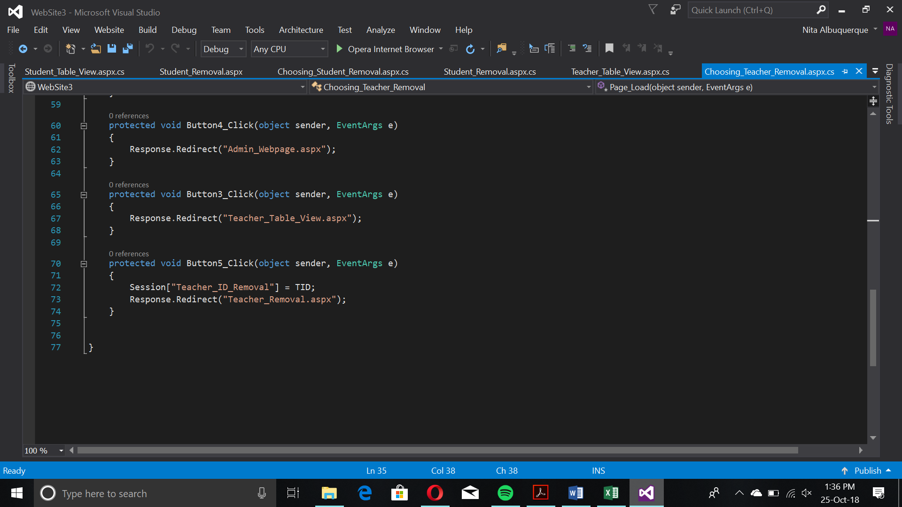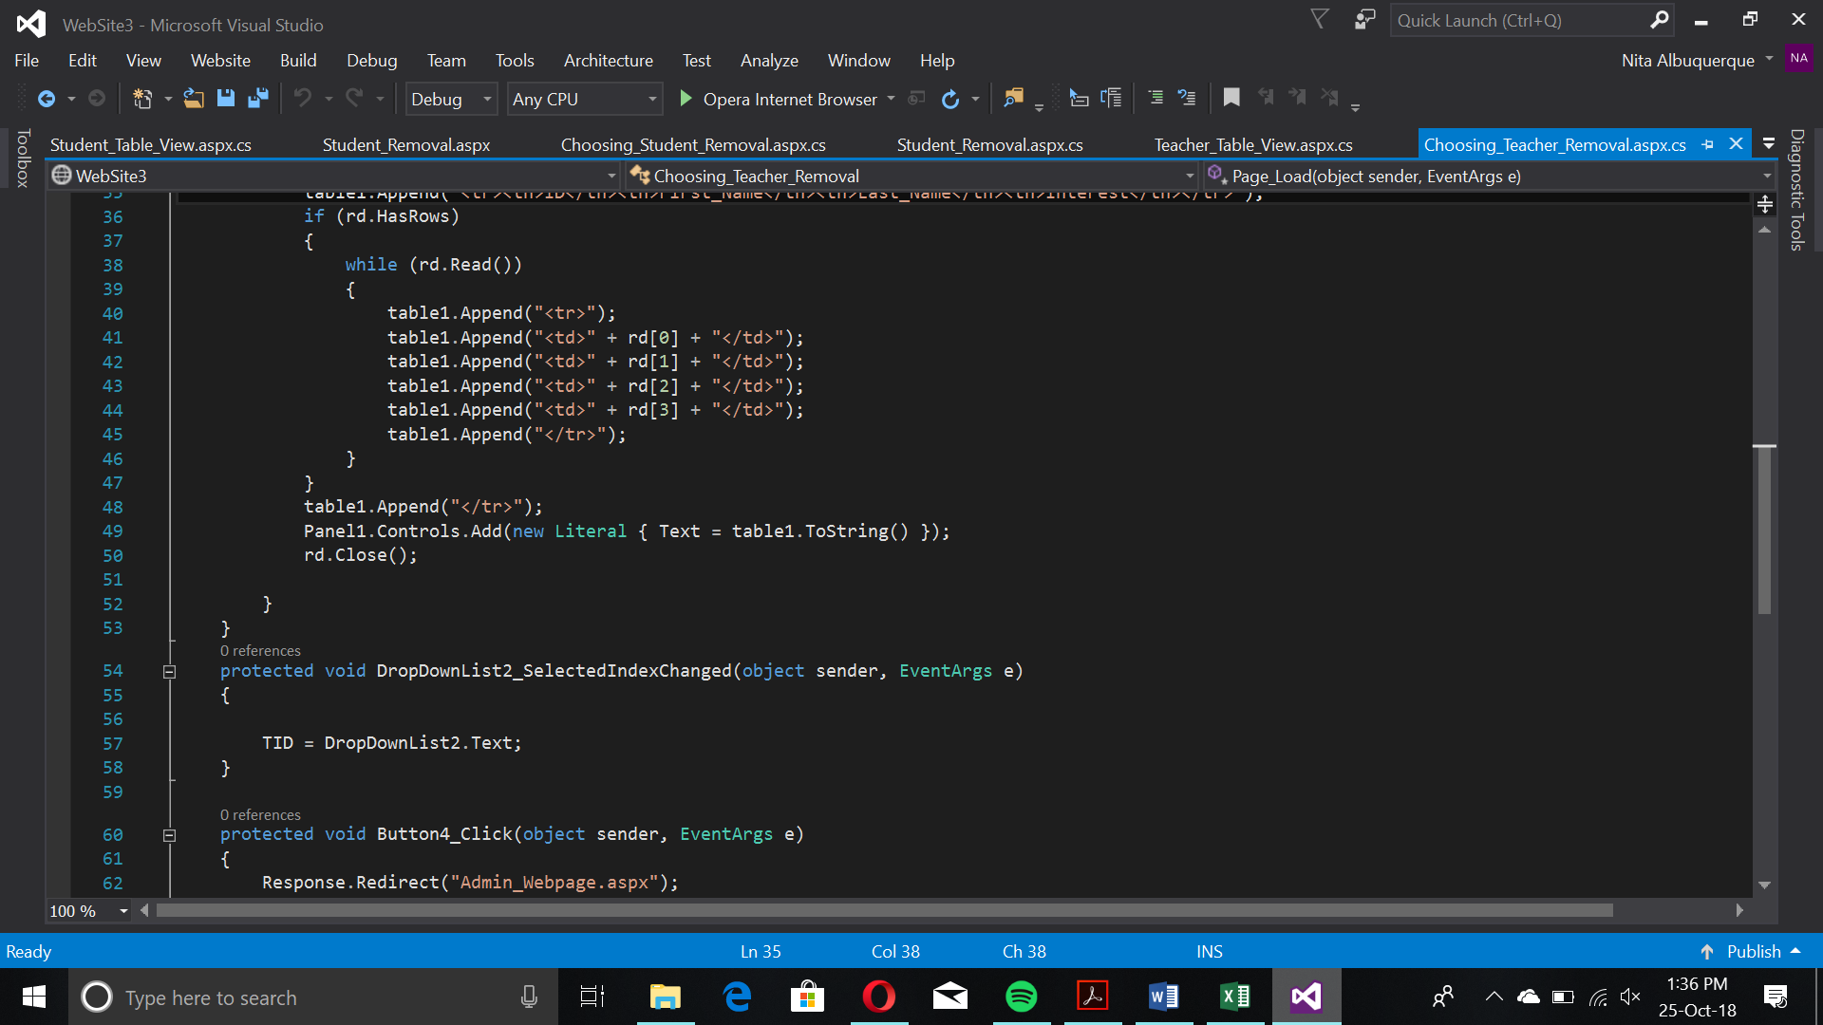

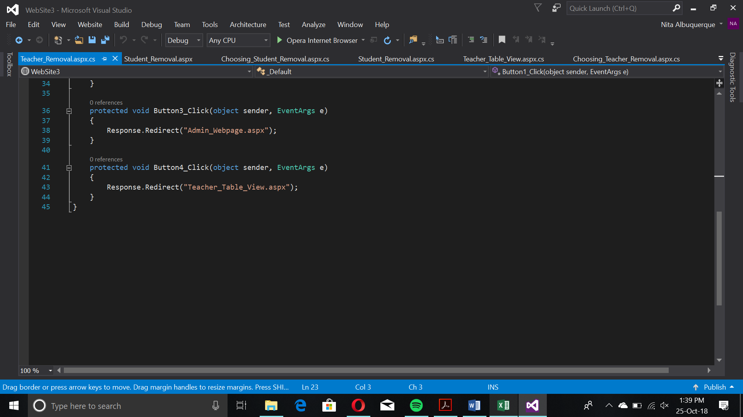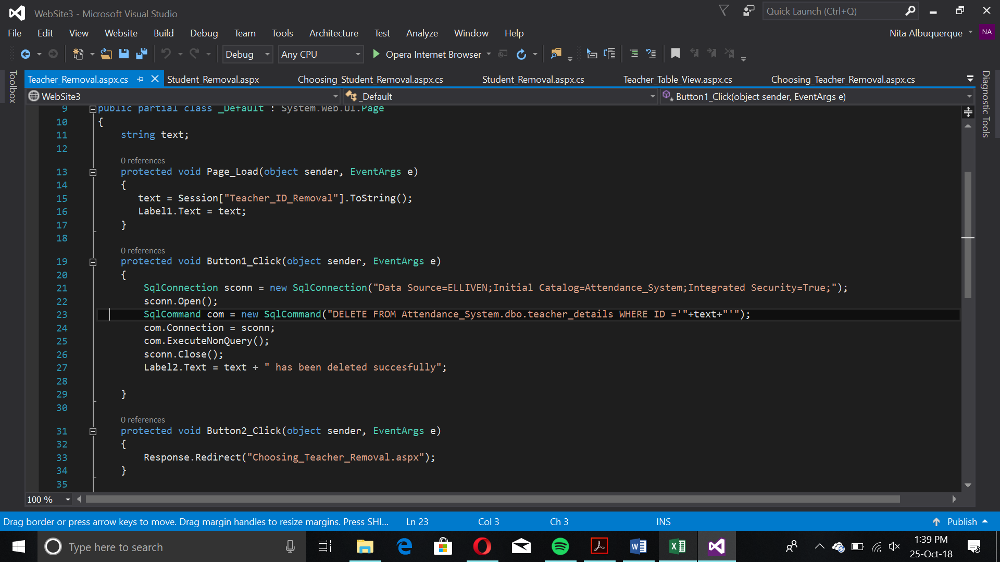

Attendance Report Generation

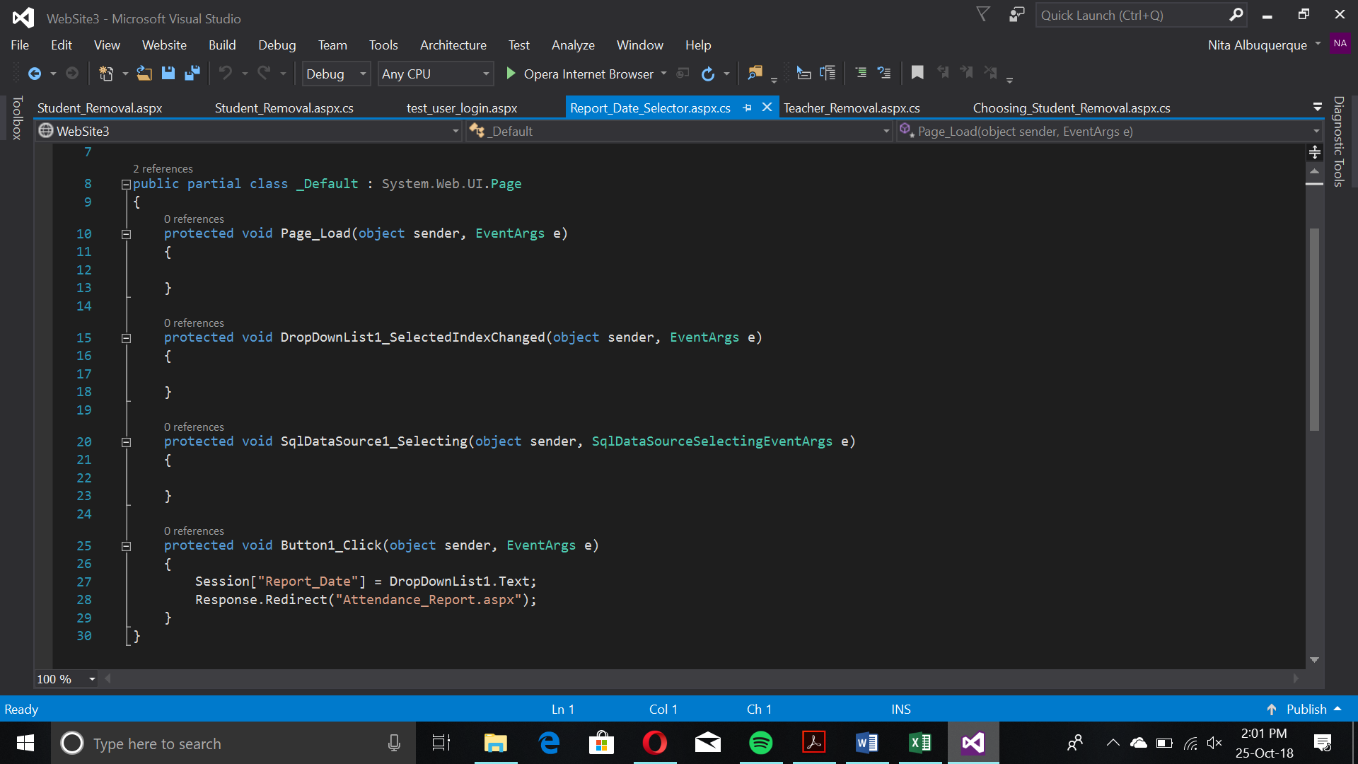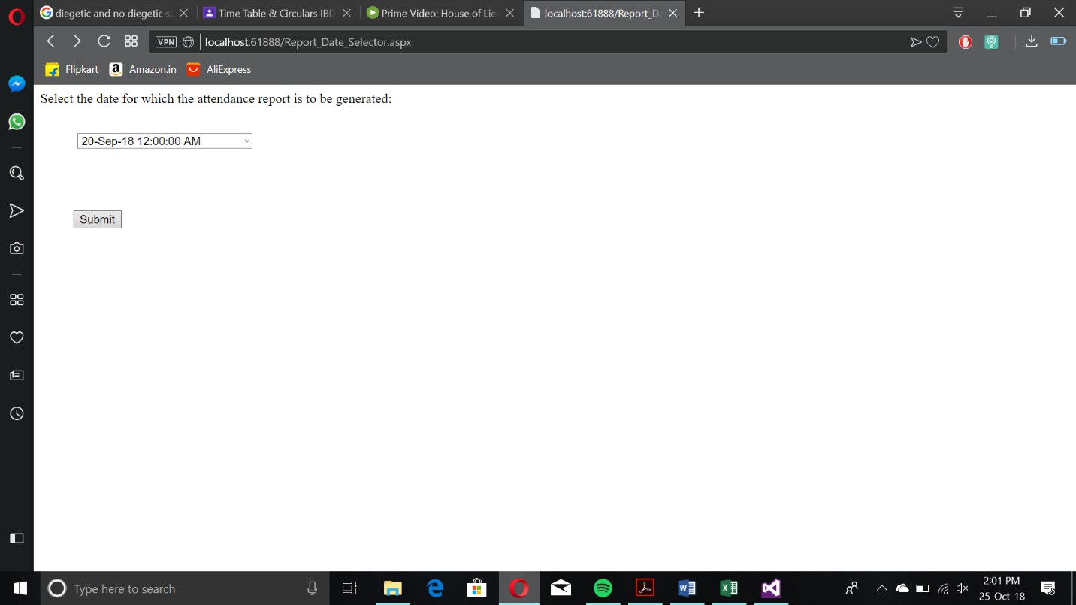

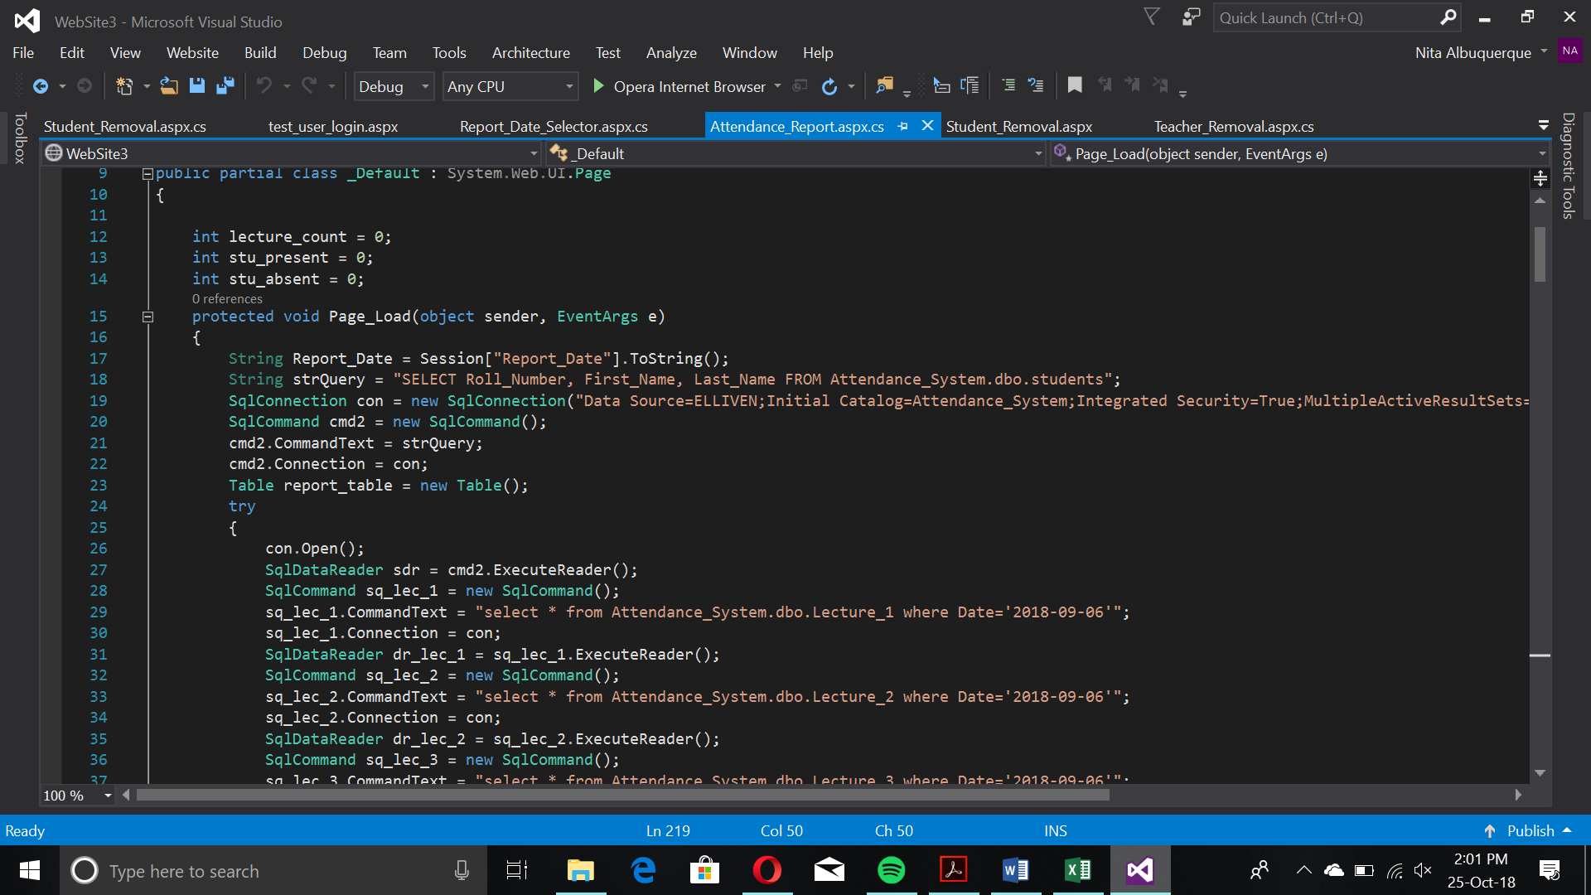

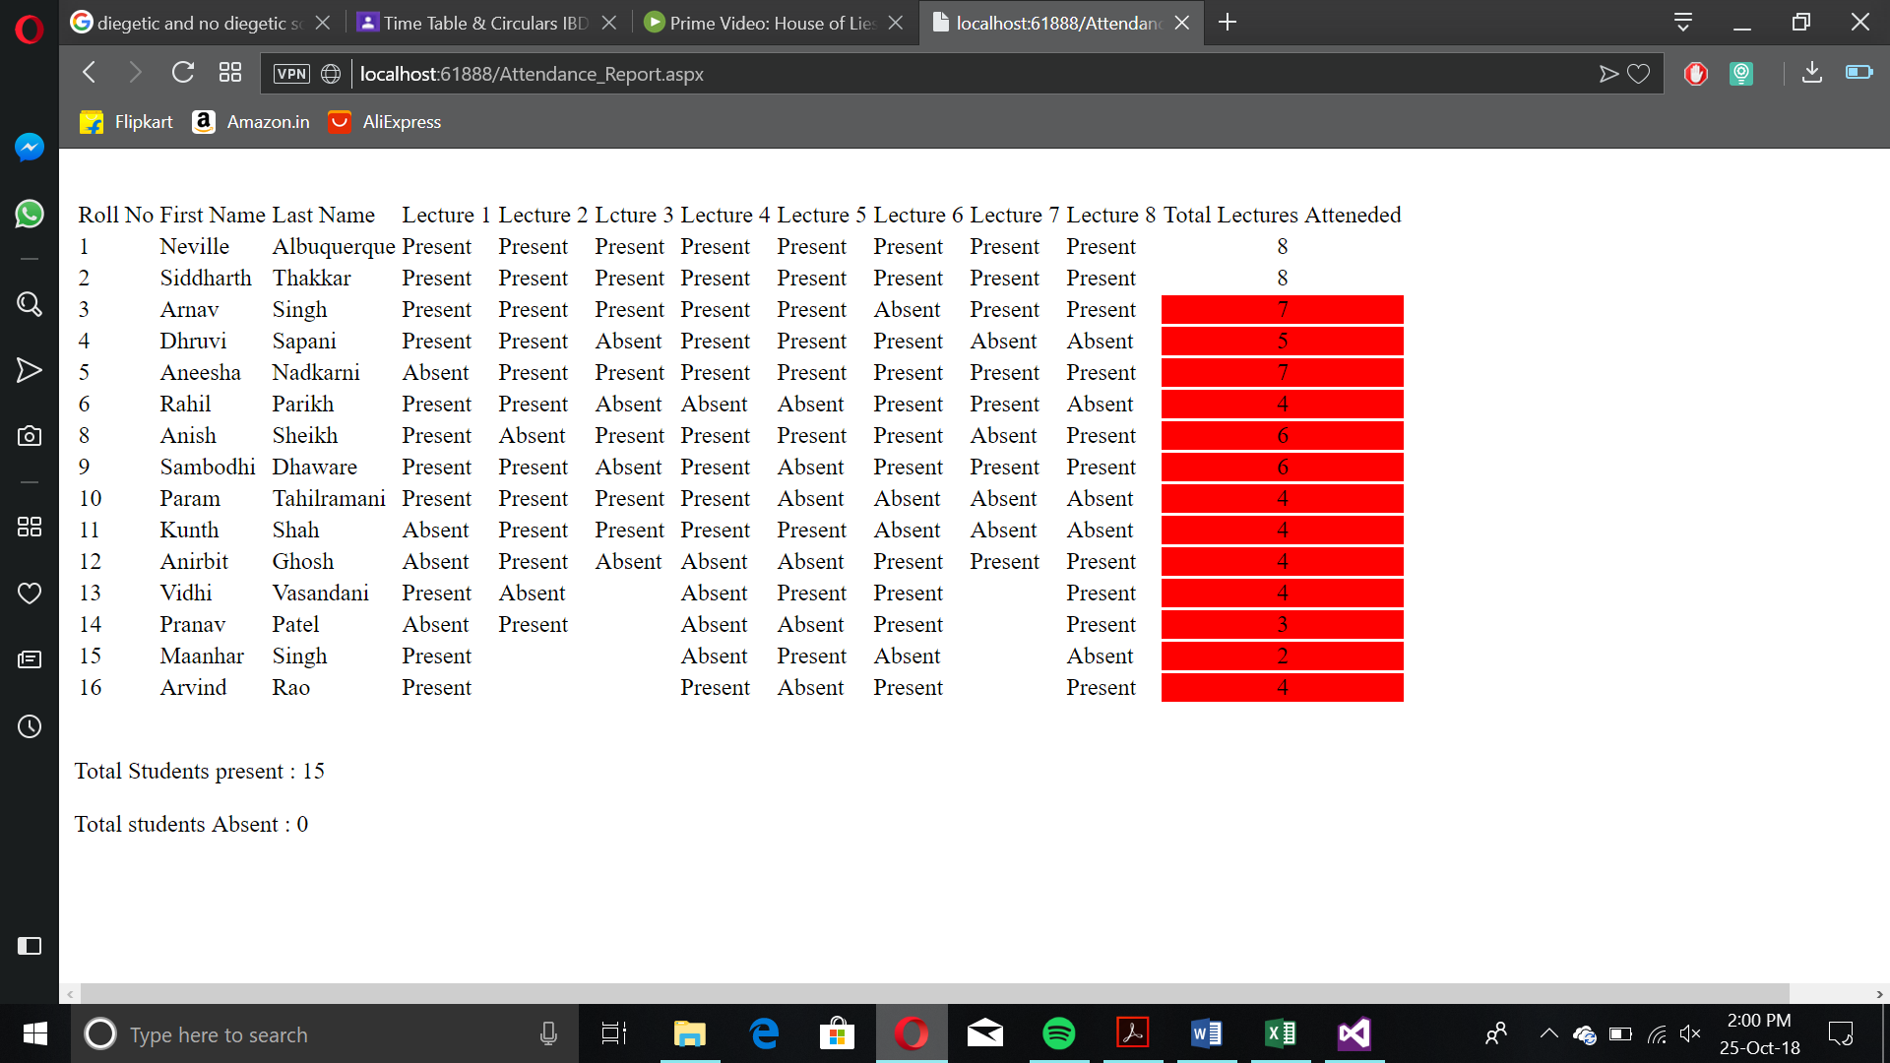

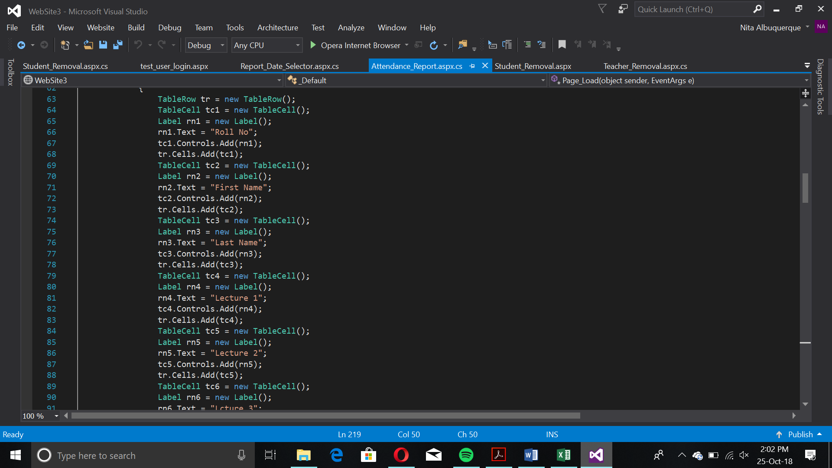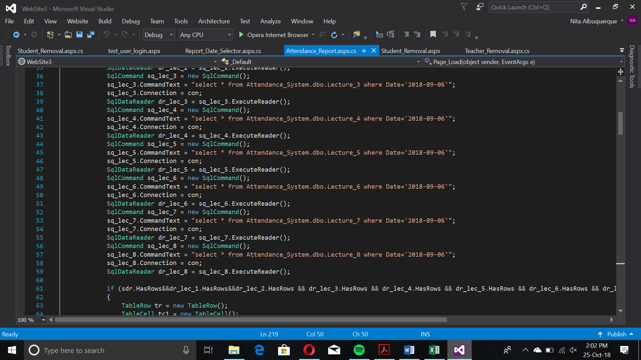

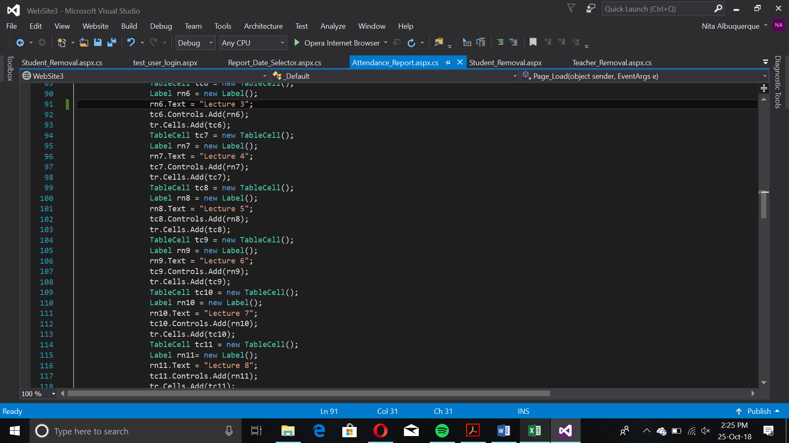

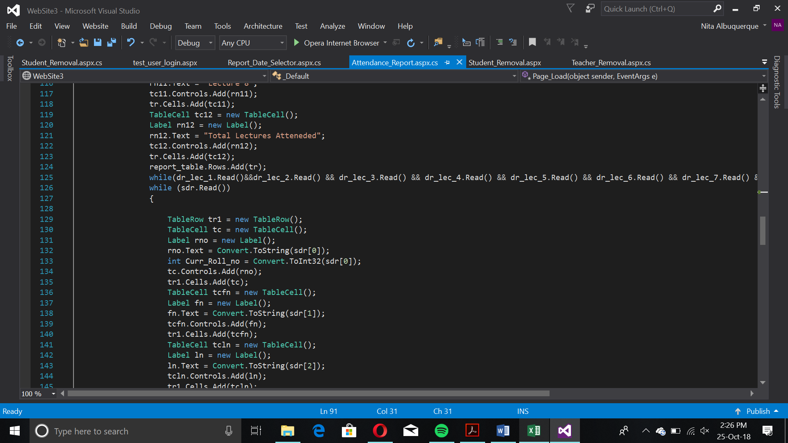

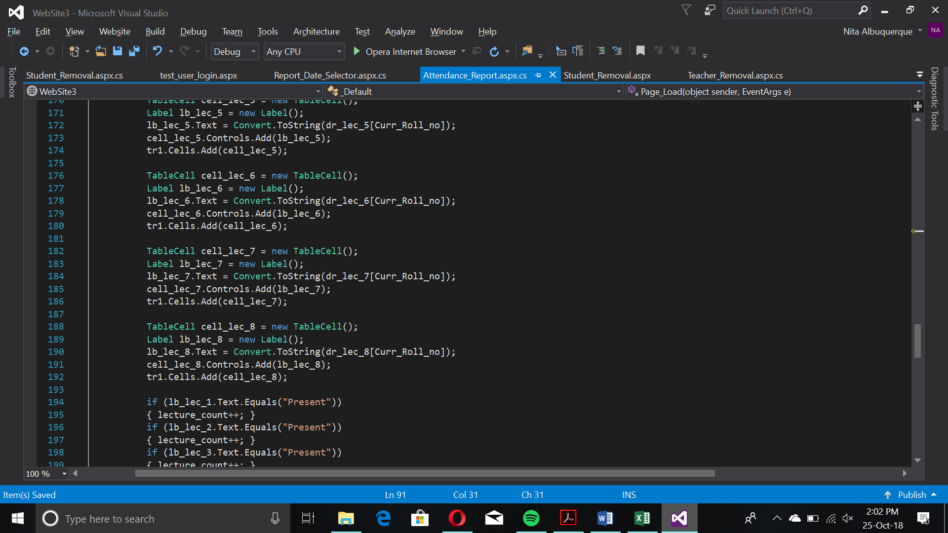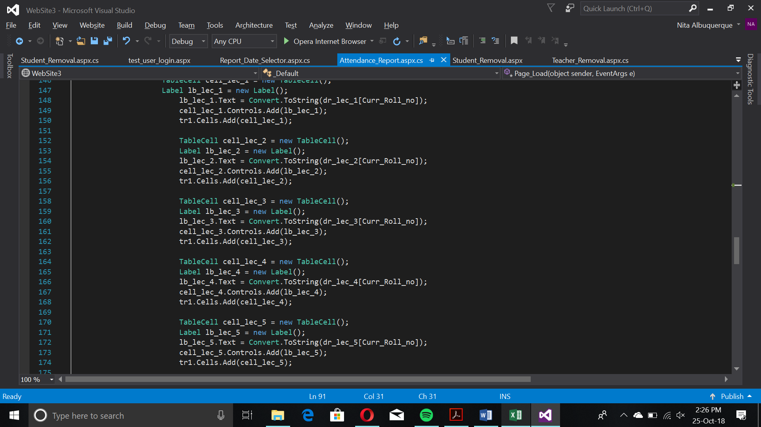

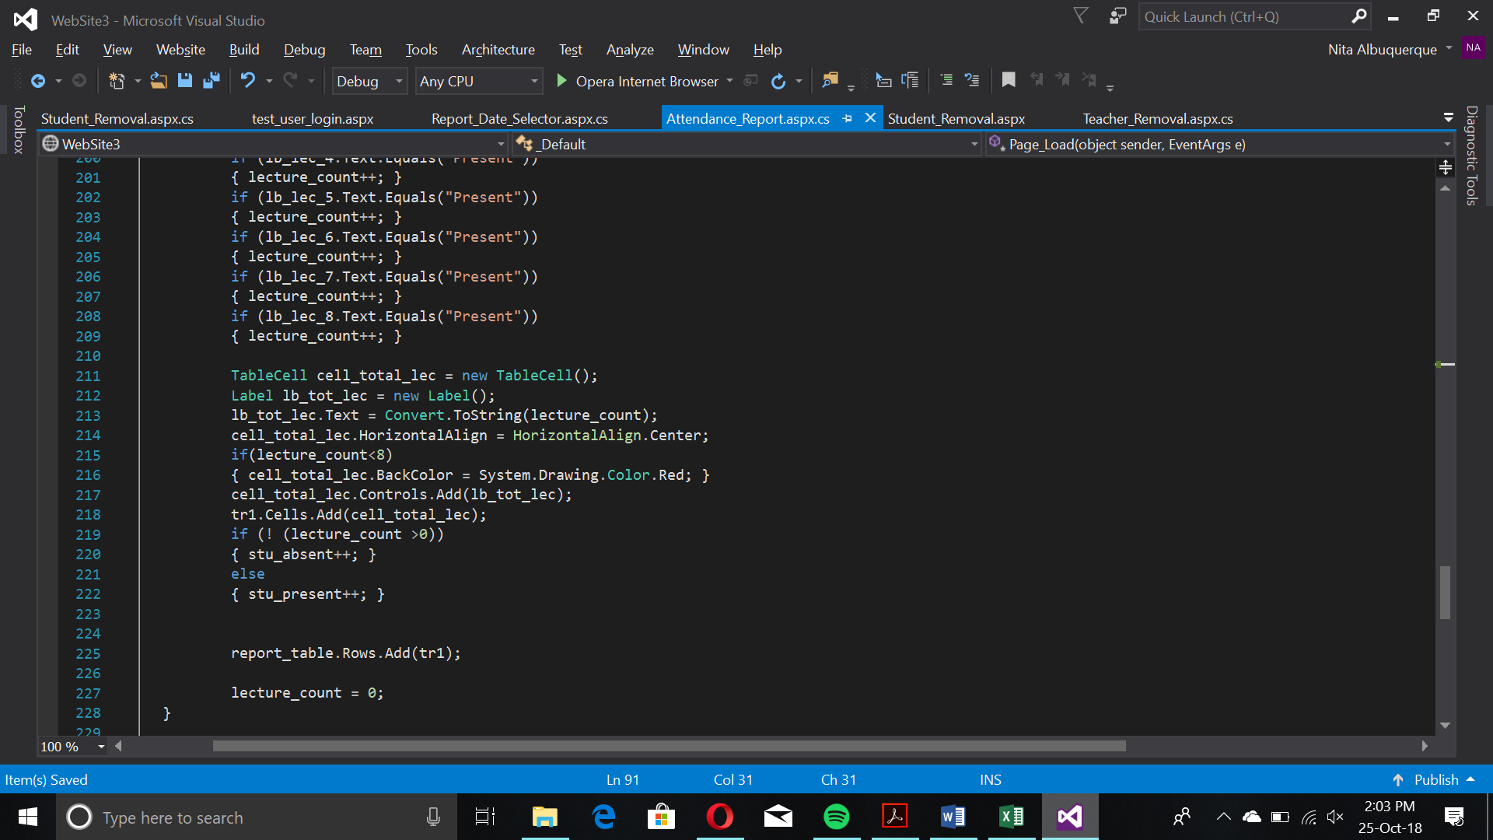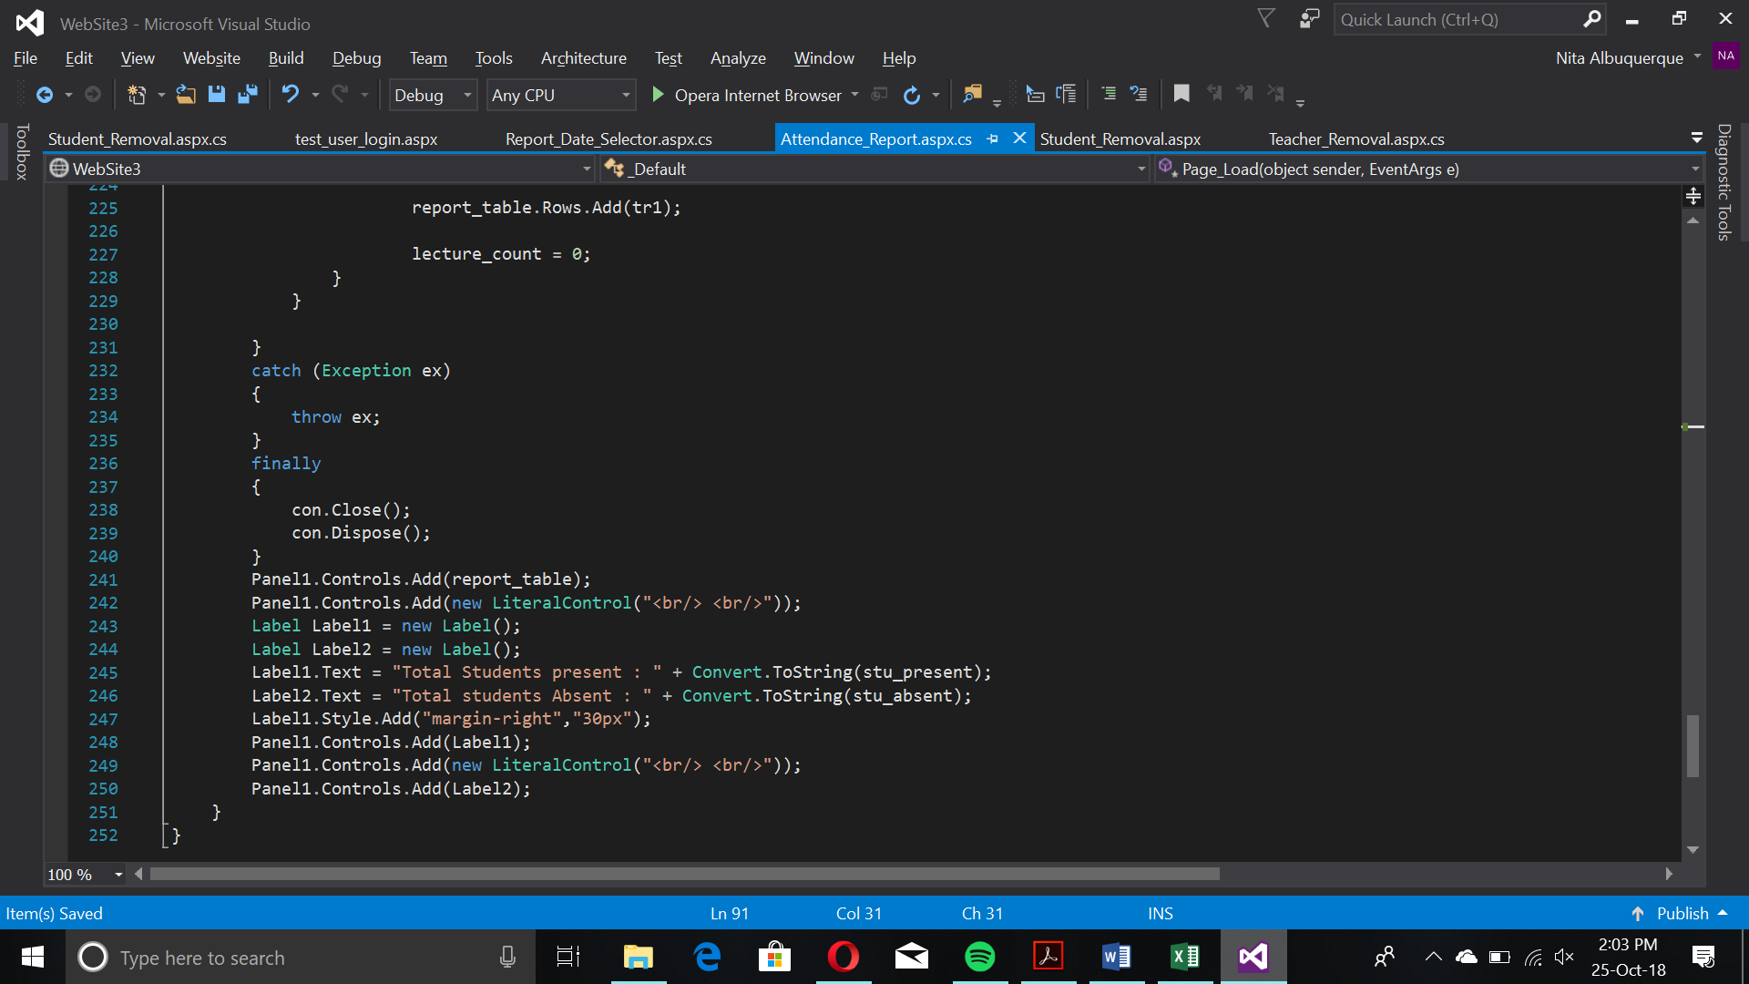

This creates the table containing the red flags (which indicate absence or bunking), attendance (lecture-wise) and gives a total figure for the coordinator in terms of total present and absent. The table is just a view from joining all the 8 lecture tables.

Teacher Webpage

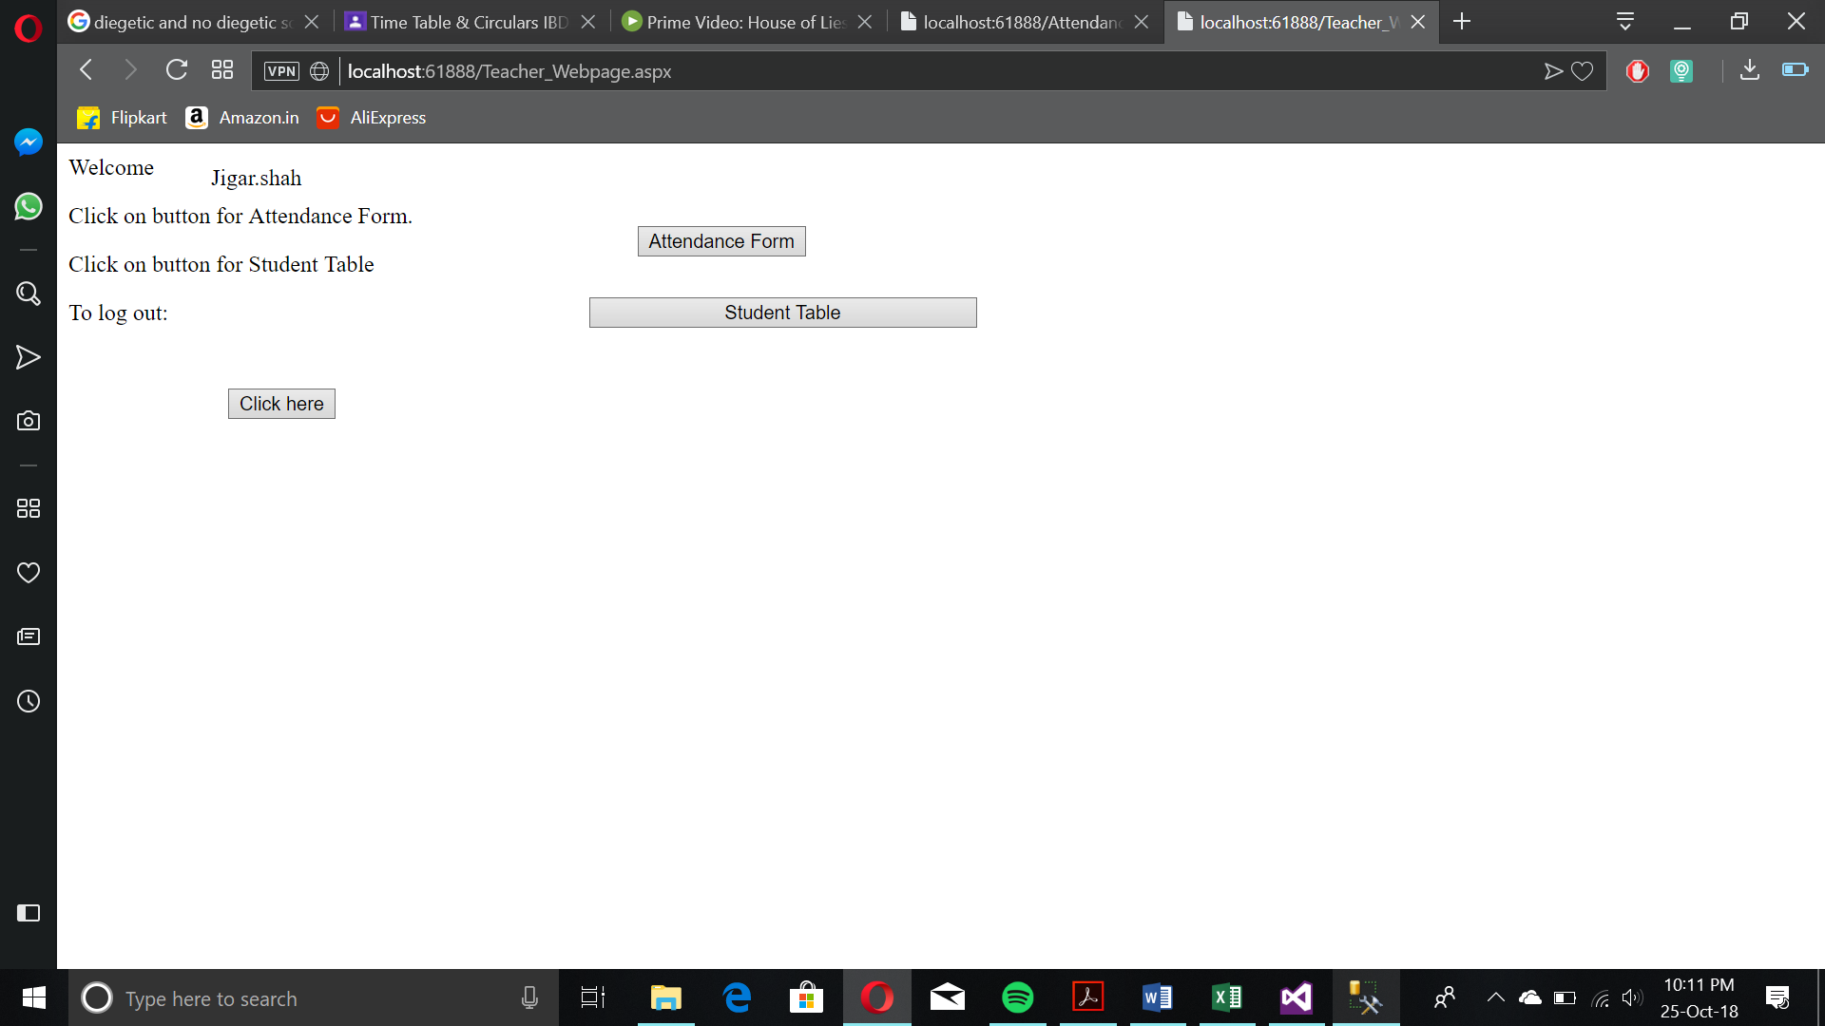

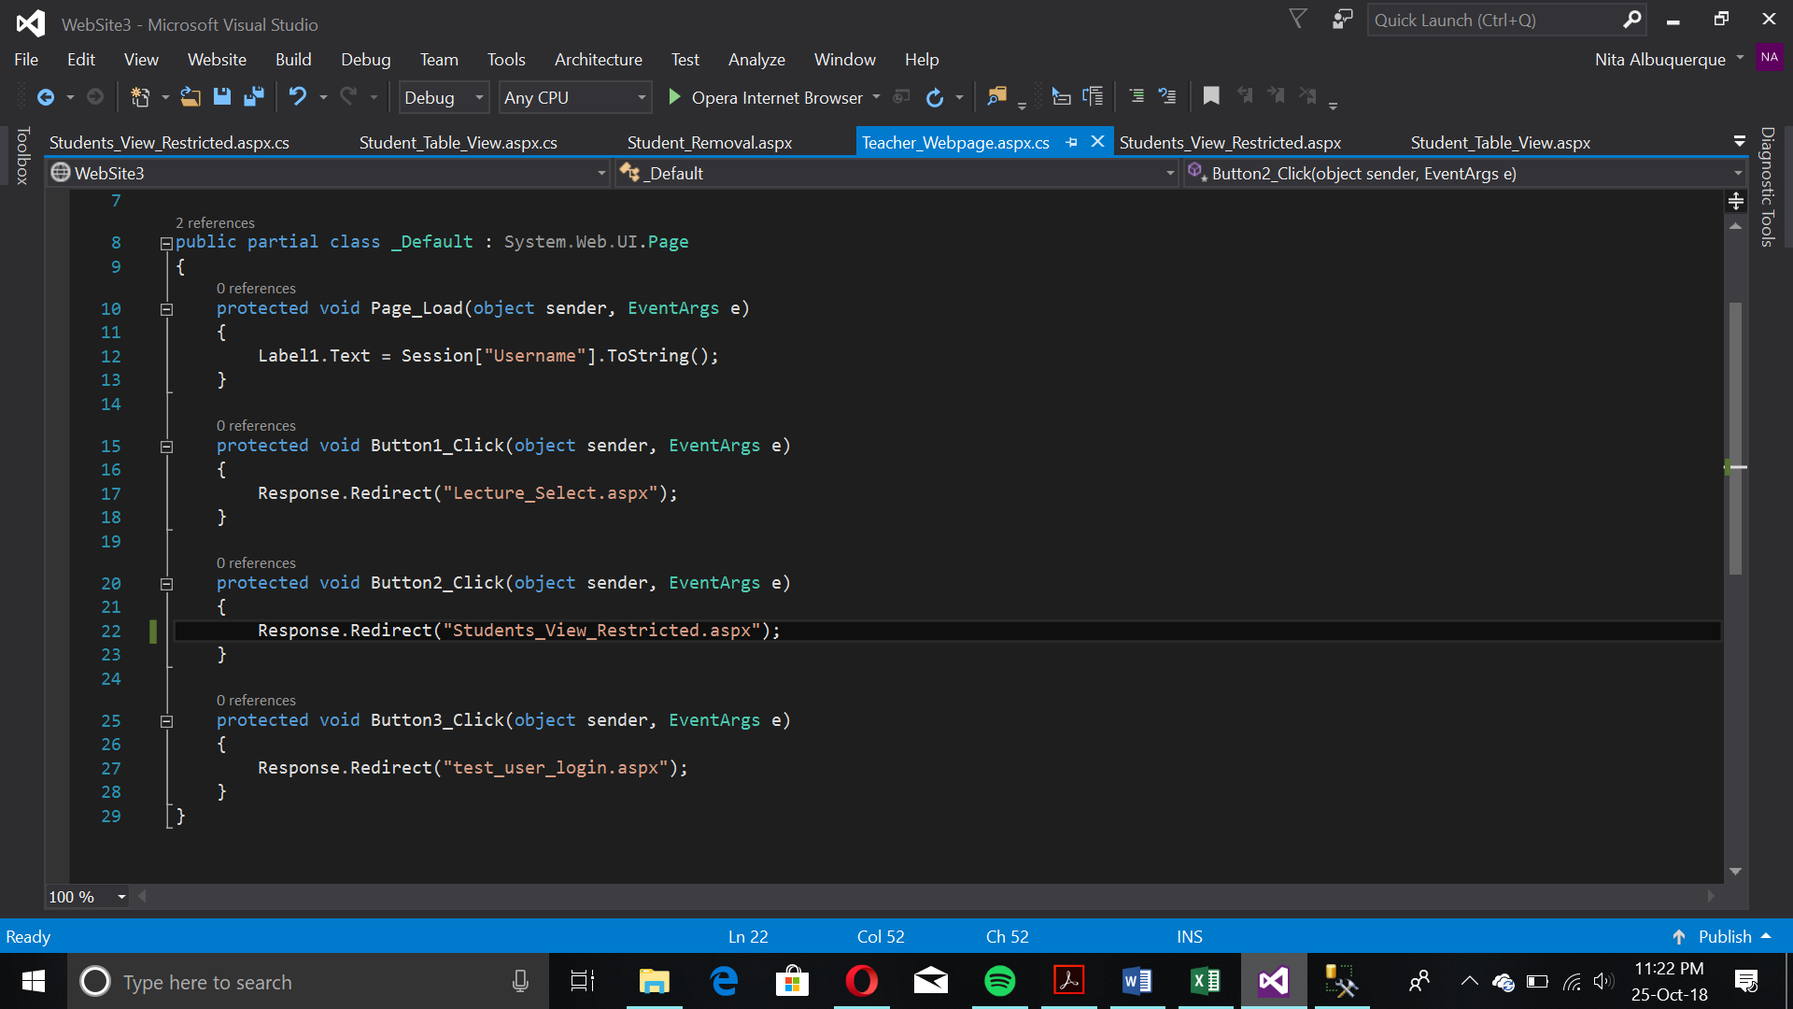

This page is the home page for teachers wherein they record the attendance during lectures and view the student table. Due to less functions, it’s quicker in terms of number of clicks to reach the attendance form.

Attendance Recording

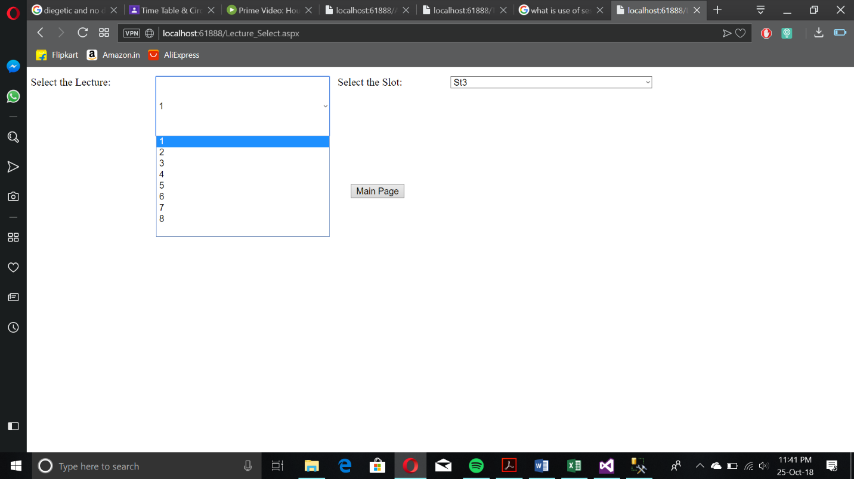

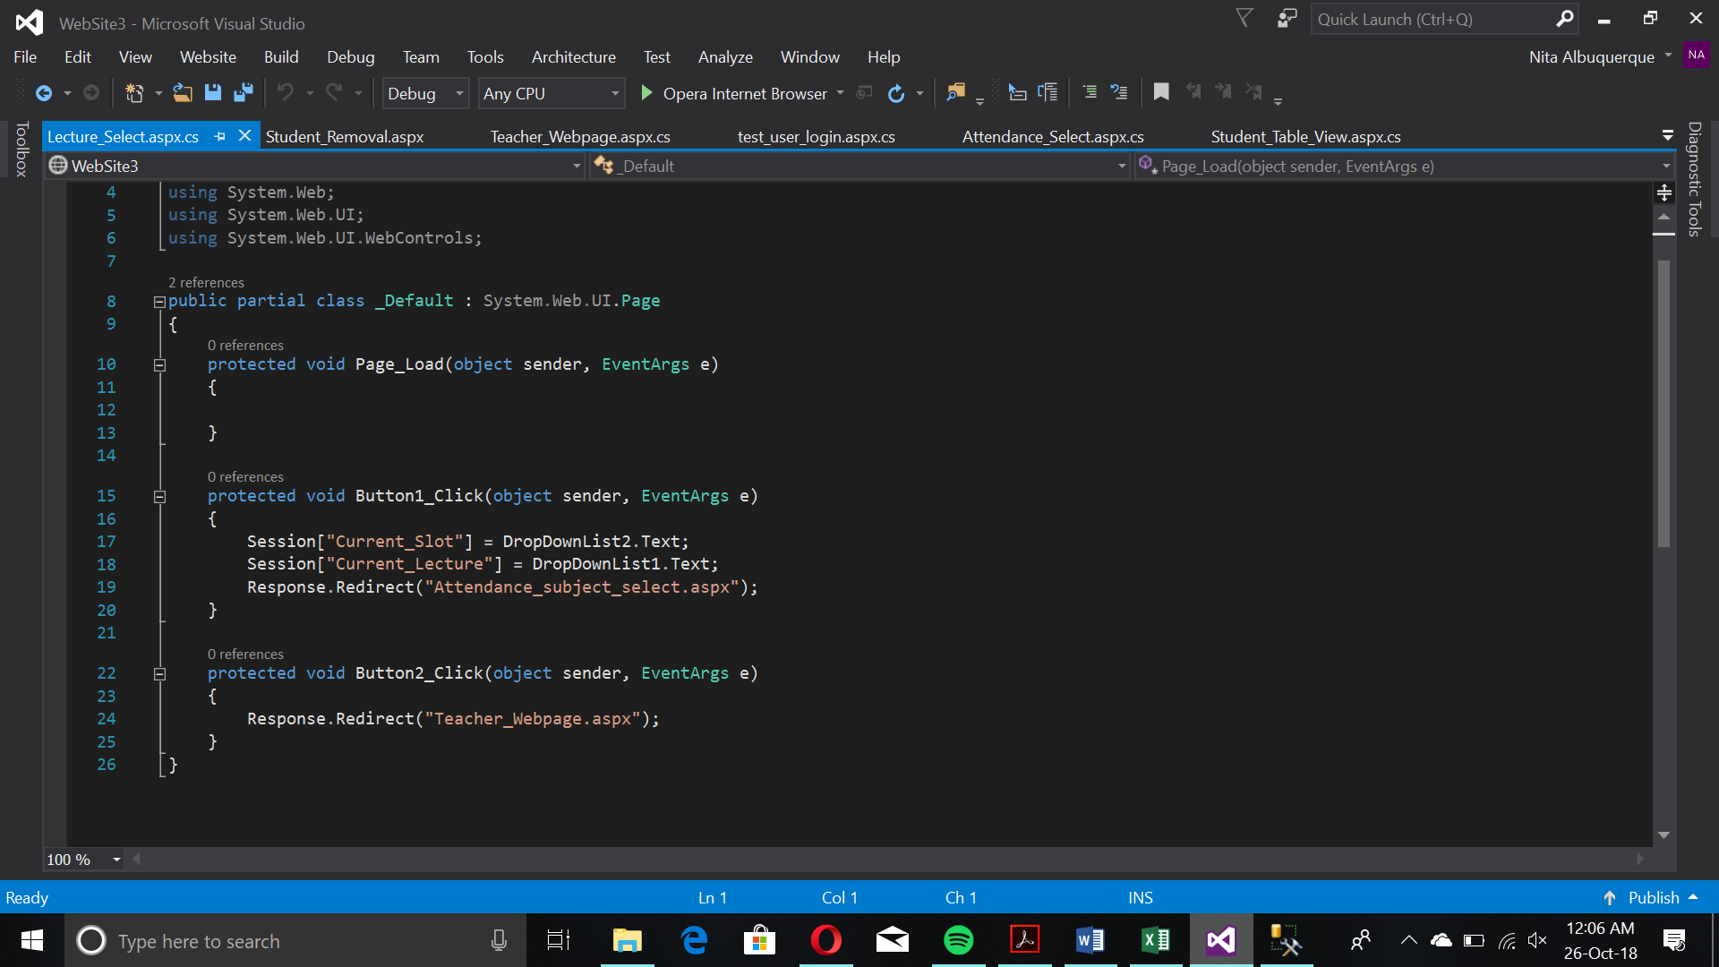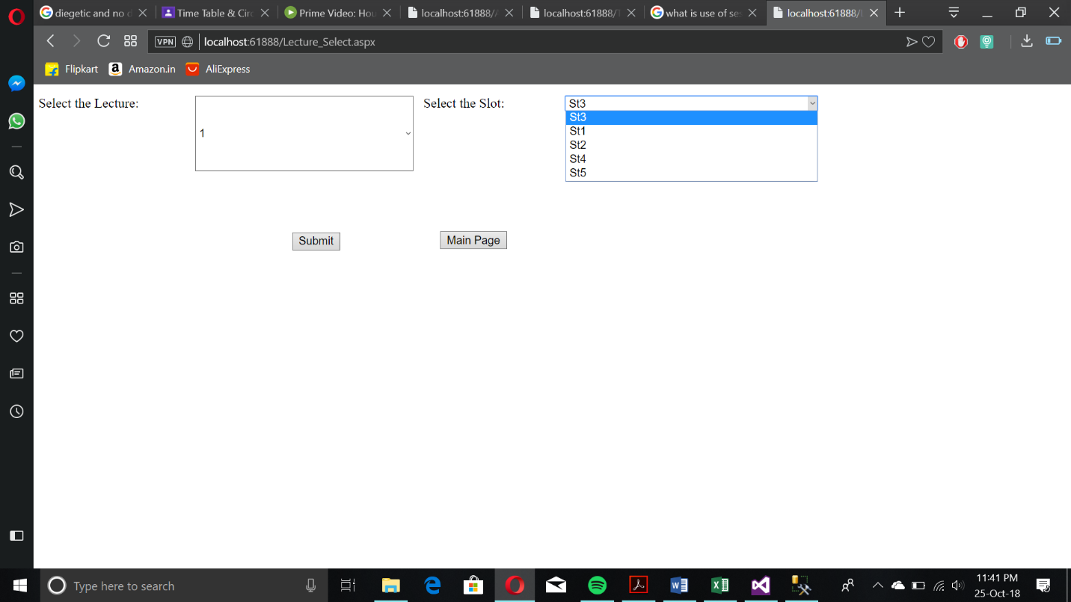

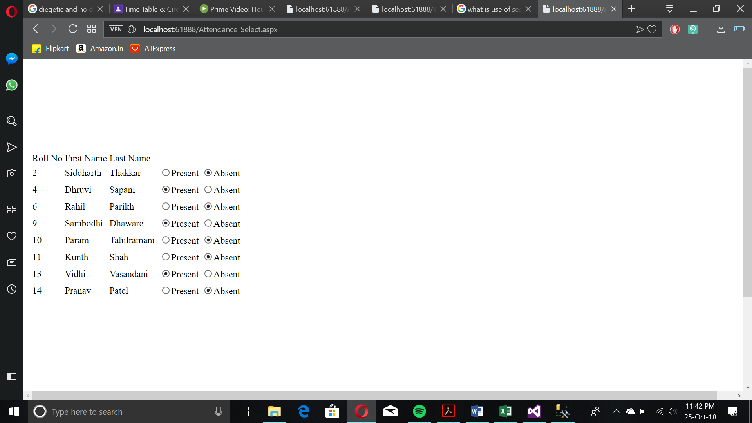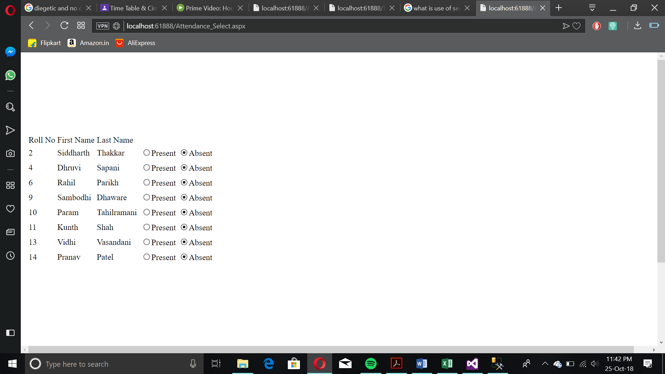Starts with lecture and slot selection so that the teacher can select their slots and lectures hence filtering the subjects that would be entered otherwise.

Main Attendance Select Form

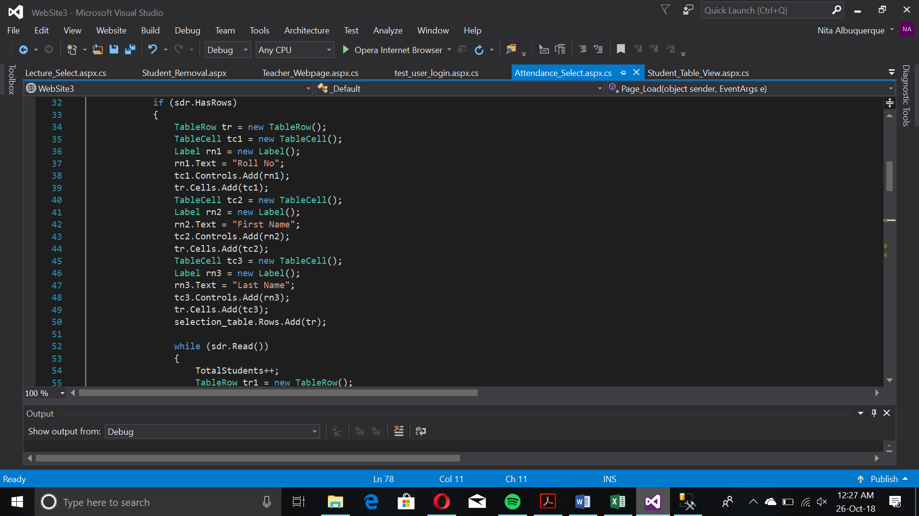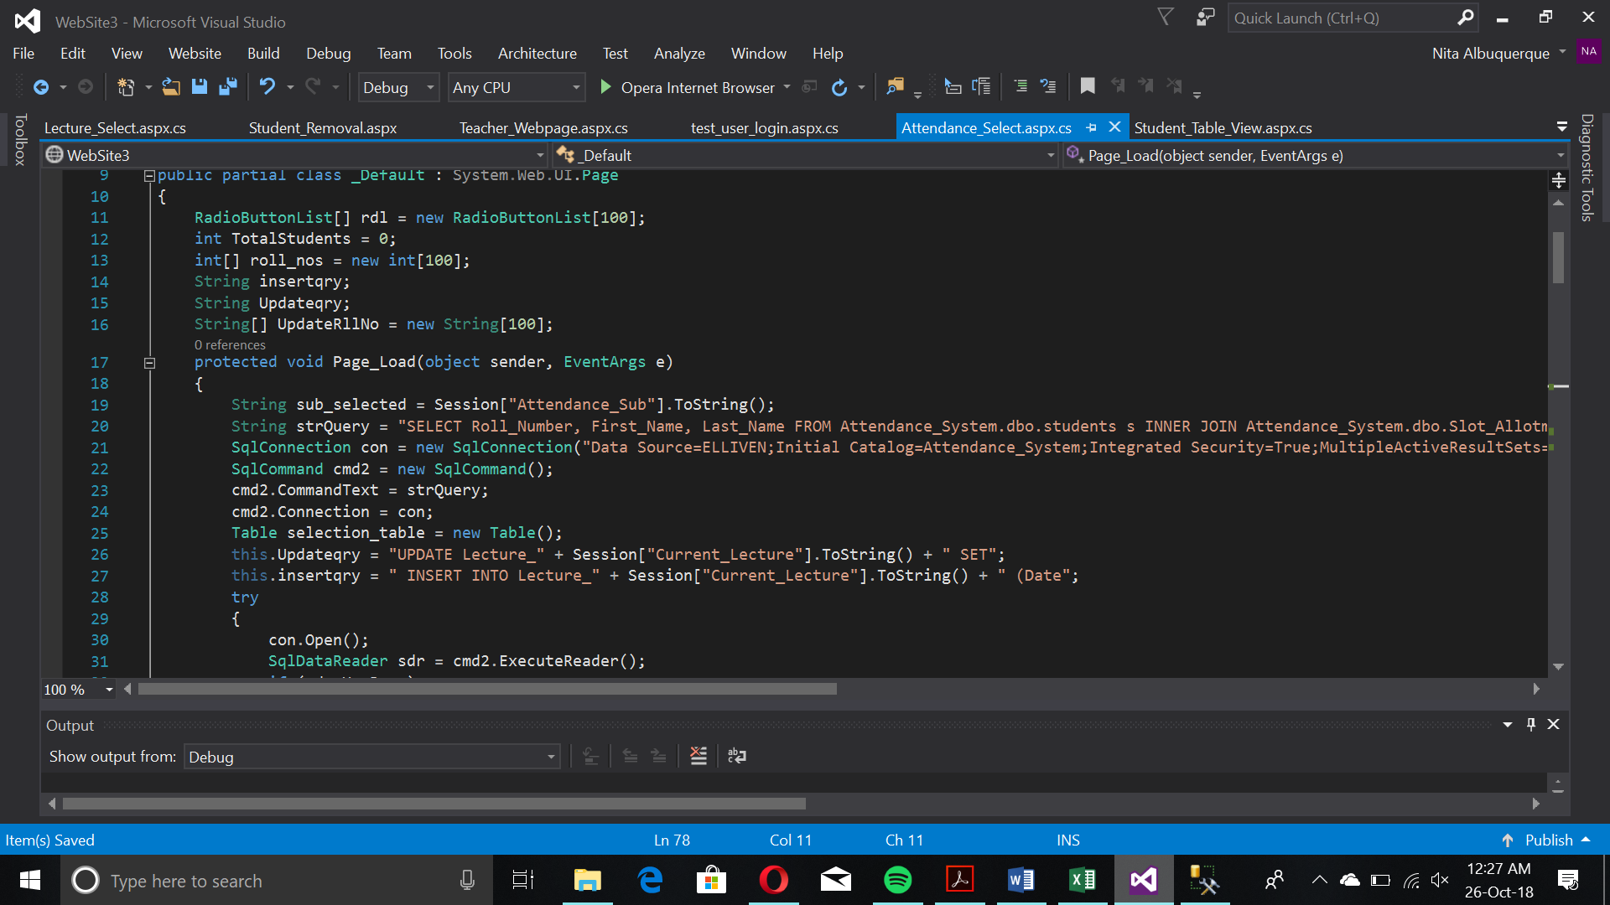

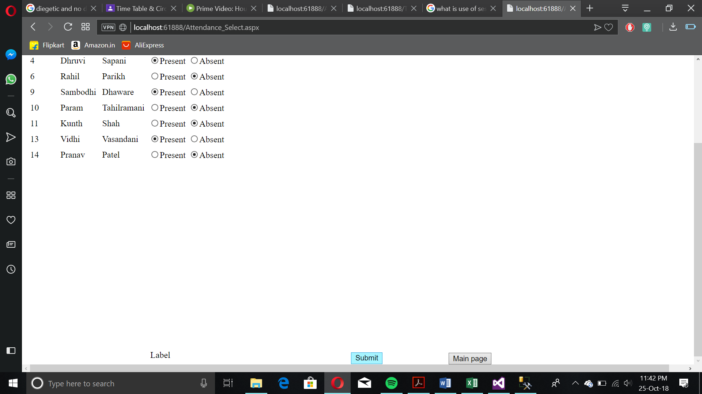

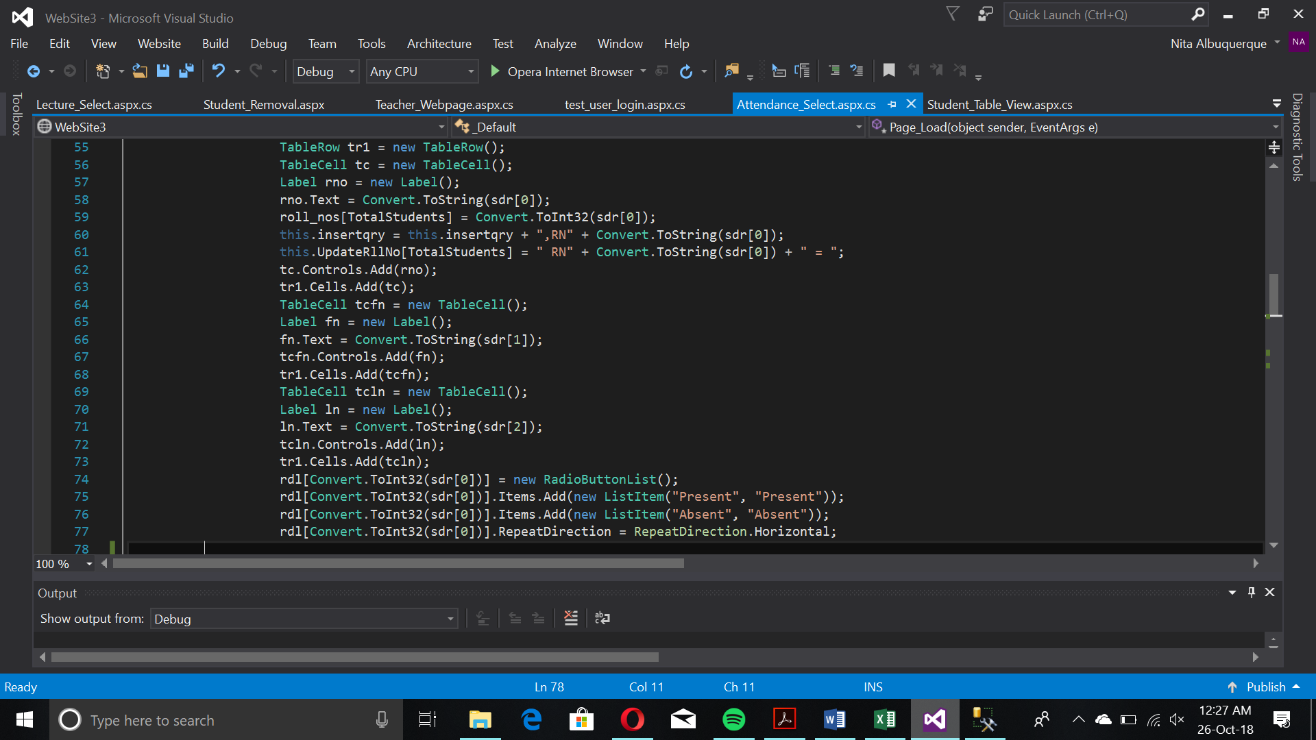

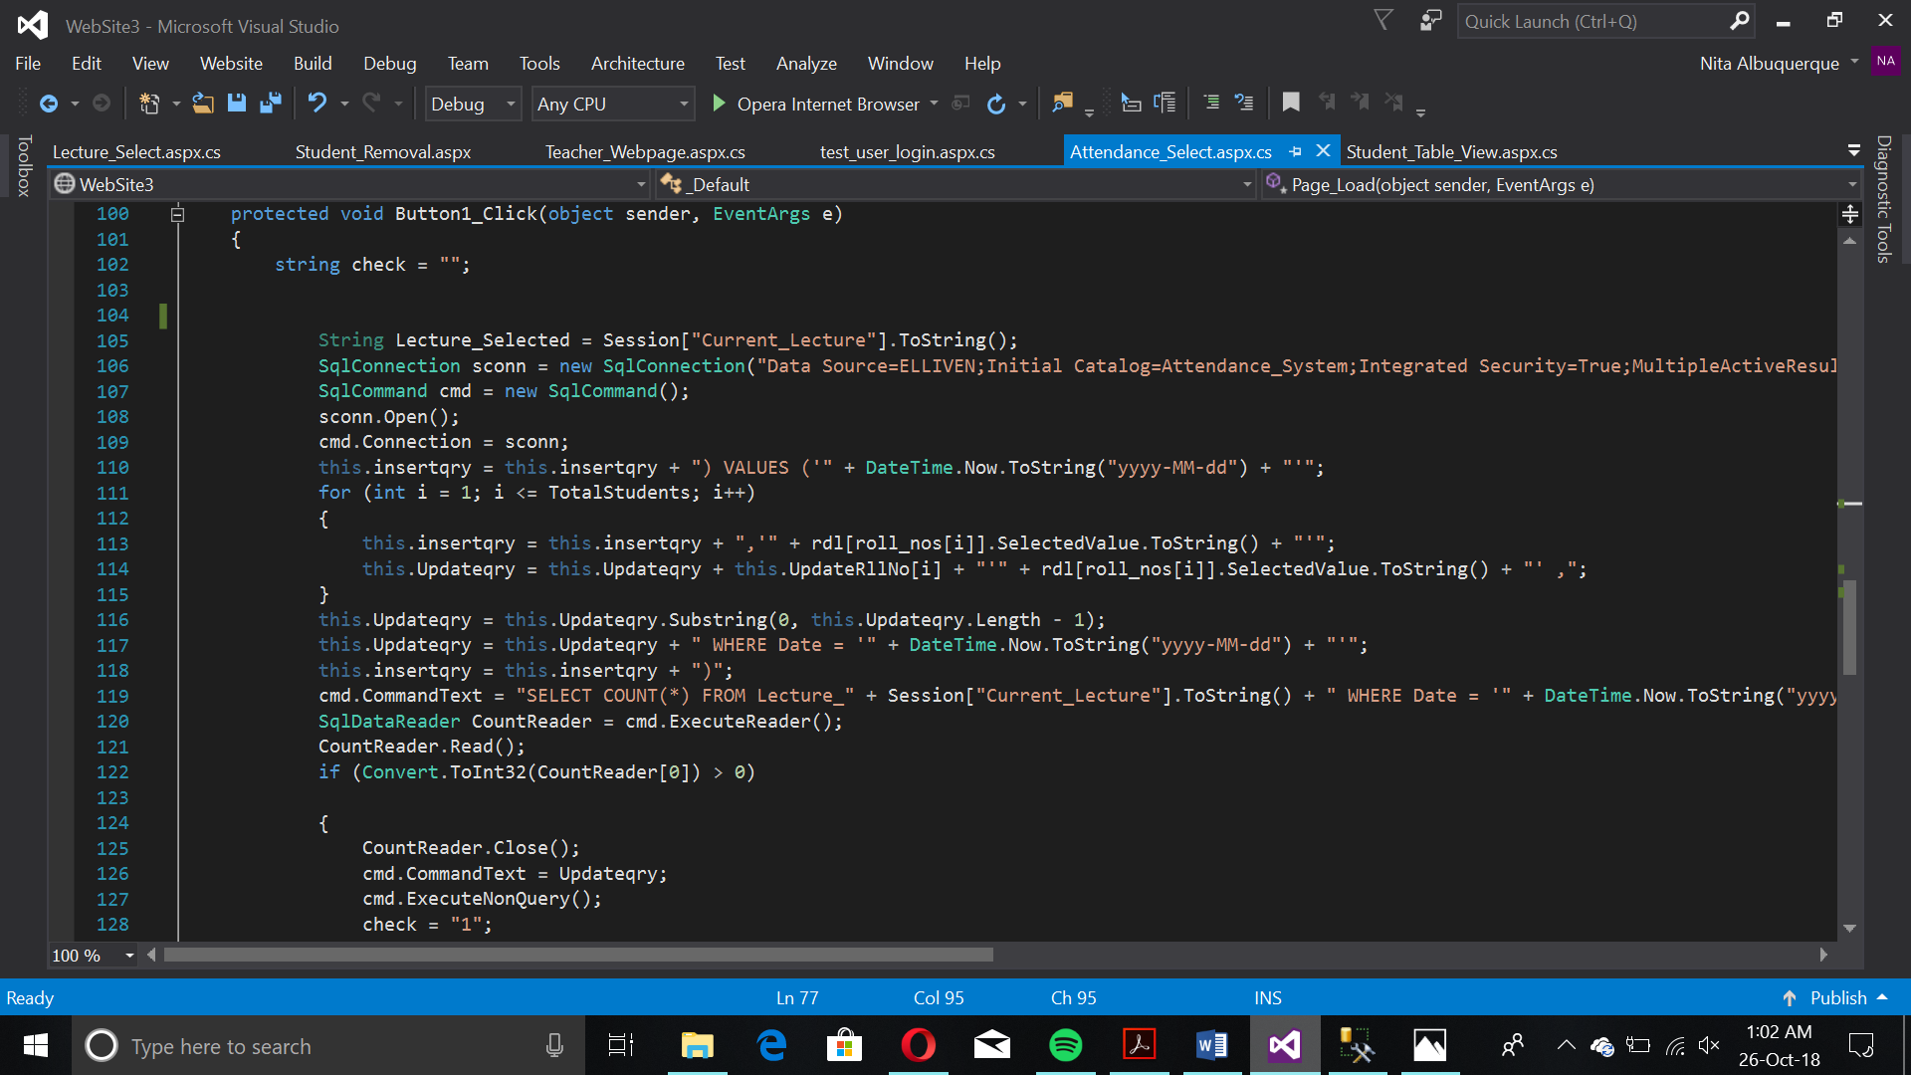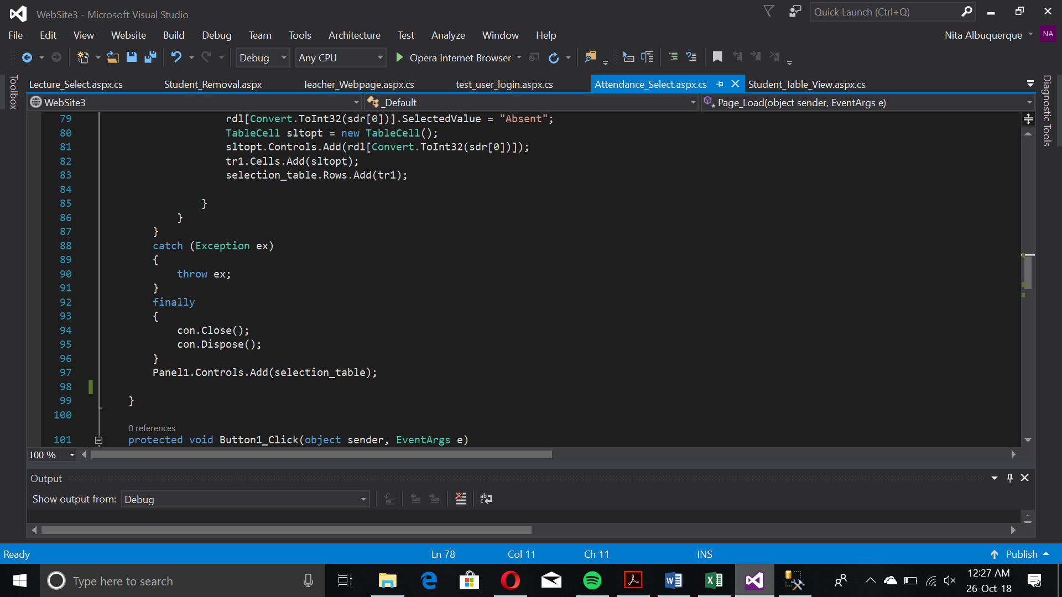

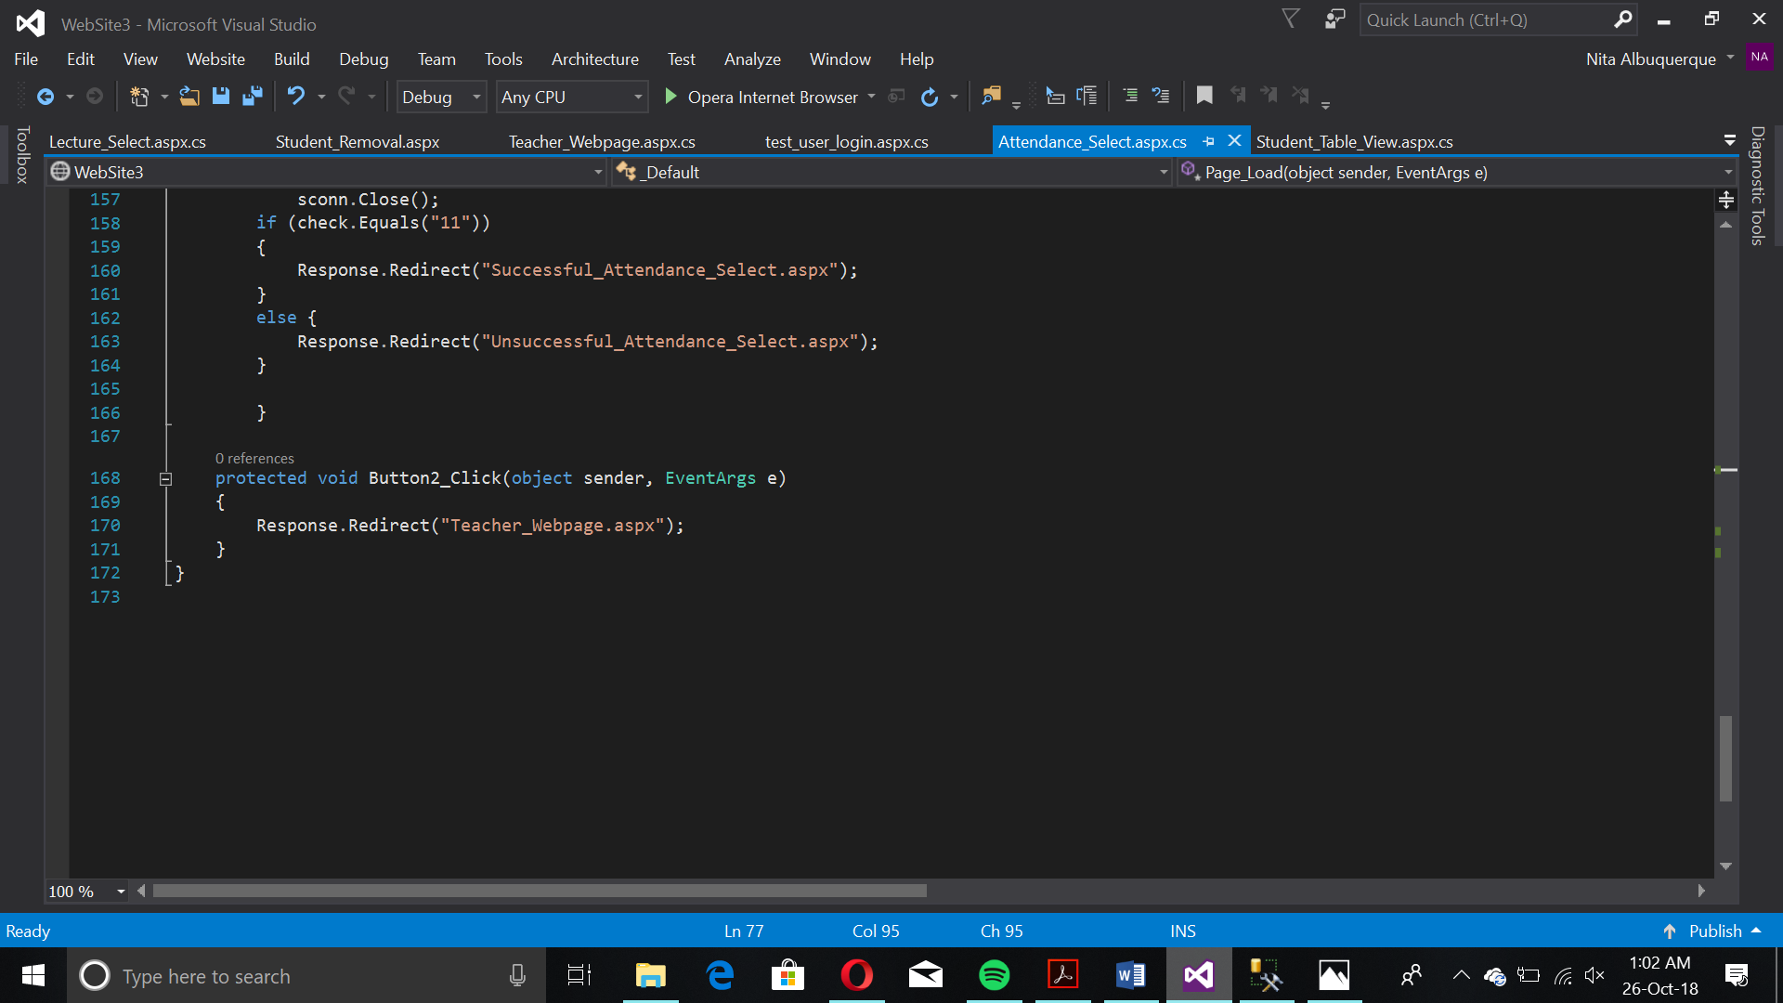

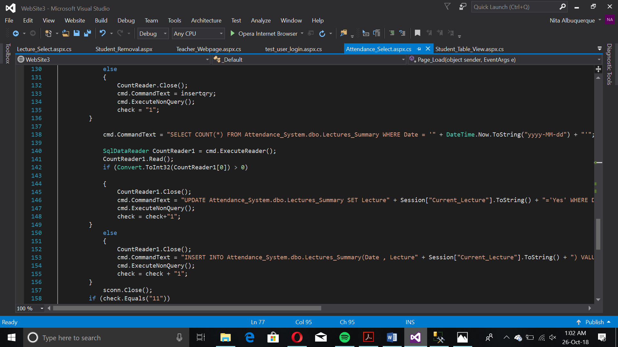The queries are dependent upon whether the initial table was filled. If it was, by another teacher e.g. within the same lecture, instead of an INSERT query, an UPDATE query is used. This allows the individual lecture tables to be filled.